CF91
KTM 1290 Adventure 2016-

Mounting kit left side |  |  |  |  | Mounting kit right side
ID | Description | Cat. No. | Pcs |  |  | ID | Description | Cat. No. | Pcs
1 | Upper crash frame | CF91 | 1 |  |  | 1 | Upper crash frame | CF91 | 1
2 | Bolt M10x100 | 885 | 1 |  |  | 2 | Bolt M10x100 | 885 | 1
3 | Safety nut M8 | 809 | 4 |  |  | 3 | Safety nut M8 | 809 | 4
4 | Washer M8 – flat | 802 | 4 |  |  | 4 | Washer M8 – flat | 802 | 4
5 | dural. roller d=60mm | 6 | 1 |  |  | 5 | dural. roller d=60mm | 6 | 1
6 | 3M tape |  | 4 |  |  | 6 | 3M tape |  | 4
7 | Plastic cap M8 | X46 | 4 |  |  | 7 | Plastic cap M8 | X46 | 4
8 | Stirrup M8 | X78 | 2 |  |  | 8 | Stirrup M8 | X78 | 2
9 | Bolt M8x30 | 834 | 1

Mounting instructions:

Proceed with mounting the crash frames following instructions on attached pictures.

The procedure stays the same for both sides, except that the front bolt M8 (ID.8) is fitted from left side.

Note - For threads of all screws, we recommend using a medium strength (blue) glue.
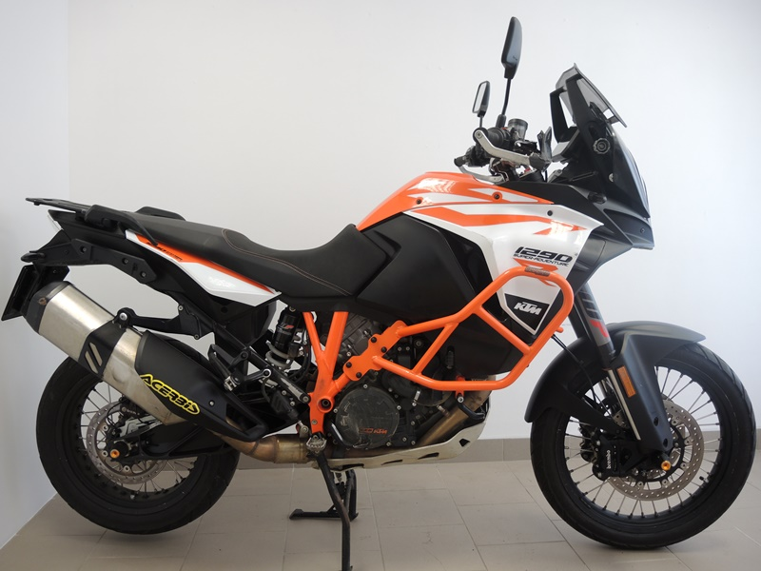

šroub M10x45 ID5 + podložka M10 (plochá) ID6 + duralový váleček d=10mm ID7

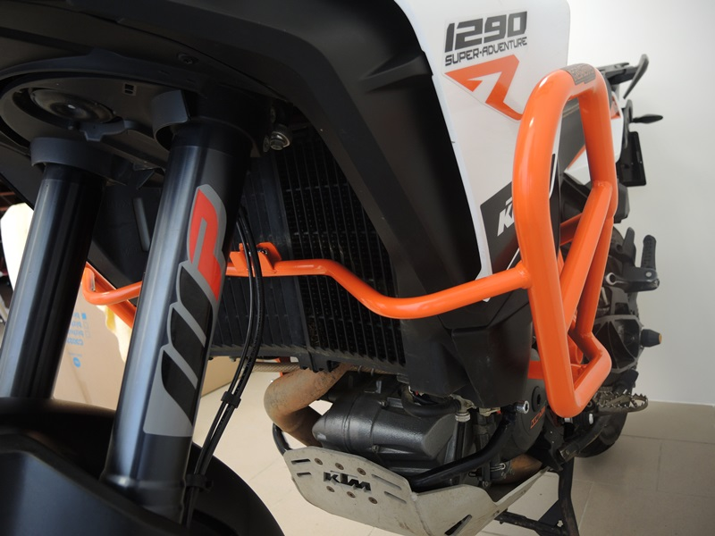
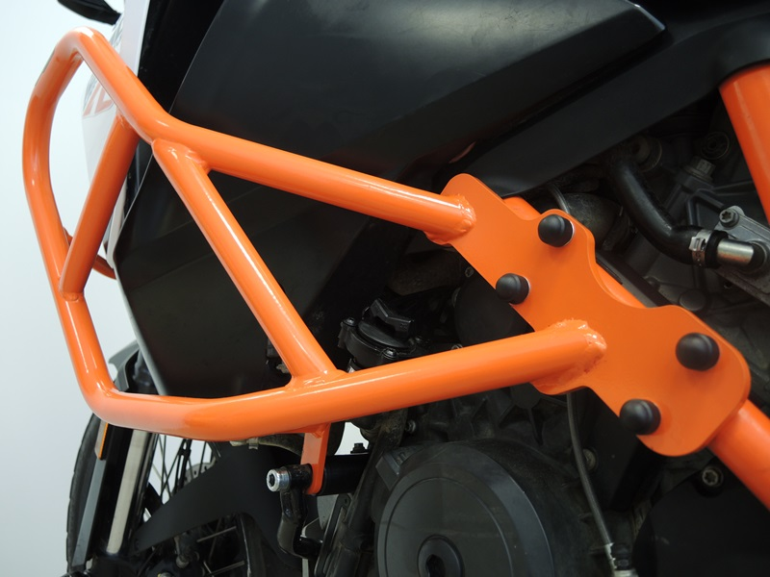

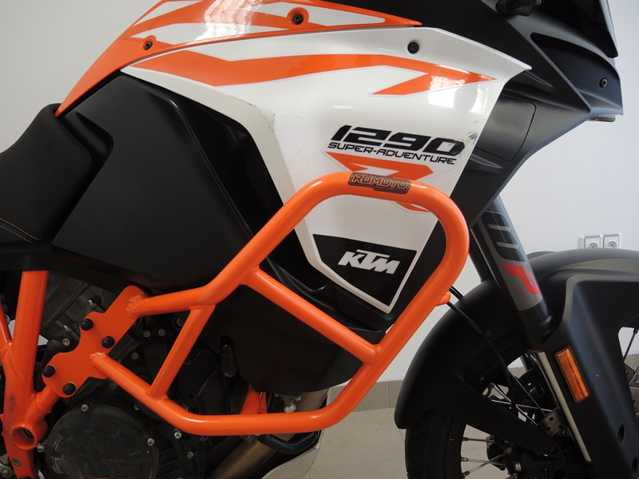
Bolt M8x30 (ID.9)
Stirrup M8 (ID.8) + Washer M8(ID.4) + safety nut M8 (ID.3) + cap M8 (ID.7) + 3M tape (ID.6).
Bolt M10x100 (ID.2) + dural. roller (ID.5)

