CF92
KTM 690 Enduro R 2012-

Kit for left side |  |  |  |  | Kit for right side
Poz. | Popis | Kat.číslo | Počet |  |  | Poz. | Popis | Kat.číslo | Počet
1 | carsh frames upper | CF92 | 1 |  |  | 1 | carsh frames upper | CF92 | 1
2 | stirrup | X52 | 1 |  |  | 2 | stirrup | X52 | 1
3 | self-locking nut M6 | 948 | 2 |  |  | 3 | self-locking nut M6 | 948 | 2
4 | washer M6 – plochá | 947 | 2 |  |  | 4 | washer M6 – flat | 947 | 2
5 | bolt M10x45 | 848 | 1 |  |  | 5 | bolt M10x45 | 848 | 1
6 | Washer flat M10 | 804 | 2 |  |  | 6 | washer flat M10 | 804 | 2
7 | dural. roller d=10mm | 108 | 1 |  |  | 7 | dural. roller d=10mm | 108 | 1
8 | tape 3M |  | 2 |  |  | 8 | tape 3M |  | 2
9 | sticker RDmoto |  | 1 |  |  | 9 | sticker RDmoto |  | 1
10 | dural. roller d=24mm | 1248 | 1 |  |  | 10 | dural. roller d=24mm | 1248 | 1
11 | bolt M8x20 | 823 | 1 |  |  | 11 | bolt M8x20 | 823 | 1
12 | washer flat M8 | 802 | 1 |  |  | 12 | washer flat M8 | 802 | 1
13 | strut | X96 | 1 |  |  | 13 | bolt M10 x180 | 978 | 1
14 | Self-locking nut M10 | 810 | 2 |  |  | 14 | Self-locking nut M10 | 810 | 2
15 | Dural. roller | DV433 | 1 |  |  | 15 | Dural. roller | DV433 | 1

Instruction :

Install the drop frames as instructed on the attached photos.
Mounting starts from the right side, so screws through, under the screw head is a washer and on the left side there are washers and nuts.

The installation of the frames for the left and right sides is the same.

We recommend using a medium-strength thread glue.

Stirrup X52-ID2 + washer flat M6-ID4 + self-locking nut M6 –ID3 + tape 3M – ID8.
bolt M10x45 ID5 + washer M10 (flat) ID6 + duralový roller d=10mm ID7
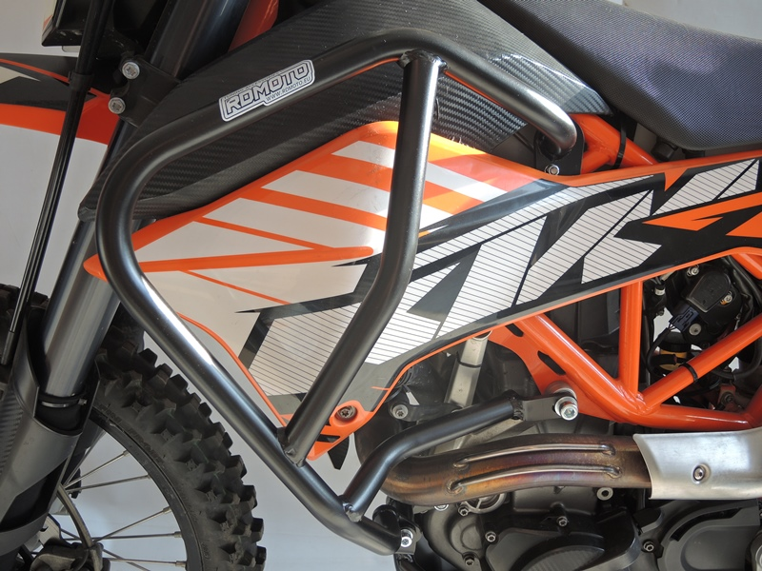

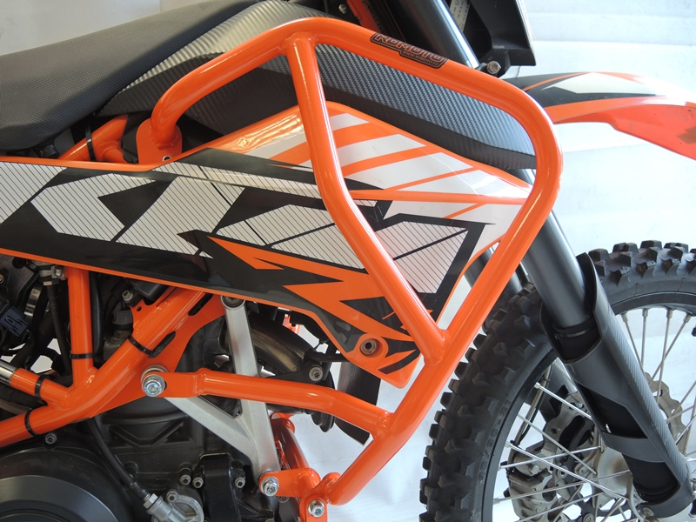
Strut ID13 + Bolt M10x180 ID13 +dural. roller ID10 + 2x washer M10 ID6 + 1x self-locking nut M10
Strut ID.13 +Bolt M8x20 ID11 + dural. roller ID.15 + washer M8 flat ID12

