CF93
KTM 690 Enduro R 2012-

Kit for left side |  |  |  |  | Kit for right side
Poz. | Popis | Kat.číslo | Počet |  |  | Poz. | Popis | Kat.číslo | Počet
1 | Crash frame lower part | CF93 | 1 |  |  | 1 | Crash frame lower part | CF93 | 1
2 | Dural. cylinder d= 5mm | DV433 | 1 |  |  | 2 | Dural. cylinder d= 5mm | DV433 | 1
3 | Self-locking nut M6 | 948 | 3 |  |  | 3 | Self-locking nut M6 | 948 | 3
4 | Washer M6 – flat | 947 | 3 |  |  | 4 | Washer M6 – flat | 947 | 3
6 | Washer M10 – flat | 804 | 2 |  |  | 6 | Washer M10 – flat | 804 | 2
8 | Self-locking nut M10 | 810 | 2 |  |  | 8 | Bolt M10 x 170mm | 935 | 1
10 | Sticker RDmoto |  | 1 |  |  | 10 | Sticker RDmoto |  | 1
11 | Dural. cylinder d=24mm | 1248 | 1 |  |  | 11 | Dural. cylinder d=24mm | 1248 | 1
12 | Bolt M8x20 | 823 | 1 |  |  | 12 | Bolt M8x20 | 823 | 1
13 | Washer flat M8 | 802 | 1 |  |  | 13 | Washer flat M8 | 802 | 1
14 | Bolt M6x16 | 962 | 3 |  |  | 14 | Bolt M6x16 | 962 | 3
15 | Washer M6 | 987 | 3 |  |  | 15 | Washer M6 | 987 | 3
16 | Strut | X96 | 1 |  |  | 16 | Bolt M10 x180 | 978 | 1
17 | sheet metal cover | X107 | 1
Mounting instructions:

Install the crash frames as instructed on the attached photos.¨
Begin with installation of right side with the through-bolts. Left side is for washers and nuts.

Installation of the frames for both sides is the same.

Attention: We recommend using blue color medium strenght glue for threads of all bolts.
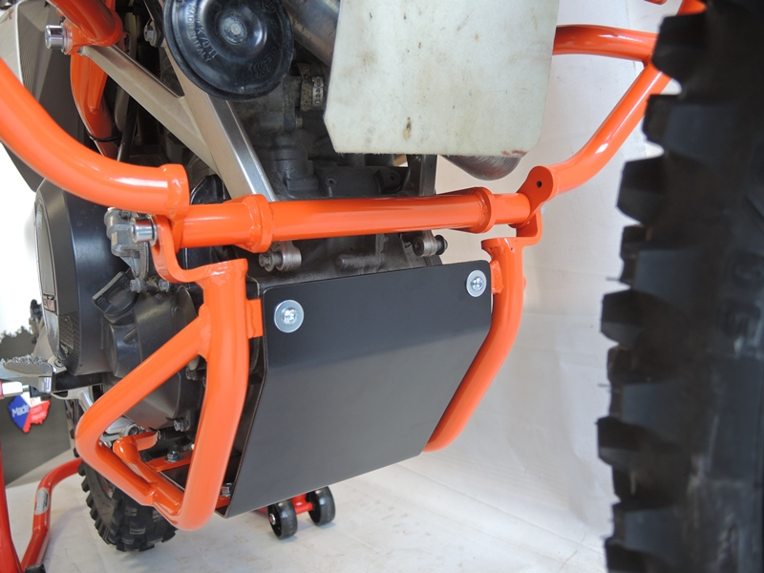

Bolt M6 ID14 + Washer M6 ID15, + Washer M6 flat ID4 + nut M6 ID.3 + sheet metal cover ID.17

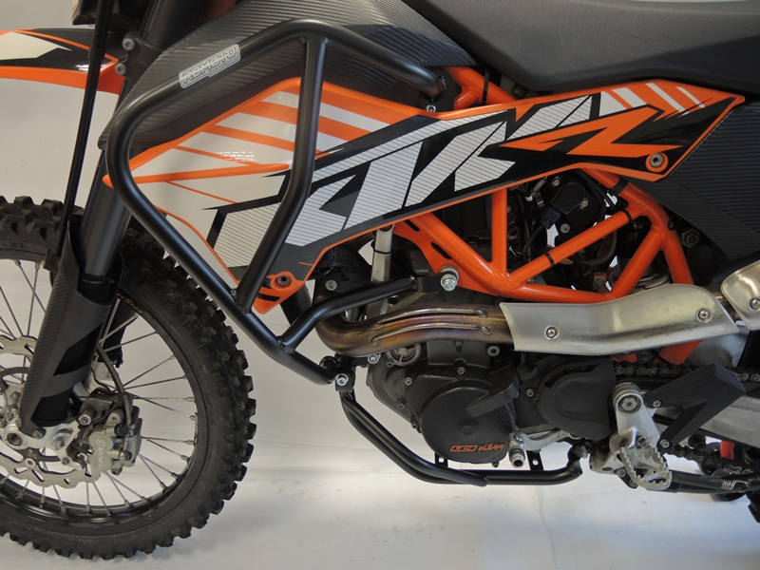
Bolt M10x170mm ID8+ 2x Washer M10 (flat) ID6 + Self-locking nut ID.8
Strut ID16 + Bolt M10x180 ID16 + Dural. Cylinder ID11 + 2x Washer M10 ID6 + 1x Self-locking nut M10 ID.8
Bolt M8x20 ID12 + Washer M8 flat ID13 + Dural. cylinder ID.2
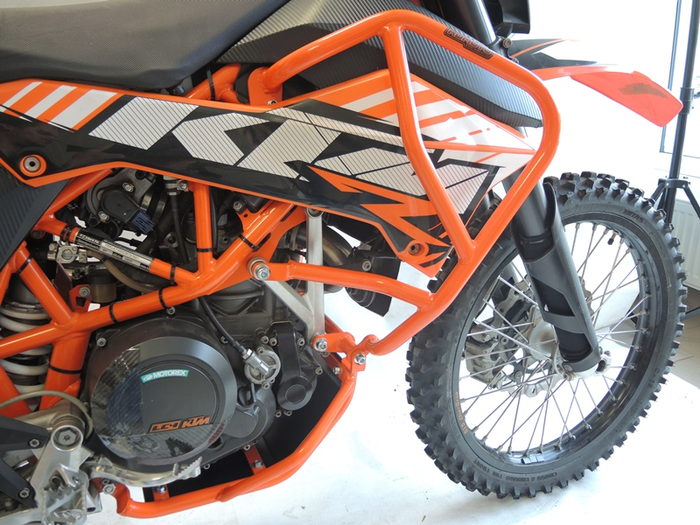

Bolt M6 ID14 + Washer M6 ID15, + Washer M6 flat ID4 + Nut M6 ID.3

