CF94
KTM 690 Enduro R 2012-

Kit for Left Side |  |  |  |  | Kit for Right Side
Pos. | Description | Cat. No. | Pcs. |  |  | Pos. | Description | Cat. No. | Pcs.
1 | Crash frame top | CF92 | 1 |  |  | 1 | Crash frame top | CF92 | 1
2 | Yoke | X52 | 1 |  |  | 2 | Yoke | X52 | 1
3 | Self-locking nut M6 | 948 | 5 |  |  | 3 | Self-locking nut M6 | 948 | 5
4 | Washer M6 – Flat | 947 | 5 |  |  | 4 | Washer M6 – Flat | 947 | 5
5 | Bolt M10x45 | 848 | 1 |  |  | 5 | Bolt M10x45 | 848 | 1
6 | Flat washer M10 | 804 | 3 |  |  | 6 | Flat washer M10 | 804 | 3
7 | Dural. roller d=10mm | 108 | 1 |  |  | 7 | Dural. roller d=10mm | 108 | 1
8 | Self-locking nut M10 | 810 | 2 |  |  | 8 | Bolt M10 x 170mm | 935 | 1
9 | Tape 3M |  | 2 |  |  | 9 | Tape 3M |  | 2
10 | Sticker RDmoto |  | 1 |  |  | 10 | Sticker RDmoto |  | 1
11 | dural. roller d=24mm | 1248 | 1 |  |  | 11 | dural. roller d=24mm | 1248 | 1
12 | Bolt M8x20 | 823 | 1 |  |  | 12 | Bolt M8x20 | 823 | 1
13 | Washer flat M8 | 802 | 1 |  |  | 13 | Washer flat M8 | 802 | 1
14 | Bolt M6x16 | 962 | 3 |  |  | 14 | Bolt M6x16 | 962 | 3
15 | Washer M6 | 987 | 3 |  |  | 15 | Washer M6 | 987 | 3
16 | Lower frame | CF93 | 1 |  |  | 16 | Bolt M10 x180 | 978 | 1
17 | Strut | X96 | 1 |  |  | 17 | sheet metal cover | X107 | 1

Montáž :

Proceed with installation of the crash frames as instructed on the attached pictures.
Mounting starts with the right side, where the through bolts are inserted. Left side is for washers and nuts.

The installation of the frames for the left and right sides is the same.

Montáž padacích rámů pro levou a pravou stranu je shodný.

Note - For threads of all screws, we recommend using a medium strength (blue) glue.

Yoke X52-ID2 + Flat Washers M6-ID4 + Self-locking nut M6 –ID3 + Tape 3M – ID9.
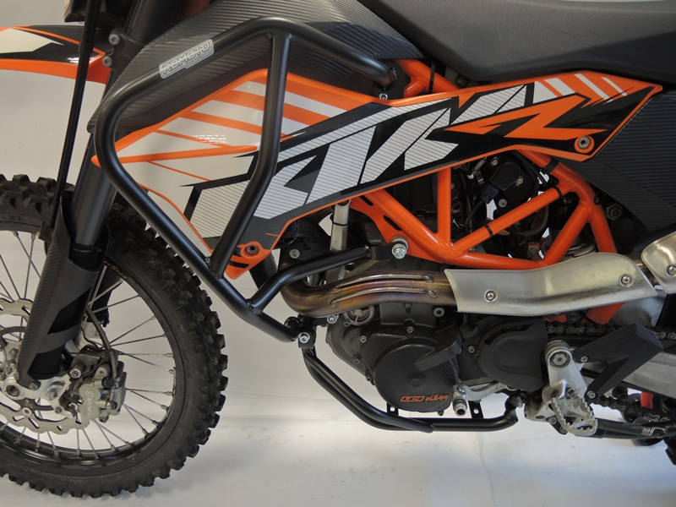
Bolt M10x170mm ID8+ Washer M10 (flat) ID6
Bolt M10x45 ID5 + Washer M10 (flat) ID6 + dural. roller d=10mm ID7
Strut ID17 + Bolt M10x180 ID16 +dural roller ID11 + 2x Washer M10 ID6 + 1x nut M10 self-locking
Bolt M8x20 ID12 + Washer M8 flat ID13
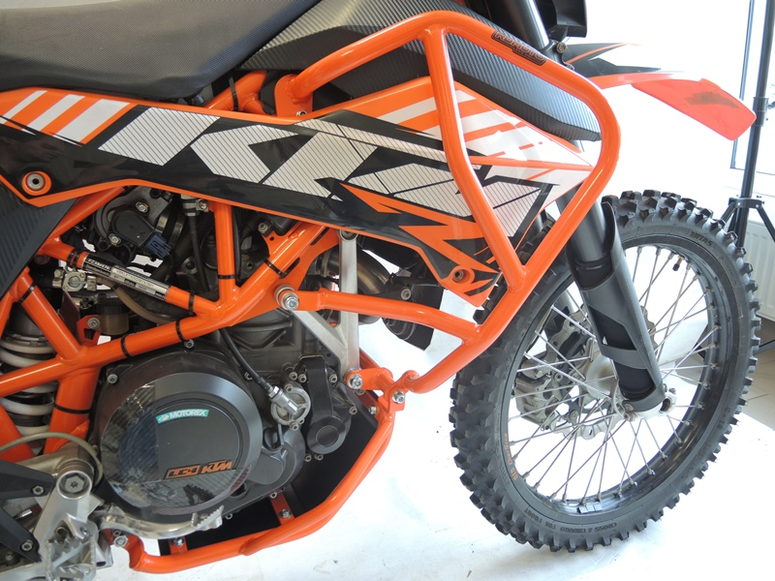

Bolt M6 ID14 + Washer M6 ID15, + Washer M6 flat ID4

