CF95
Benelli TRK 502 2017-

Kit for left side |  |  |  |  | Kit for right side
ID | Popis | Kat.č. | ks |  | ID | Popis | Kat.č. | ks
1 | Crash Frame | CF95 | 1 |  | 1 | Crash Frame | CF95 | 1
2 | Bolt M10x140 | 953 | 1 |  | 2 | Bolt M10x150 | 939 | 1
3 | Self locking nut M10 | 810 | 1 |  | 3 | Self locking nut M10 | 810 | 1
4 | Washer M10 flat | 804 | 2 |  | 4 | Washer M10 flat | 896 | 1
5 | Dural. roller d=8mm | 229 | 1 |  | 5 | Dural. roller d=8mm | 229 | 1
6 | Washer M8 flat | 802 | 2 |  | 6 | Washer M8 flat | 802 | 2
7 | Bolt M8x20 | 823 | 2 |  | 7 | Bolt M8x20 | 823 | 2
8 | Tube plug M10 | X5 | 1 |  | 8 | Tube plug M10 | X5 | 1
9 | Tube plug M8 | X4 | 2 |  | 9 | Tube plug M8 | X4 | 2
10 | Sticker RDmoto |  | 1 |  | 10 | Sticker RDmoto |  | 1

We recommend using medium strenght thread glue.

Mounting instructions (same for both sides):

- Complete one side fully before proceeding to the other one.
- Remove bolts and the original frame from your motorcycle.
- Being assembling the left side first.
- In the bottom part, fit the frame over the rubber hose.
- Using bolt ID.2 push through frame ID.1 and roller ID.5 and slightly attach it from inside using M10 ID.4 washer and M10 ID.3 nut (dont tighten yet)
- Then, fix the frame at the top part using M8 ID.7 bolt and M8 ID.6 washer.
- Proceed fixing the left bottom part of frame using ID.7 bolt and ID.6 washer.
- Finally, tighten all screws and insert tube plugs ID.8 and ID.9.
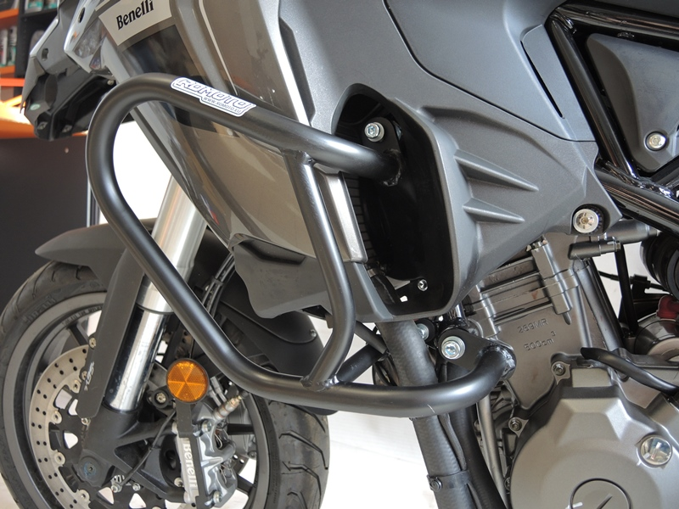

6
6

3
7

2
4
5
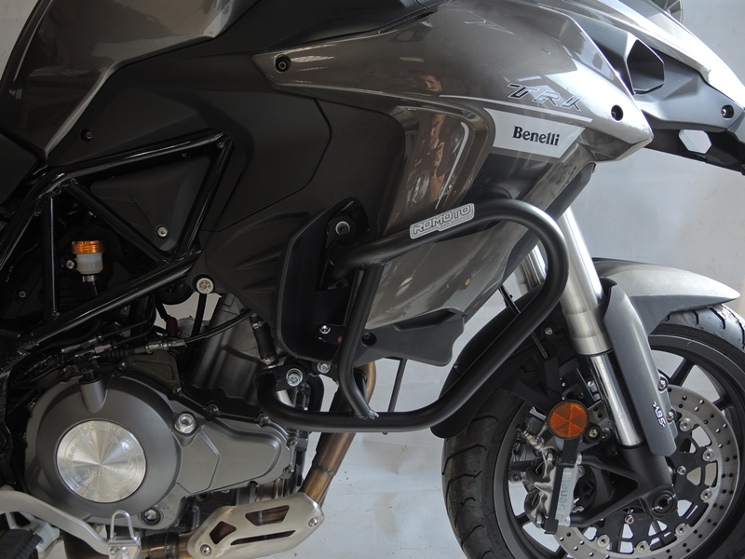
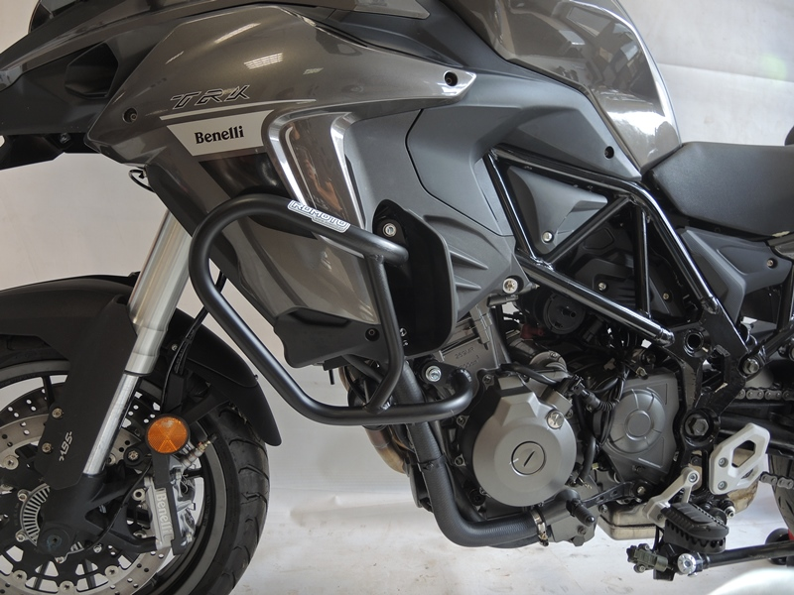
3
9
13,11,12
10
Origin.bolt
Original bolt. Rear place.

