CF96
Suzuki DL650 V-Strom XT650 2017-

Kit for left side |  |  |  |  | Kit for right side
ID | Description | Cat. No. | Pcs |  |  | ID | Description | Cat. No. | Pcs
1 | Crash frame |  | 1 |  |  | 1 | Crash frame |  | 1
2 | Bolt M8x30mm | 834 | 1 |  |  | 2 | Bolt M8x50mm | 837 | 3
3 | Bolt M8x50mm | 837 | 3 |  |  | 3 | Washer M8 (spring) | 800 | 3
4 | Washer M8 (spring) | 800 | 3 |  |  | 4 | Cap on the screw head | X5 | 3
5 | Cap on the screw head | X5 | 3 |  |  | 5 | dural. roller d=13mm | 86 | 2
6 | dural. roller d=13mm | 86 | 2 |  |  | 6 | dural. roller d=16mm | 252 | 1
7 | dural. roller d=16mm | 252 | 1 |  |  | 7 | Plastic plug | X19 | 1
8 | Plastic plug | X19 | 1 |  |  | 8 | Sticker RDmoto |  | 1
9 | Sticker RDmoto |  | 1

Mounting instructions:

Proceed with mounting as shown on the pictures attached.

Procedure for left and right side is the same.

Attention – for threads of all bolts, we recommend using medium strenght thread glue (blue color).

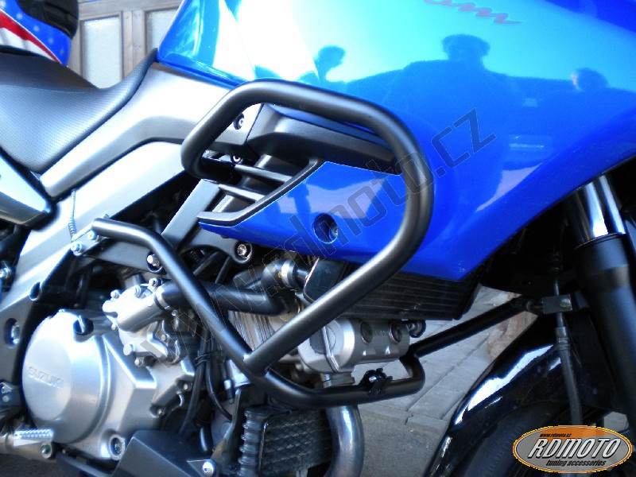
Bolt M8x30mm to attach to the frame

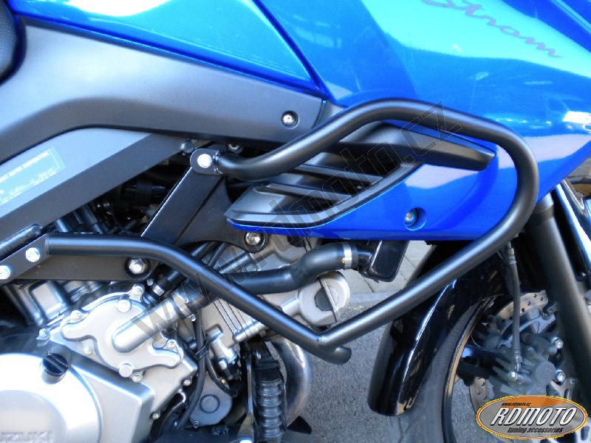
Bolt M8x50mm + dural. roller 13mm + Spring washer + Cap for the screw head
Bolt M8x50mm to attach to the frame + dural. roller 16mm + Spring washer + cap for the screw head
Bolt M8x50mm + dural. roller 13mm + Spring washer + cap for the screw head

