CF97
Kawasaki Z900RS 2018-

Kit for left side |  |  |  |  | Kit for right side
ID | Description | Cat. no. | Pcs |  | ID | Description | Cat. no. | Pcs
1 | Frame | CF97 | 1 |  | 1 | Frame | CF97 | 1
2 | Bolt M10x85x1.25 | 934 | 1 |  | 2 | Bolt M10x85x1.25 | 934 | 1
3 | Bolt M10x55x1.25 | 915 | 1 |  | 3 | Bolt M10x55x1.25 | 915 | 1
4 | Bolt M10x40x1.25 | 941 | 1 |  | 4 | Bolt M10x80x1.25 | 920 | 1
5 | Dural. roller d=43mm | 1246 | 1 |  | 5 | Dural. roller d=43mm | 1246 | 1
6 | Washer M10 flat | 804 | 2 |  | 6 | Washer M10 flat | 804 | 2
7 | Dural. roller d=30,5mm | 197 | 1 |  | 7 | Dural. roller d=30,5mm | 197 | 1
8 | Plastic plug | X19 | 1 |  | 8 | Plastic plug | X19 | 1

We recommend using medium strenght thread glue.

Instructions (identical for left and right side):

- Finish installation of one side completely before beginning with the other.
- Remove original bolt from the upper part of the frame.
- Screw the ID.2 bolt through crash frame ID.1 and ID.5 roller and snap it into the motorcycle frame (do not tighten).
- Remove the original bolt from rear and bottom part of the frame.
- Screw the left bottom part of frame using ID.4 bolt and right using ID.4 M10x60x1.25.
- Use ID.3 bolt and ID.7 roller to attach the rear top part.
- Finally, tighten all screws.
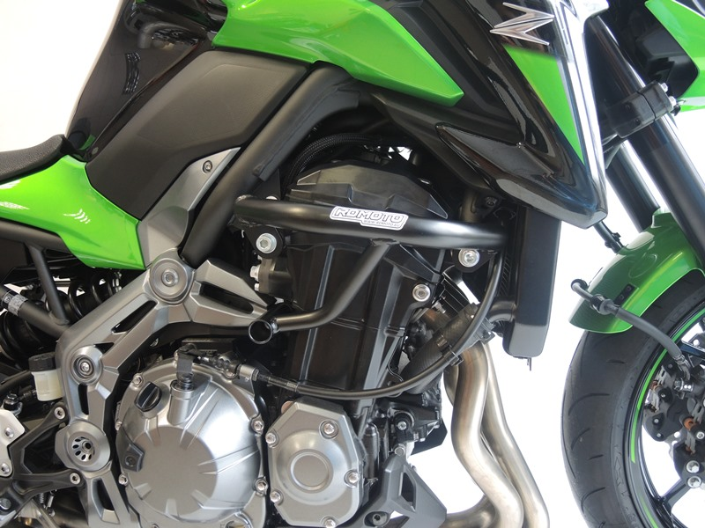

6
6
7
2
3
4
8
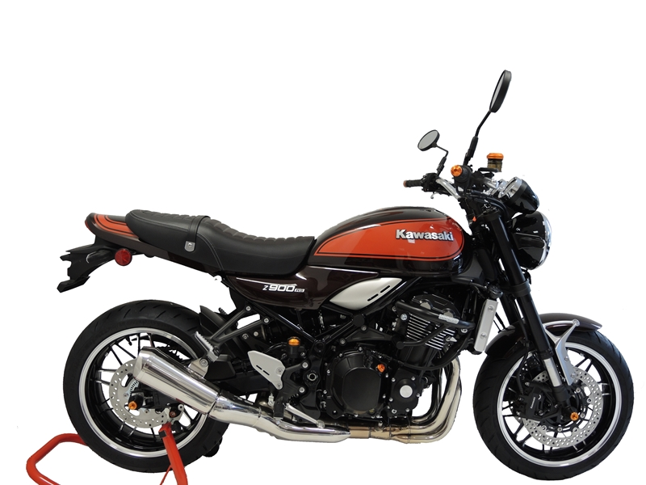
9
13,11,12
10
Origin.bolt
Original bolt. Rear place.

