CF98
BMW R1150 R 2001-2006

Kit for right side |  |  |  |  | Kit for left side
Poz. | Popis | Kat.číslo | Počet |  |  | Poz. | Popis | Kat.číslo | Počet
1 | Crash frame |  | 1 |  |  | 1 | Crash frame |  | 1
2 | Dural. roller d=61mm | DV1223 | 1 |  |  | 2 | Dural. roller d=61mm | DV1223 | 1
3 | Silentblok | X21 | 1 |  |  | 3 | Silentblok | X21 | 1
4 | Nut M10 hat | 961 | 1 |  |  | 4 | Nut M10 hat | 961 | 1
5 | Washer M10 – flat | 804 | 3 |  |  | 5 | Washer M10 – flat | 804 | 3
6 | Bolt M10x100 | 885 | 1 |  |  | 6 | Bolt M10x100 | 885 | 1
7 | Nut M8 self-locking | 809 | 1 |  |  | 7 | Nut M8 self-locking | 809 | 1
8 | Washer M8 flat | 802 | 1 |  |  | 8 | Washer M8 flat | 802 | 1
9 | Bolt M10x60 | 850 | 1 |  |  | 9 | Bolt M10x60 | 849 | 1
10 | Rod 10x230x30x30 |  | 1 |  |  | 11 | Dural. roller d=15mm | DV1170 | 1
11 | Dural. roller d=15mm | DV1170 | 1 |  |  | 12 | Dural. roller d=88mm | DV1256 | 1
12 | Dural. roller d=38mm | DV1255 | 1 |  |  | 13 | Sticker RDmoto |  | 1
13 | Sticker RDmoto |  | 1

Mounting instructions:

Proceed with mounting as shown on the pictures attached.

Attention – for threads of all bolts, we recommend using medium strenght thread glue (blue color).

Right side:

Replace the original bolt with bolt M10x100(ID.6.) onto which you fit dural. roller DV1223(ID.2), between the thread and frame.
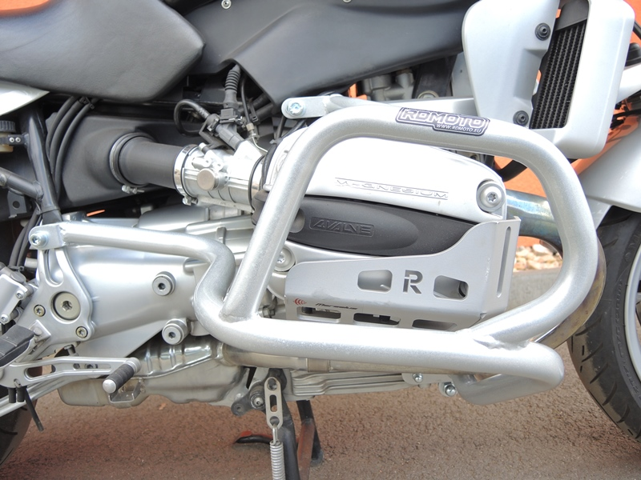
Rod 10x230x30x30 + DV1255 Washer M10 + hat type nut

Bolt M10x60 (ID.9) + Washer flat M10 (ID.5.), put dural. roller between crash frame and motorcycle frame (ID.11)
Nut M8 (self-locking) + Washer M8 (flat) +lean the silentblock against engine block

Left side:

Replace the original bolt with bolt M10x100 (ID.6.) onto which you fit dural. roller DV1223(pozn.2) between crash and motorcycle frame.
.

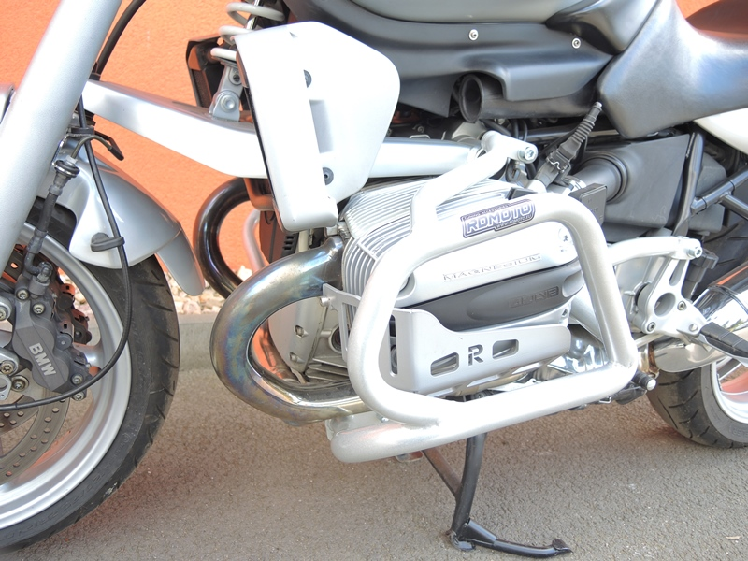
Bolt M10x50mm + Dural. roller (lenght 15mm) + Washer M10 (flat)

Hat type nut M8 + Washer M8 (flat) + silentblock
Dural. roller DV1256(pozn.12.) + Washer M10 + Hat type nut M10

