CF99
Honda XRV 750 Africa Twin (1993-2003)

Kit for left side |  |  |  |  | Kit for right side
ID. | Description | Cat. No. | Pcs |  |  | ID. | Description | Cat.No. | Pcs
1 | Crash Frame | - | 1 |  |  | 1 | Crash Frame | - | 1
2 | Safety nut M10 | 810 | 1 |  |  | 2 | Safety nut M10 | 810 | 1
3 | Washer M10 – flat | 804 | 2 |  |  | 3 | Washer M10 – flat | 804 | 2
4 | Plastic cover M10 | X35 | 1 |  |  | 4 | Plastic cover M10 | X35 | 1
5 | Rod 270x10x30x30 |  | 1 |  |  | 5 | RDmoto Sticker |  | 2
6 | Upper strut | X110 | 1 |  |  | 6 | Stirrup M6 | X112 | 2
7 | Washer M6 | 947 | 1 |  |  | 7 | Washer M6 | 947 | 1
8 | Safety nut M6 | 948 | 1 |  |  | 8 | Safety nut M6 | 948 | 1
9 | Bolt M10x30 | 882 | 2 |  |  | 9 | Bolt M10x30 | 882 | 2
10 | Lower Strut | X111 | 1 |  |  | 10 | Blowout | X104 | 1
11 | Bolt M8x65 | 982 | 1 |  |  | 11 | Bolt M8x65 | 982 | 1
12 | Washer M8 flat | 802 | 1 |  |  | 12 | Washer M8 flat | 802 | 1
13 | Washer M8 Spring | 800 | 1 |  |  | 13 | Washer M8 spring | 800 | 1
14 | Plastic cap M8 | X5 | 1 |  |  | 14 | Plastic cap M8 | X5 | 1
15 | Plastic cap M10 | X4 | 1 |  |  | 15 | Plastic cap M10 | X4 | 1
16 | Bolt M8x30 | 834 | 1

Mounting instructions:
Proceed with mounting the crash frames following the procedure shown on attached pictures. On right hand side, take off the exhaust cover before mounting our crash frames. Note – We recommend using medium strenght thread glue for all bolts (blue color).
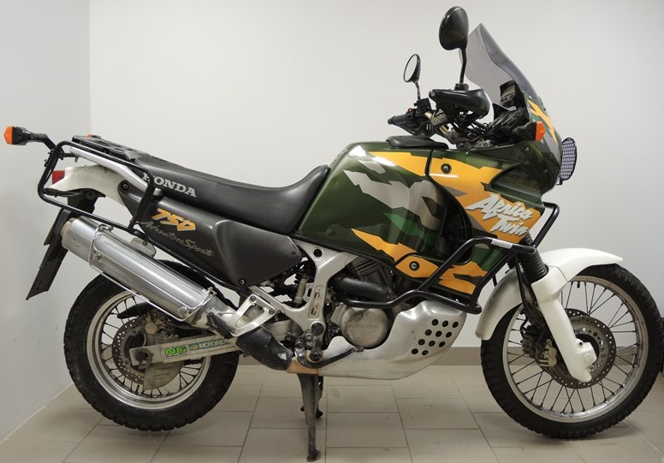

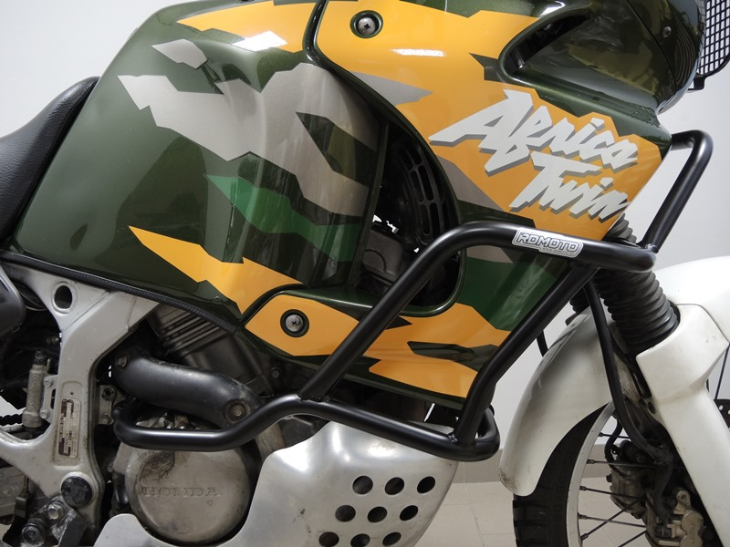
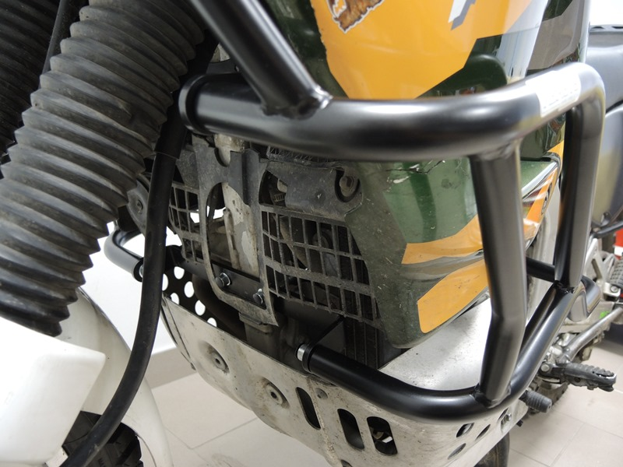
Lower Strut ID.10
+ blowout ID.10
+ 2x Bolt M8 ID.11
+ 2x Washer M8 Flat ID.12
+ 2x Plastic cap M8 ID.14
+ 2x Bolt M10 ID.9
+ 2x Washer M10 Flat ID.3

Rod 270x10x30x30 ID.5
+ Washer M10 ID.3
+ Nut M10 ID.2
+ Plastic cover ID.4
Upper Strut ID.6
+ 2x Stirrup M6 ID.6
+ 2x Washer M6 ID.7
+ 2x Nut M6 ID.8
+ 2x Bolt M10 ID.9
+ 2x Washer flat M10 ID.3
Bolt M8x30 ID.16

