A11S
Aprilia Caponord 1200 2013-

Kit for left side: |  |  |  |  | Kit for fight side:
ID. | Description | Cat.N | QTY |  |  | ID. | Description | Cat.N | QTY
1 | Dural.adapter | 301 | 1 |  |  | 1 | Dural.adapter | 301 | 1
2 | Bolt M6x25 | 877 | 3 |  |  | 2 | Bolt M6x25 | 877 | 3
3 | Bolt M4x16 | 876 | 2 |  |  | 3 | Bolt M4x16 | 876 | 2
4 | Steel nut M12 | X12 | 1 |  |  | 4 | Steel nut M12 | X12 | 1

5 | Innox rod M12x385x1,25mm | N6 | 1

For Connect left and right side use inox rod ID.5 length 385mm with threads M12x385x1,25.

Assembly instruction:

1. Dismantle original bolt M12 from frame.
2. Insert inox rod ID.5 into the frame.
3. Put on from left and right side dural.adapters ID.1.
4. Tighten adapters use nuts ID.4.
5. Put on sliders, use bolts ID.2.
6. Insert covers, use bolts ID.3.

Warning: We recommend use the glue of all threads. Medium strong.

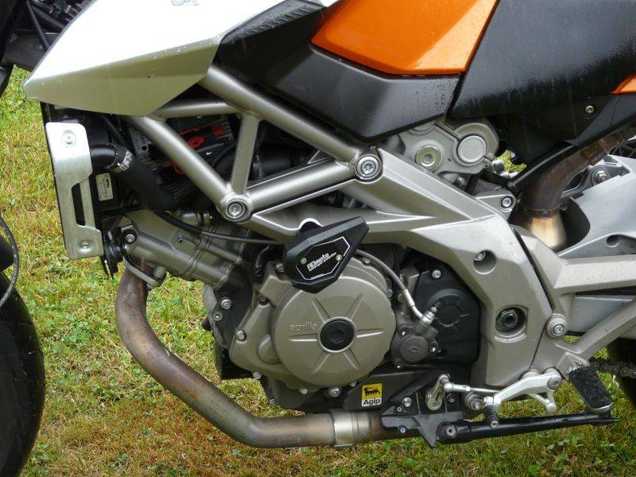
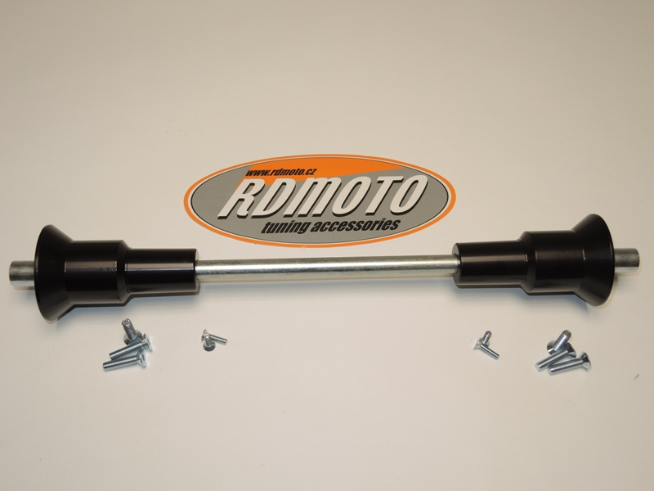
3
2
1
1
5
4
3
2
4

