A11
Aprilia Caponord 1200

ID. | Description | Cat.N | Qt
1 | Steel nut M12 | X12/X2 | 1
2 | Alu spacer d=61mm | 31 | 1
Fitting kit left side: Fitting kit right side:

ID. | Description | Cat.N | Qt
1 | Steel nut M12 | X12/X2 | 1
2 | Alu spacer d=61mm | 31 | 1
 | Steel connection bar M12x425x(1,25)x30x30 |  | 1

Assembly:

- Dismantle orignal bolt M12.
- Place steel bar into the frame M12x425x1,25mm
- Place alu. spacers ID.2 on this bar from booth sides.
- Tighten it by nuts ID.1.

Note: We recommend use medium strong glue for all threads.

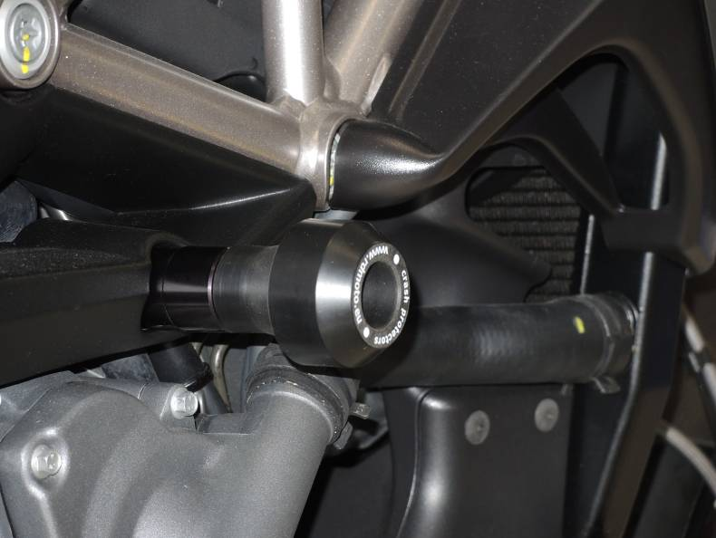

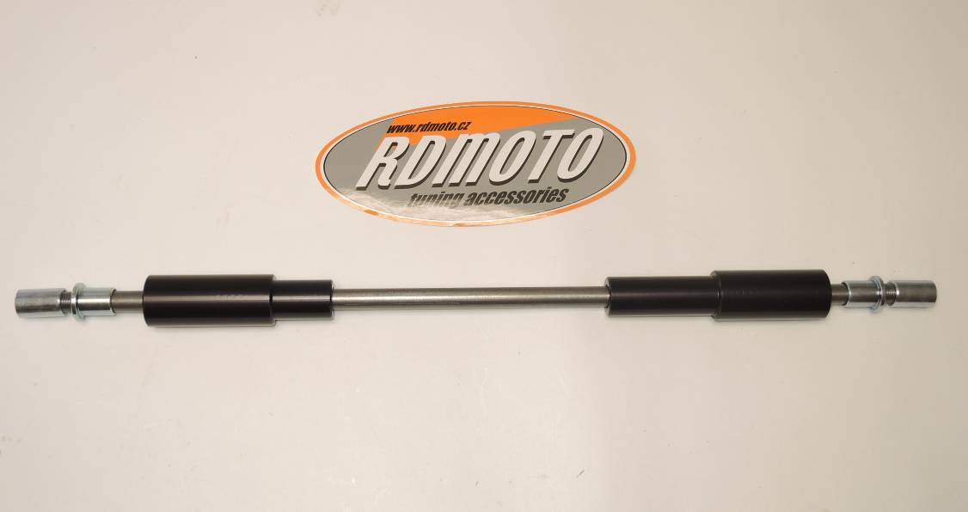

1
3
2
1
4
3
2

