A1
Aprilia RSV100 Mille 2001-2003

Fitting kit:
ID | Description | Cat.N | Qty
1 | Steel box M12 | X2 | 2
2 | Dural.adapter | 504 | 1
3 | Dural.adapter | 505 | 1
4 | Dural.cylinder d=80mm with thread M12 | 131 | 2
5 | Dural.cylinder d=15mm | 148 | 2
6 | Bolt M10x40 | 854 | 4
7 | Washer M10 | 804 | 4
8 | Bolt M12x40(6 edge) | 826 | 2
9 | Bolt M12x40(imbus) | 857 | 2
10 | Washer M12 | 803 | 2

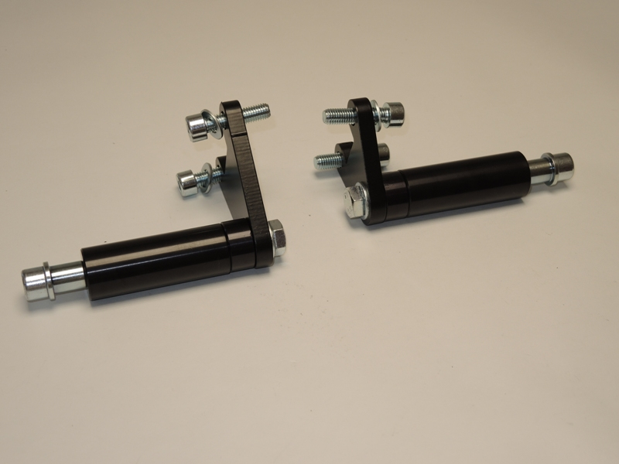

Assembly:
- From back side gripping dural.cylinder ID.5 and ID.4 to dural. adapter (ID.2,ID.3) use bolts and washer ID.8 and ID.10.
- This kit mounting on the bike by bolt and washer ID.6 a ID.7.
- Into the protector insert ID.1 and bolt ID.9.
- This kit mounting into the dural. cylinder with thread.

Warning: We recommend use the glue of all threads. Medium strong.

