A2
Aprilia Tuono 2002-2005

Fitting kit:
ID | Description | Cat.N | Qt
1 | Steel box M10 | X1 | 2
2 | Bolt M10x60 | 850 | 2
3 | Dural.cylinder d=15mm | 8 | 2

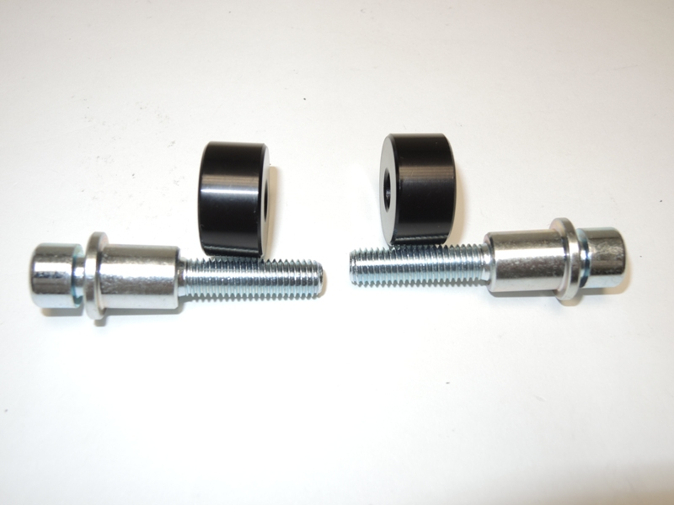
3
3

1
1

2
2

Assembly:
- Into the protector insert steel box ID.1 and bolt ID.2.
- Put the dural.cylinder under the protector ID.3
- This set mounting on the frame.

Warning: We recommend use the glue of all threads. Medium strong.

