A3S
Aprilia Tuono (06-10)

ID | Description | Cat.no. | Pcs
1 | Dural. adapter | 502 | 1
2 | Bolt M10x95 | 822 | 1
3 | Bolt M8x30 | 834 | 1
4 | Dural. cylinder 31mm | 134 | 1
5 | Alu. cylinder 40mm | 132 | 1
6 | Bolt M10x30 | 882 | 1
7 | Slider adapter 20mm | 292 | 1
8 | Bolt M10x35 (cone) | 976 | 1
9 | Bolt M6x25 | 877 | 3
10 | Bolt M4x16 | 876 | 2
LEFT SIDE KIT RIGHT SIDE KIT
ID | Description | Cat.no. | Pcs
1 | Dural. adapter | 503 | 1
2 | Bolt M10x100 | 885 | 1
3 | Bolt M10x30 | 846 | 1
4 | Dural. nut | 1172 | 1
5 | Bolt M8x25 | 833 | 1
6 | Dural. cylinder 38mm | 133 | 1
7 | Alu. cylinder 40mm | 132 | 1
8 | Bolt M10x30 | 882 | 1
9 | Slider adapter 20mm | 292 | 1
10 | Bolt M10x35 (cone) | 976 | 1
11 | Bolt M6x25 | 877 | 3
12 | Bolt M4x16 | 876 | 2
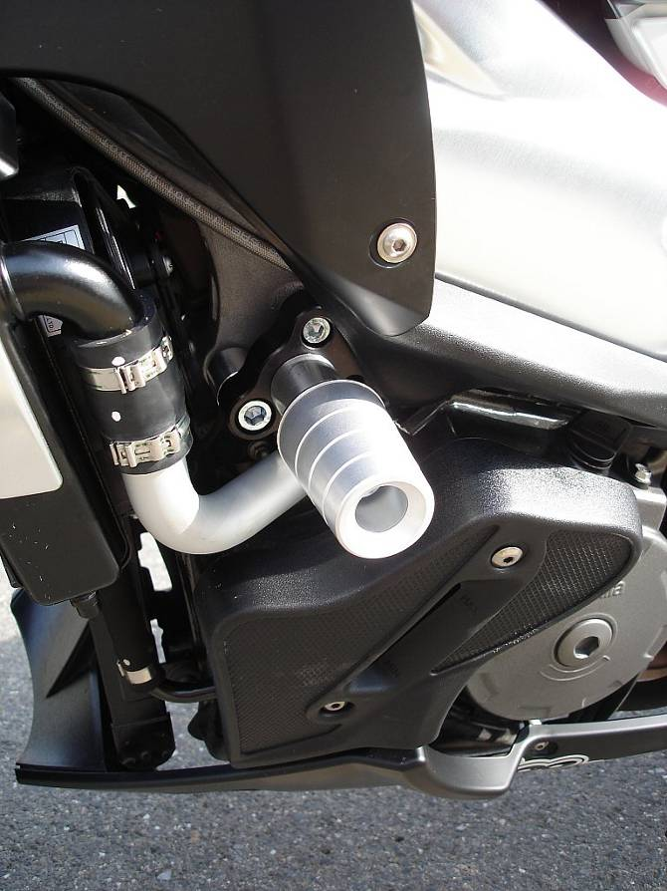
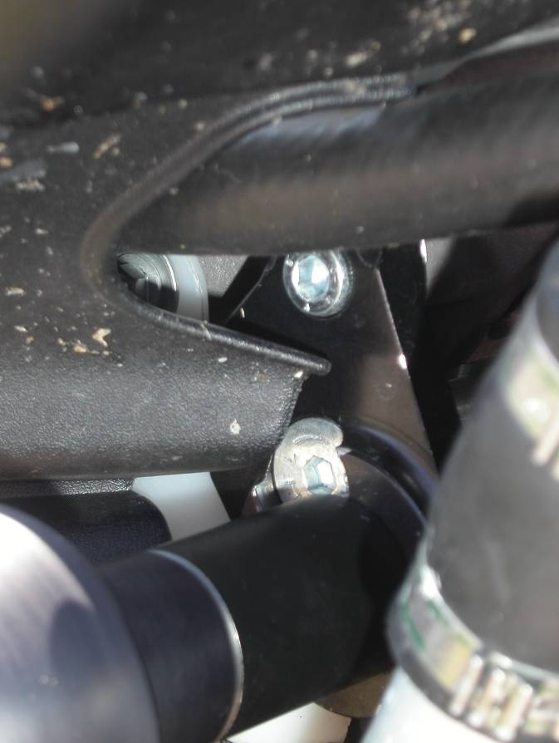
3

- Unbolt original bolt from the frame of motorcycle according to the picture.
- Assembly adapters according to the picture and mount ii into the frame of motorcycle.
- Fit slider using three M6 bolts.
- Fit cover using two M4 bolts.

We recommend to use safety glue on all threads.

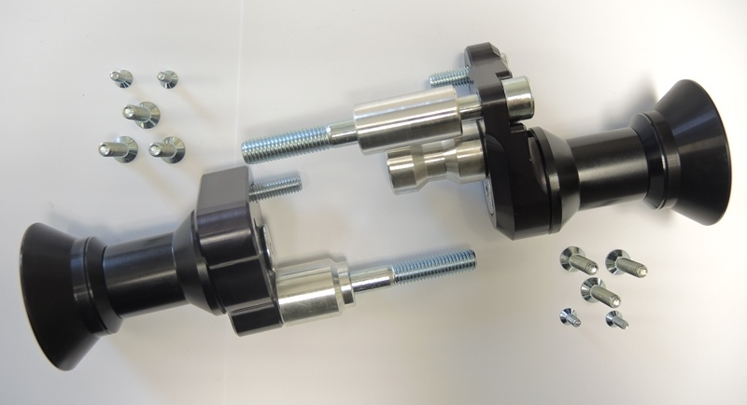
1
6
5
4
7
3
2
4
6
2
1
5
8
8
10
3
9
7

