A3
Aprilia Tuono ´06-´10

ID | Description | Cat.N | Qt
1 | Alu.adapter | 502 | 1
2 | Bolt M10x95 | 822 | 1
3 | Bolt M8x30 | 834 | 1
4 | Alu. spacer d=31mm | 134 | 1
5 | Al.u. spacerd=40mm | 132 | 1
6 | Bolt M10x40 | 854 | 1
7 | Steel bush M10 | X1 | 1
8 | Bolt-come M10x35 | 976 | 1
Fitting kit left side: Fitting kit right side:
ID | Description | Cat.N | Qt
1 | Alu. adapter | 503 | 1
2 | Bolt M10x100 | 885 | 1
3 | Bolt M10x30 | 846 | 1
4 | Alu.special hexa nut | 1172 | 1
5 | Bolt M8x25 | 833 | 1
6 | Alu. spacer d=38mm | 133 | 1
7 | Al. spacer d=40mm | 132 | 1
8 | Bolt M10x40 | 854 | 1
9 | Steel bushe M10 | X1 | 1
10 | Bolt M10x35 cone | 976 | 1
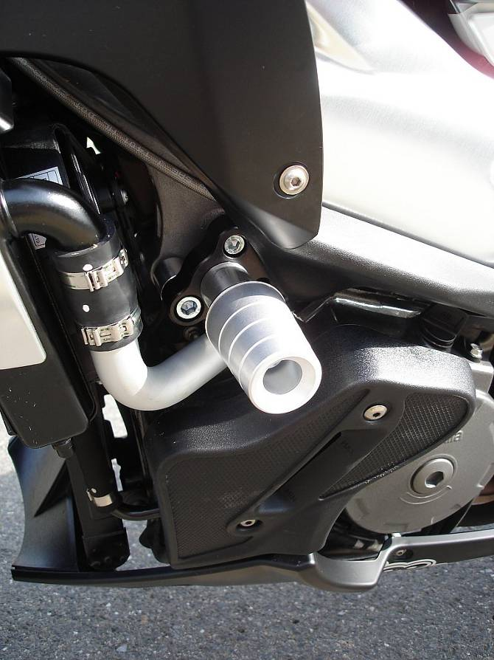
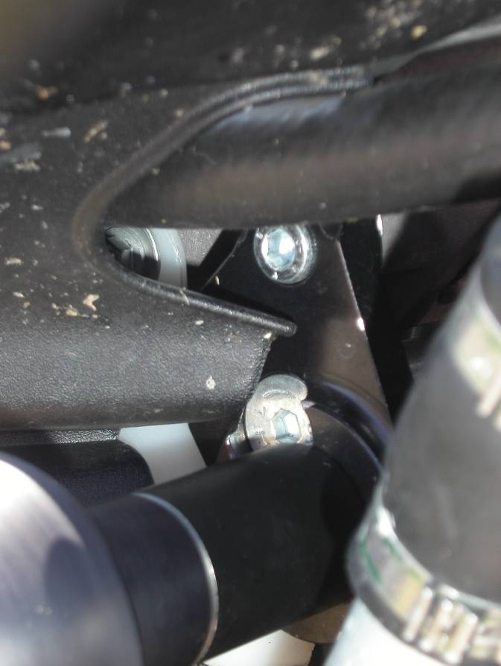

3

- Dismantle orginal bolts from chassi as you can see on the picture.
- Put together fitting kit for protectors as you can see on the picture below.
- If you put adapters on the chassi, Cheb all bolts.
- Insert ID.9 and ID.7 into the crash protectors. Under the protectors place spacers ID.7 and ID.5. For protector fix use bolts M10x40 ID.8 and ID.6.

Note: Use medium strong glue for bolts and threads during assembly.

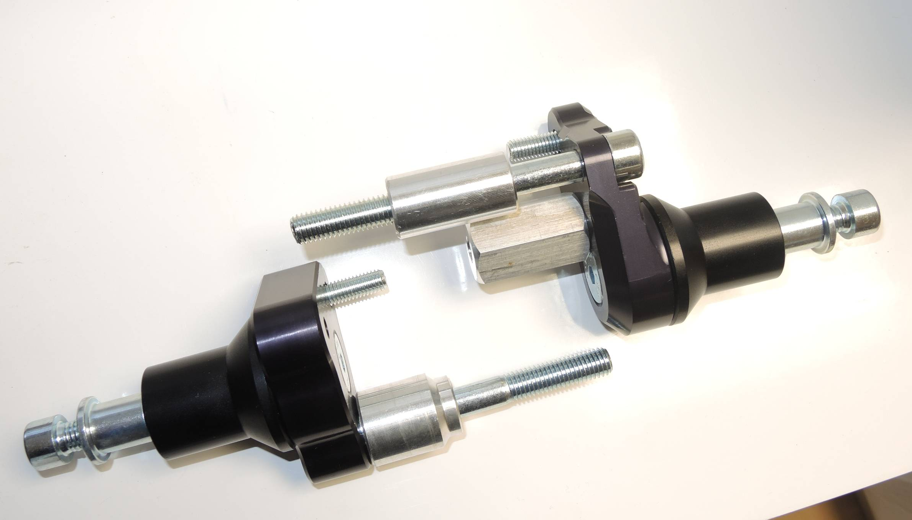
1
6
5
4
7
3
2
4
6
2
1
5
8
8
10
3
9
7

