A4
Aprilia RSV 1000 Mile ´04-´08

Fitting kit left side: Fitting kit right side:
ID | Description | Cat.N | Qty
1 | Steel box M12 | X2 | 1
2 | Steel adapter | 650 | 1
3 | Bolt M10x100 | 885 | 1
4 | Bolt M8x40 | 828 | 1
5 | Dural. spacer d=12mm | 130 | 1
6 | Dural.spacer d=43mm | 129 | 1
7 | Dural.cylinder with thread d=70 | 420 | 1
8 | Bolt M12x40 | 826 | 1
9 | Bolt M12x50 | 869 | 1
ID | Description | Cat.N | Qty
1 | Steel box M12 | X2 | 1
2 | Steel adapter | 651 | 1
3 | Bolt M10x100 | 885 | 1
4 | Bolt M8x30 | 834 | 1
5 | Dural.spacer d=41,5mm | 128 | 1
6 | Dural.cylinder with thread d=80 | 131 | 1
7 | Bolt M12x40 | 826 | 1
8 | Bolt M12x50 | 869 | 1
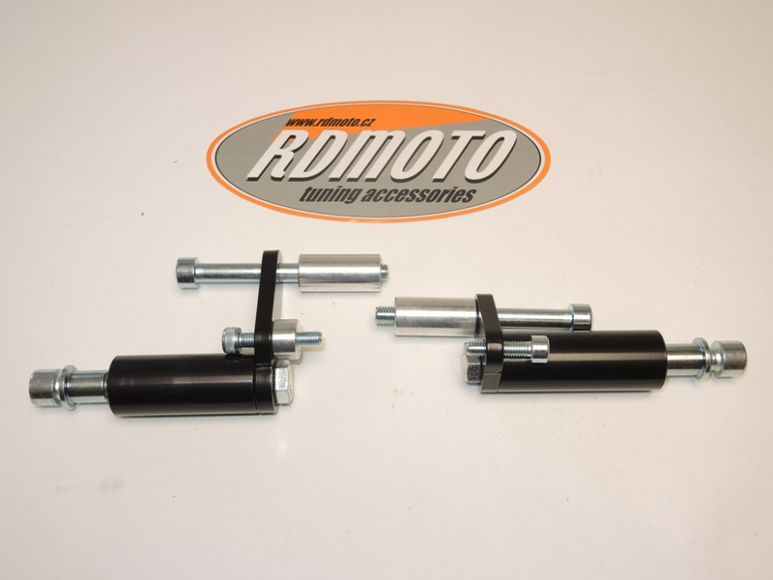

2
6
3
5
2
3
1

8
4
4
9
1
6
7
5
7
8

Fitting kit left side:
- Remove the left hand side fairing and make hole into the fairing.
- Remove the original bolt from frame as shown on the picture.
- On the adapter ID.2 mounting dural.cylinder ID.7 from the back side tighten it by bolt ID.8.
- Insert bolts ID.3 and ID.4 trough the adapter. On this bolts insert dural.cylinder ID.5 and ID.6. Longer is front.
- This kit mounting on the frame and refit the left side fairing.
- Into the protector insert steel box ID.1 Gripping protector by bolt ID.9
Fitting kit right side:
- Remove the left hand side fairing and make hole into the fairing.
- Remove the original bolt from frame as shown on the picture.
- On the adapter ID.2 mounting dural.cylinder ID.6 from the back side tighten it by bolt ID.7.
- Insert bolts ID.3 and ID.4 trough the adapter. On the bolt M10x100 insert dural.cylinder ID.5.
- This kit mounting on the frame and refit the right side fairing.
- Into the protector insert steel box ID.1 Gripping protector by bolt ID.8.

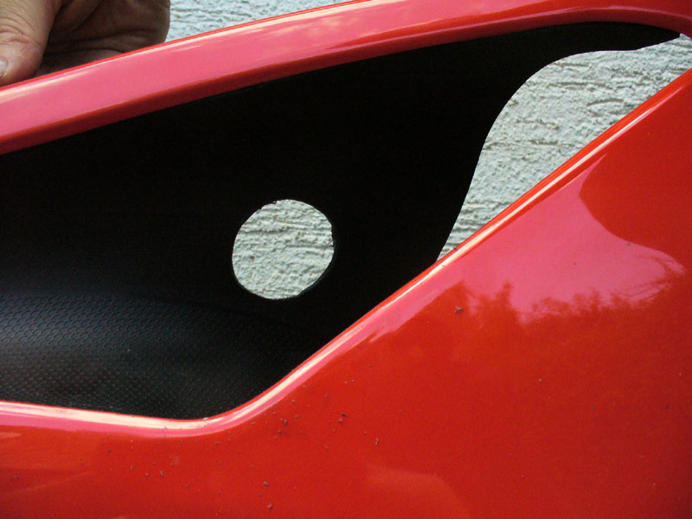

You will have to drill the hole in the fairing during installation. It is therefore necessary intervention in the original fairing!

Warning: We recommend use the glue of all threads. Medium strong.

