A6
Aprilia RSV-4

Mounting kit Left Side: Mounting kit Right Side:
ID | Description | Cat.no |  | Pc
1 | Aluminium Insert M10 | X1 | 1
2 | Bolt M10x75mm | 1007 | 2
3 | Bolt M10x55mm | 1002 | 1
4 | Dural. roller d=20mm | 2 | 1
5 | Dural. roller d=20,7mm | 459 | 2
6 | Dural. adapter | 501 | 1
7 | Plastic cover M10 | X4 | 2
ID | Description | Cat.No. | Pc
1 | Aluminium Insert M10 | X1 | 1
2 | Bolt M10x90mm | 880 | 2
3 | Bolt M10x55mm | 1002 | 1
4 | Dural. roller d=20mm | 2 | 1
5 | Dural. roller d=20,7mm | 459 | 2
6 | Dural. Adapter | 500 | 1
7 | Plastic cover M10 | X4 | 2
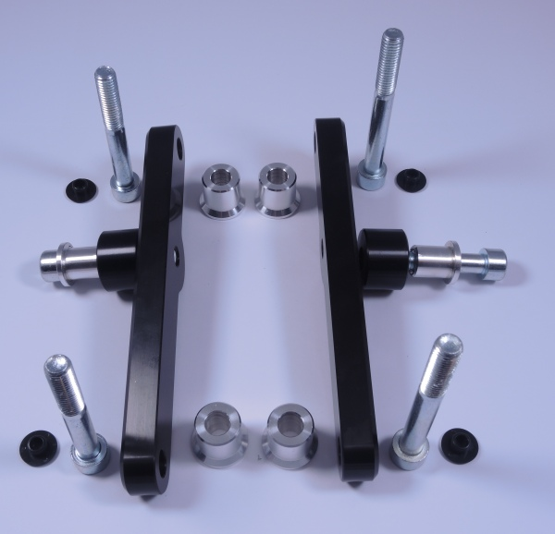
1
1
2
2
2
2
3
3
4
4
5
5
5
5
6
6
7
7
7
7

Mounting Kit Left Side:
- Unmount the original side plastic and M10 bolts from motorcycle frame.
- Mount the dural. adapter (ID.6) onto the motorcycle frame (see place of fitment at the bottom picture).
- Now insert the dural. rollers (ID.5) under the dural. adapter and tighten the bolts (ID.2). Place ID.7 plastic covers on top of the bolts.
- Equip ID.3 bolt with ID.1 aluminium insert. Then insert ID.4 dural. roller underneath the protector and tighten with the ID.3 bolt.

Mounting Kit Right Side:
Mounting instructions for right side are the same as on the left.
- Unmount the original side plastic and M10 bolts from motorcycle frame.
- Mount the dural. adapter (ID.6) onto the motorcycle frame (see place of fitment at the bottom picture).
- Now insert the dural. rollers (ID.5) under the dural. adapter and tighten the bolts (ID.2). Place ID.7 plastic covers on top of the bolts.
- Equip ID.3 bolt with ID.1 aluminium insert. Then insert ID.4 dural. roller underneath the protector and tighten with the ID.3 bolt.

Note: We recommend using medium strenght thread glue during assembly.

