A7
Aprilia NA 850 Mana

Kit for the left side |  |  |  |  | Kit for the right side
No. | Description | Cat.no. | Pcs |  | No. | Description | Cat.no. | Pcs
1 | Steel box M12 | X2 | 1 |  | 1 | Steel box M12 | X2 | 1
2 | Steel nut M12 | X12 | 1 |  | 2 | Steel nut M12 | X12 | 1
3 | Duralumin cylinder d=107,5mm | 69 | 1 |  | 3 | Duralumin cylinder d=95,5mm | 70 | 1
 | Stainless steel bar (14)M12(50)x510x1,25x30x30 |  | 1

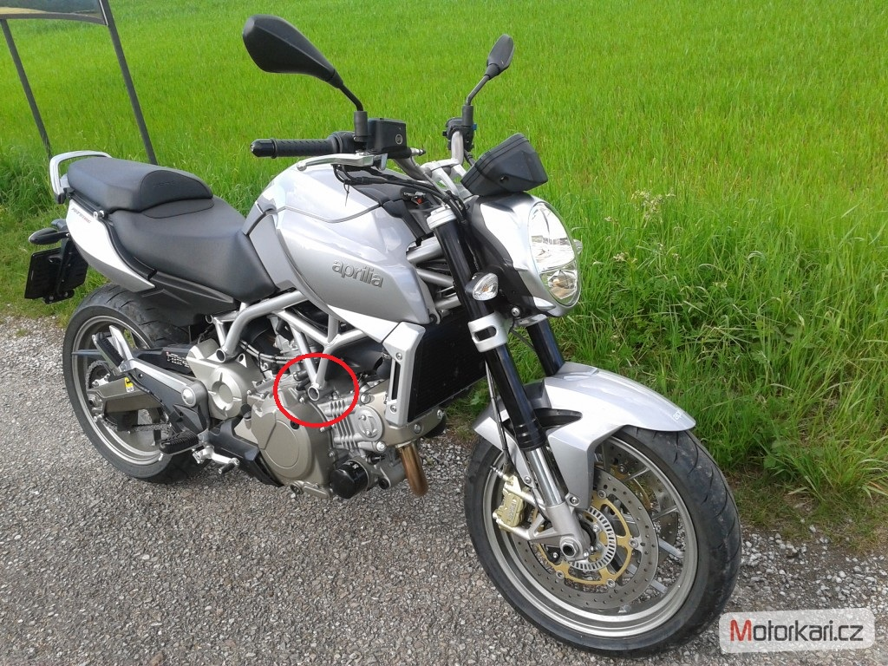
Installation:

- dismount the long original bolt M14
- insert through bar the stainless steel bar (14)M12(50)x510x1,25x30x30
- give duralumin cylinder (No. 3) on this stainless steel bar both sides
- insert steel box (No. 1) into protector and now give protectors on stainless steel bar too
- finally screw up all with nuts M12 (No. 2)

Warning – we recommend to use safety glue on threads of all bolts (moderate strong – blue colour).

