A8
Aprilia RS125

Fitting kit left side: Fitting kit right side:
ID | Description | Cat.no | QTY
1 | Crash protektor | PH | 1
2 | Steel box | X2 | 1
3 | Bolt M12x40 | 857 | 1
4 | Dural.cylinder d=60 | 448 | 1
5 | Bolt M12x40 | 826 | 1
6 | Steel bracket | 694 | 1
7 | Bolts M8x45 | 836 | 2
8 | Washer M8 | 802 | 2
9 | AL cylinder d=38 | 133 | 1
10 | Nut M10 | 810 | 1
11 | Washer M10 | 804 | 1
12 | Stainless steel bar 10x295x30x30mm | - | 1
ID | Description | Cat.no | QTY
1 | Crash protektor | PH | 1
2 | Steel box | X2 | 1
3 | Bolt M12x40 | 857 | 1
4 | Dural.cylinder d=70 | 420 | 1
5 | Bolt M12x40 | 826 | 1
6 | Steel bracket | 695 | 1
7 | Bolts M8x45 | 836 | 2
8 | Washer M8 | 802 | 2
9 | AL cylinder d=38 | 133 | 1
10 | Nut M10 | 810 | 1
11 | Washer M10 | 804 | 1

Instruction to assembly-left side:
- Take off fairings and make a hole into the fairing.
- Dismantle original bolts M8 from frame and bolt M10 which is going through the engine.
- Take bolt M12x40 ID.5 and mount steel cylinder d=60 ID.4 from back side.
- Steel adapter ID.6 is mounting on the frame, use bolts and washer M8 (ID.7,ID.8).
- Between the steel adapter and frame insert AL cylinder d=38mm ID.9.
- Insert stainless steel bar ID.12 throught the engine and for gripping use nut M10 and washer M10 (ID.10,ID.11).

Instruction to assembly-right side:
- Take off fairings and make a hole into the fairing.
- Dismantle original bolts M8 from frame and bolt M10 which is going through the engine.
- Take bolt M12x40 ID.5 and mount steel cylinder d=70 ID.4 from back side.
- Steel adapter ID.6 is mounting on the frame, use bolts and washer M8 (ID.7,ID.8).
- Between the steel adapter and frame insert AL cylinder d=38mm ID.9. This cylinder put on the steel bar.
- Use nut and washer M10 (ID.10,ID.11) and fix stainless steel bar.

Instruction to assembly protectors.
- Now, put on the bike fairing with holes and moutning cash protectors.
- Insert steel box into the protektors and use bolts M12x40

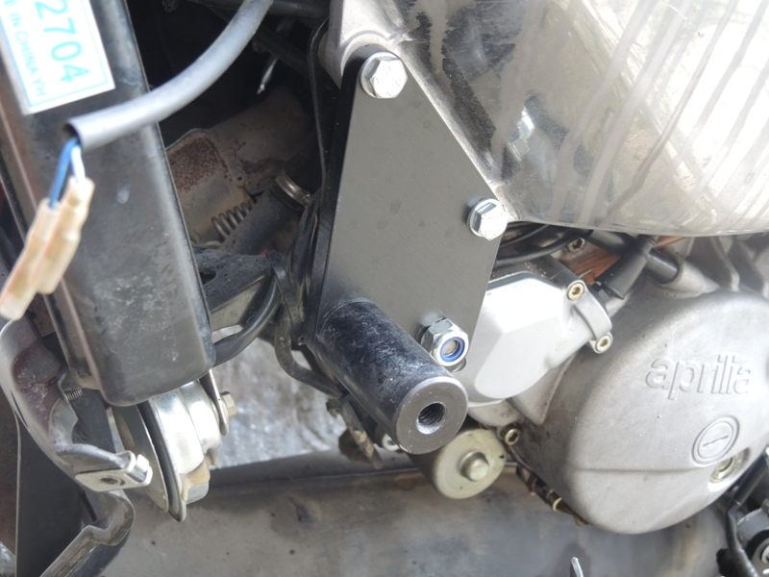
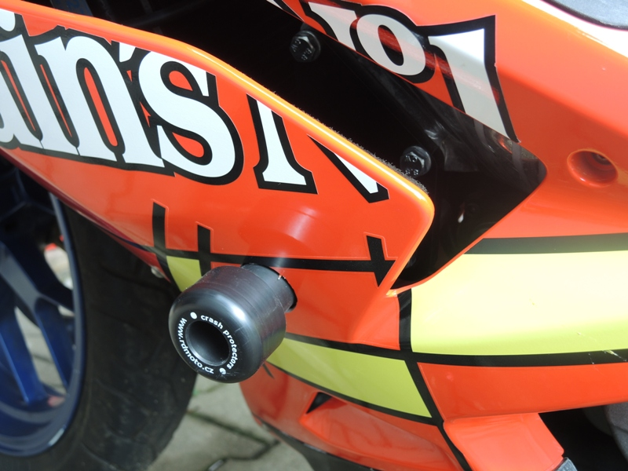
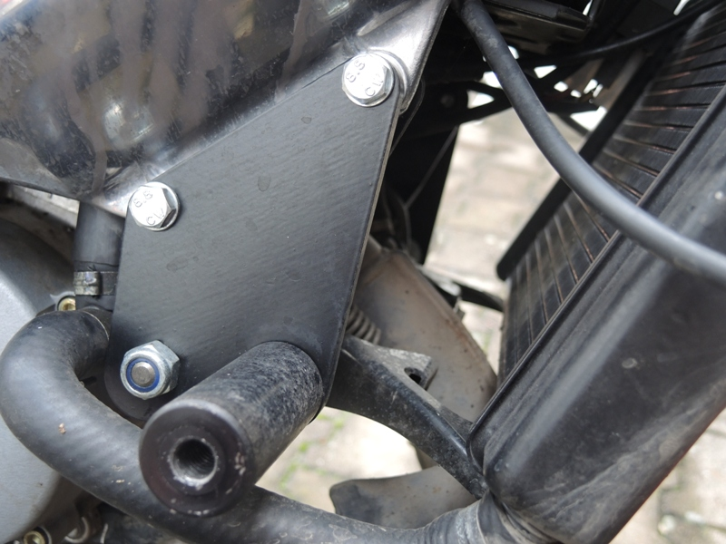
Warning:
We recommend use the glue of all threads. Medium strong.

