A9
Aprilia RS4 125

Fitting kit left side: Fitting kit right side:
ID | Description | Cat.N | Qty
1 | Steel box M10 | X1 | 1
2 | Bolt M10x40 | 854 | 1
3 | Bolt M10x20 | 819 | 1
4 | Bolt M10x110 | 879 | 1
5 | Bar bracket | 698 | 1
ID | Description | Cat.N | Qty
1 | Steel box M10 | X1 | 1
2 | Bolt M10x40 | 854 | 1
3 | Nut M10 | 810 | 1
4 | Washer | 804 | 1
5 | Bar bracket | 699 | 1
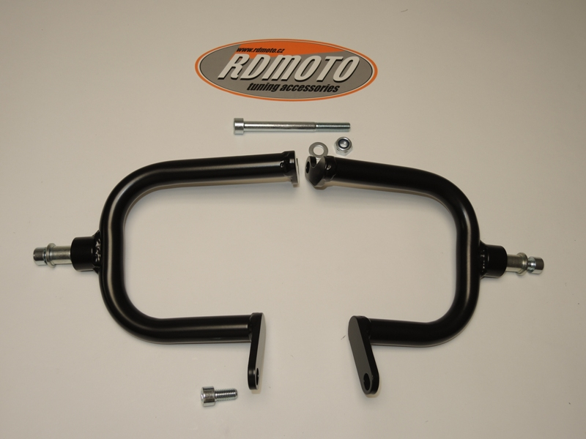

4
3,4

2
1

2
5

1
5

3
Instruction to assembly:
- Take off left and right fairing.
- Dismantle original bolt M10 in front of engine.
- Dismantle original bolt from frame on the left side (red market on picture 1).
- Put bracket and fixed it by bolt ID.3 and insert through bolt ID.4
- On the right side dismantle orig.bolt.
- Put bracket for tighten use original bolt and nut wit washer ID.3 and ID.4
- Put fairing back to bike.
- Insert bolt ID.2 and steel box ID.1 into the protectors and tighten it on the bracket.

Warning: We recommend use the glue of all threads. Medium strong.

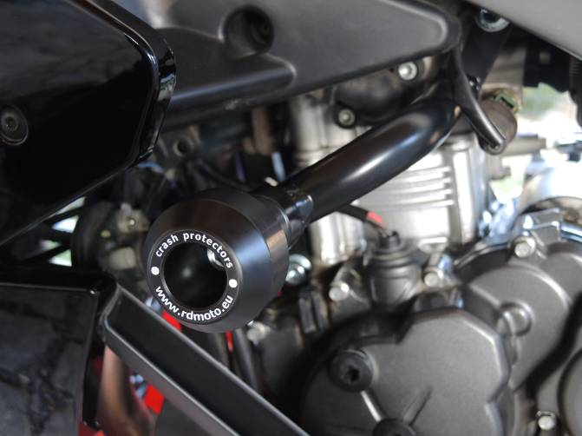
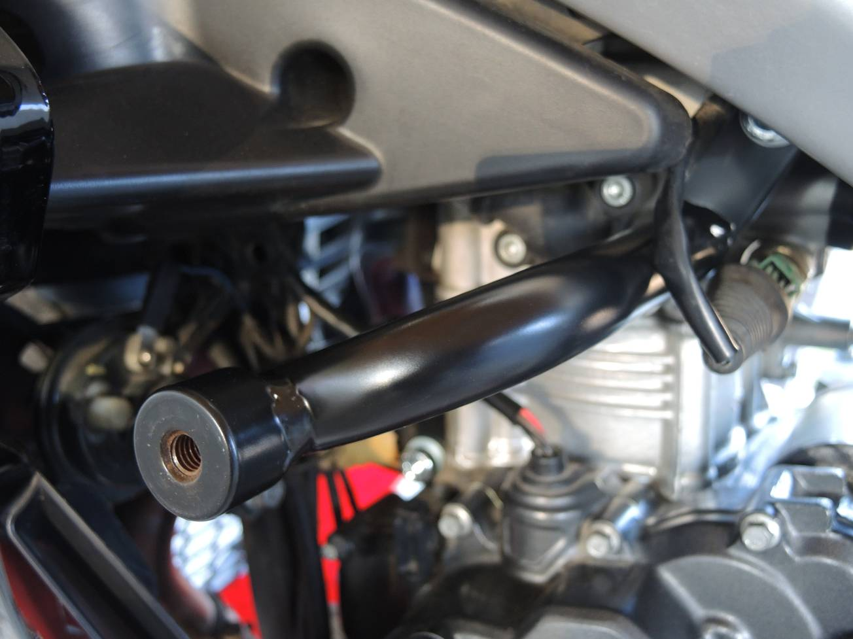
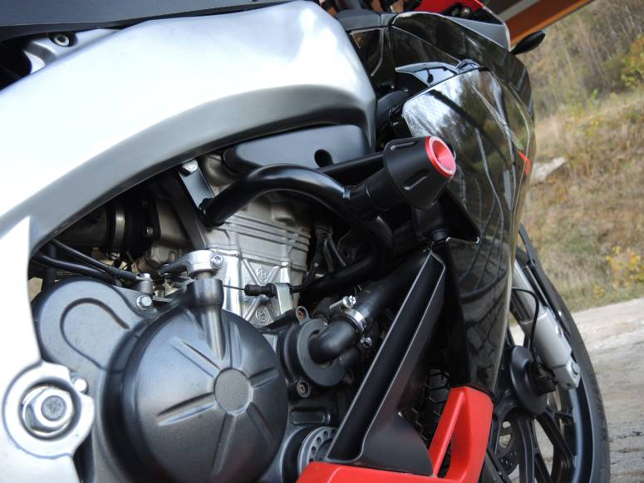
(picture1)

