B15
BMW S1000R 2017-

Kit for Left Side |  |  |  |  | Kit for Right Side
ID | Description | Cat.No | Pcs |  | ID | Description | Cat.No | Pcs
1 | Steel Adapter | 758 | 1 |  | 1 | Steel Adapter | 759 | 1
2 | Dural. sleeve d=8mm | 1334 | 2 |  | 2 | Dural. sleeve d=8mm | 1334 | 2
3 | Screw M10x60mm | 1048 | 2 |  | 3 | Screw M10x60mm | 1048 | 2
4 | AL insertion M10 | X1 | 1 |  | 4 | AL insertion M10 | X1 | 1
5 | Screw M10x70mm | 851 | 1 |  | 5 | Screw M10x40mm | 854 | 1
6 | Dural. sleeve d=5mm | 1335 | 1 |  | 6 | Dural. sleeve d=5mm | 1335 | 1
7 | Screw M5x25mm | 1036 | 1 |  | 7 | Screw M5x25mm | 1036 | 1
8 | Washer M5 - large | 1057 | 1 |  | 8 | Washer M5- large | 1057 | 1
9 | Dural. sleeve d=30mm | 3 | 1

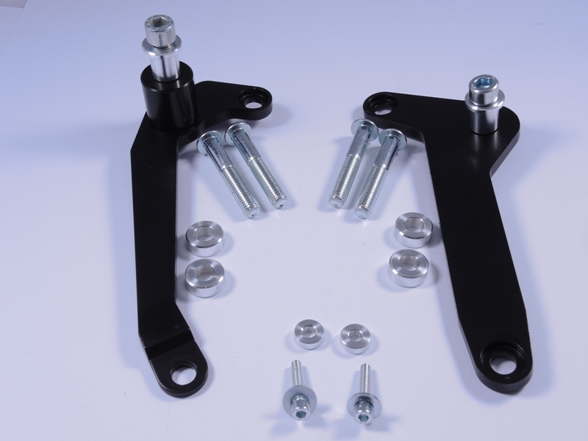
Right Side:

- Dismount rear motorcycle hood.
- Dismount the original screws.
- Prepare ID.1 steel adapter and ID.3 screws, insert the screws into adapter and from other side, put on the ID.2 dural. sleeves.
- Mount this assembly onto the motorcycle frame.
- Now you can mount back the rear hood. To increase the distance between hood and frame, use ID.6 dural. sleeve in the rear part, which achieves support for the hood. With ID.7 screw and ID.8 washer you can now tighten the fit.
- Take the protector and insert ID.4 Aluminium insertion
- Insert ID.5 screw into the protector with insertion.
- Mount this aseembly into the adapter on your bike.
- Tighten using recommended Tightening torque provided by motorcycle manufacturer. This information is to be found in moto manual.

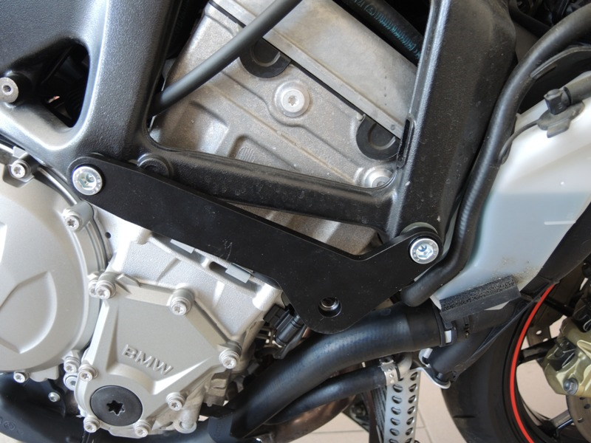

Left Side :

- Dismount rear motorcycle hood.
- Dismount the original screws.
- Prepare ID.1 steel adapter and ID.3 screws, insert the screws into adapter and from other side, put on the ID.2 dural. sleeves.
- Mount this assembly onto the motorcycle frame.
- Now you can mount back the rear hood. To increase the distance between hood and frame, use ID.6 dural. sleeve in the rear part, which achieves support for the hood. With ID.7 screw and ID.8 washer you can now tighten the fit.
- Take the protector and insert ID.4 Aluminium insertion.
- Insert ID.5 screw into the protector and from other side put on the ID.9 sleeve.
- Mount this aseembly into the adapter on your bike.
- Tighten using recommended Tightening torque provided by motorcycle manufacturer. This information is to be found in moto manual.
Note- We recommend using medium strenght thread glue during assembly for threads of all screws (blue color).

