B18S
BMW S1000RR 2019-

Kit for Left Side |  |  |  |  | Kit for Right Side
ID | Description | Cat.No. | Pcs |  | ID |  | Description | Cat.No. | Pcs.
1 | Slider adapter | 317 | 1 |  | 1 |  | Slider adapter | 317 | 1
2 | Screw M10x30mm | 882 | 1 |  | 2 |  | Screw M10x85mm | 981 | 1
3 | Safety nut M10 | 810 | 1 |  | 3 |  | Dural. sleeve d=34mm | 1333 | 1
4 | Dural. sleeve d=24mm | 1332 | 2 |  | 4 |  | Bolt M6x25 | 877 | 3
5 | Steel adapter | 757 | 1 |  | 5 |  | Bolt M4x12 | 876 | 2
6 | Screw M10x80mm | 853 | 2
7 | 3M Tape |  | 2
8 | Bolt M6x25 | 877 | 3
9 | Bolt M4x12 | 876 | 2

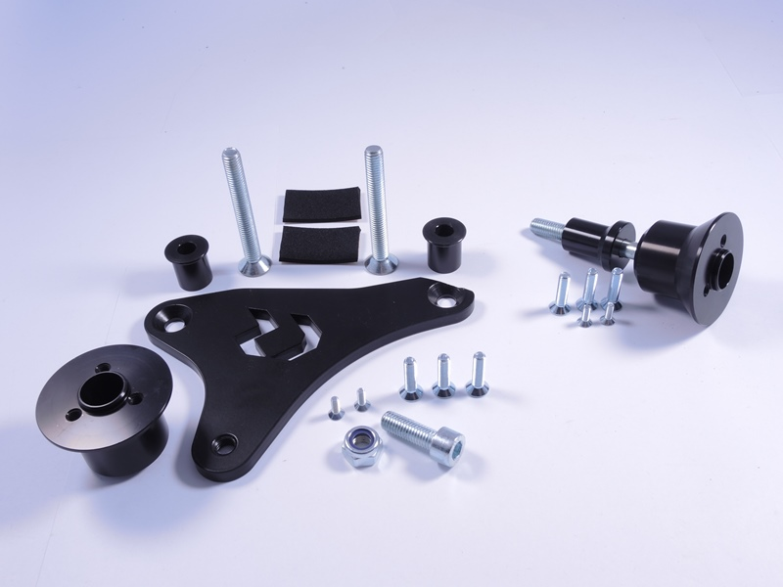
1
1
2
2
3
4
5
3
4
4
5
4
6
6
6
7
8
9
Right Side:

- Unscrew the original bolt as shown on attached picture.
- Bolt ID.2 insert into the adapter ID.1 + ID.3. This set mounting the place on frame.
- Place slider and tighten it by bolts ID.4.
- Place alu. cover into the slider use bolts ID.5.
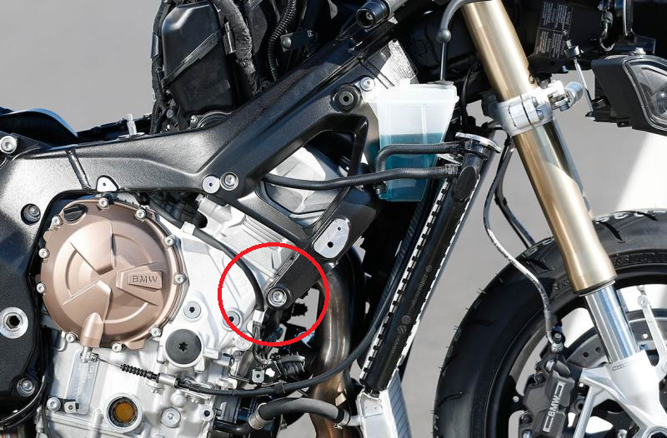
- Tighten using recommended tightening torque described in your motorcycle’s manual.

Left Side:

- Dismount the hood and original bolts as shown on pictures.
- Take the ID.5 steel adapter and insert ID.6 screws.
- From the rear adapter side, equip screws with ID.4 dural. sleeves.
- Mount this assembly onto the bike. Use the included 3M ID.7 tape when you feel its needed.
- Mount the hood back.
- Bolt ID.2 insert into the adapter ID.1.This set mounting the place on steel adapter
- Mount this assembly onto the steel adapter.
- From rear side of the adapter, use ID.3 nut to secure the assembly.
- Place slider and tighten it by bolts ID.8
- Place alu. cover into the slider use bolts ID.9.
- Tighten using recommended tightening torque described in your motorcycle’s manual.

Note – For threads of all screws we recommend using medium strenght thread glue (blue color).

