B18
BMW S1000RR 2019-

Kit for Left Side |  |  |  |  | Kit for Right Side
ID | Description | Cat.No. | Pcs |  | ID |  | Description | Cat.No. | Pcs.
1 | AL Insertion M10 | X1 | 1 |  | 1 |  | AL Insertion M10 | X1 | 1
2 | Screw M10x50mm | 849 | 1 |  | 2 |  | Screw M10x95mm | 822 | 1
3 | Dural. sleeve d=10mm | 1 | 1 |  | 3 |  | Dural. sleeve d=34mm | 1333 | 1
4 | Safety nut M10 | 810 | 1
5 | Dural. sleeve d=24mm | 1332 | 2
6 | Steel adapter | 757 | 1
7 | Screw M10x80mm | 853 | 2
8 | 3M Tape |  | 2

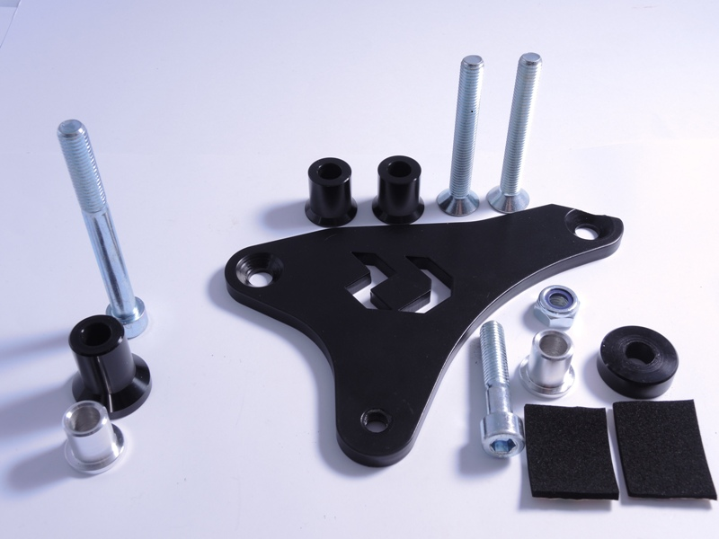

Right Side:

- Unscrew the original bolt as shown on attached picture.
- Take the protector and put in ID.1 Al insertion.
- Now insert ID.2 screw into this protector and from other side equip the screw with ID.3 dural. sleeve of 34mm lenght.
- Mount this assembly into motorcycle frame.
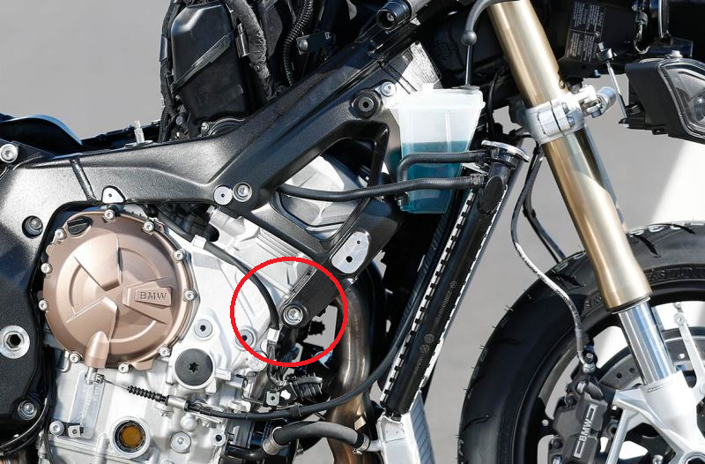
- Tighten using recommended tightening torque described in your motorcycle’s manual.

Left Side:

- Dismount the hood and original bolts as shown on pictures.
- Take the ID.6 steel adapter and insert ID.7 screws.
- From the rear adapter side, equip screws with ID.5 dural. sleeves.
- Mount this assembly onto the bike. Use the included 3M ID.8 tape when you feel its needed.
- Mount the hood back.
- Take the protector and put in the ID.1 Al insertion along with ID.2 screw.
- From rear side of the protector, put on ID.3 dural. sleeve.
- Mount this assembly onto the steel adapter.
- From rear side of the adapter, use ID.4 nut to secure the assembly.

Note – For threads of all screws we recommend using medium strenght thread glue (blue color).

