B3S
BMW K1300R/K1300R Sport
2009-

Kit for the left side: |  |  |  |  | Kit for the right side:
No. | Description | Cat.no. | Pcs |  |  | No. | Description | Cat.no. | Pcs
1 | Dural. adapter for SL | 292 | 1 |  |  | 1 | Dural. adapter for SL | 292 | 1
2 | Bolt M10x100 | 885 | 1 |  |  | 2 | Bolt M10x90 | 880 | 1
3 | Dural.spacer d=26mm | 418 | 1 |  |  | 3 | Dural.spacer d=16mm | 419 | 1
4 | Bolt M6x25 | 877 | 3 |  |  | 4 | Bolt M6x25 | 877 | 3
5 | Bolt M4x16 | 876 | 2 |  |  | 5 | Bolt M4x16 | 876 | 2
Installation:

- Installation of the left and right protector make in gripping about the attached photo above.
- Left side: Take bolt ID.2 insert ID.1 on this bolt. Into the frame insert dural.spacer ID.3.
- This kit mounting on the frame.
- For slider gripping use bolts ID.4. Insert alu. cover into the slider and tighten it, bolts ID.5
- Right side: Take bolt ID.2 insert ID.1 on this bolt. Into the frame insert dural.spacer ID.3.
- This kit mounting on the frame.
- For slider gripping use bolts ID.4. Insert alu. cover into the slider and tighten it, bolts ID.5

Warning – we recommend to use safety glue on threads of all bolts (moderate strong – blue colour).

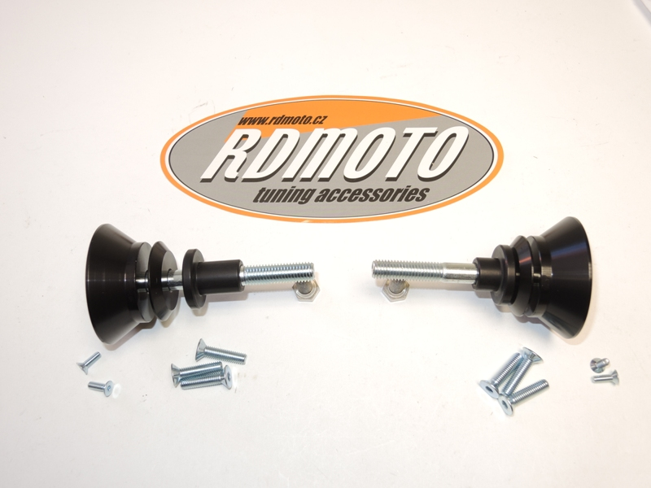
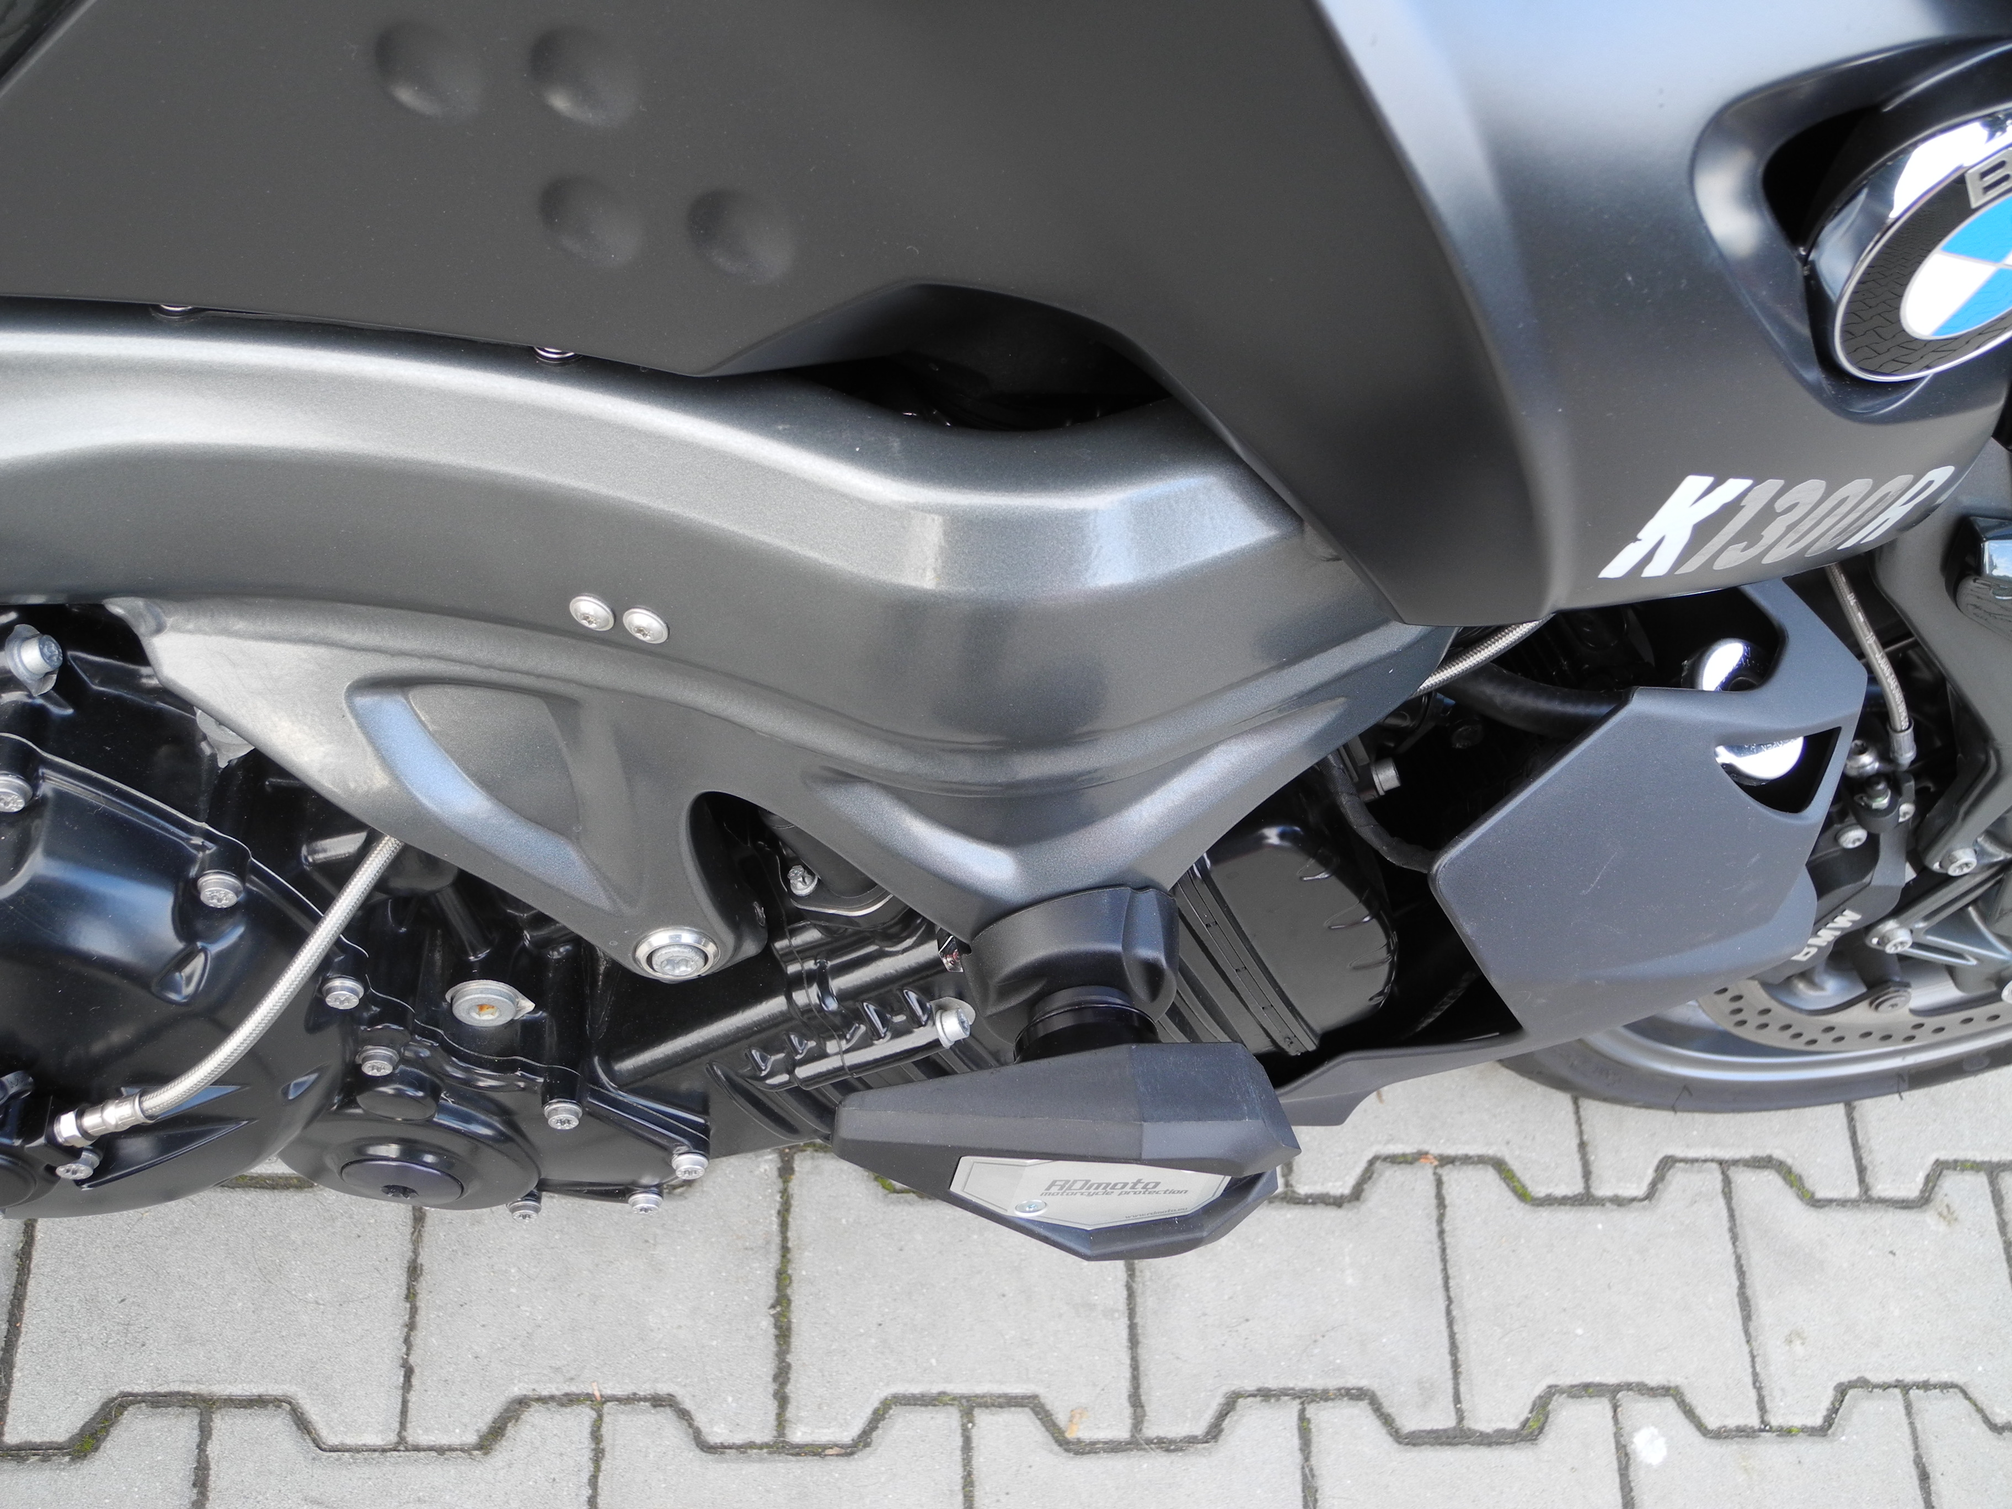
1
5
3
4
2
2
3
5
1
4

