B4S
BMW S1000RR 2010-

Kit for left side: |  |  |  |  | Kit for right side:
ID | Description | Cat.no | Qty |  |  | ID | Description | Cat.no | Qty
3 | Dural adapter for slider | DV-342 | 1 |  |  | 3 | Dural adapter for slider | DV-343 | 1
4 | Bolt M6x25 | 877 | 3 |  |  | 4 | Bolt M6x25 | 877 | 3
5 | Bolt M4x16 | 876 | 2 |  |  | 5 | Bolt M4x16 | 876 | 2
6 | Bolt M10x100mm | 885 | 1 |  |  | 6 | Bolt M10x65mm | 943 | 1
7 | Washer M10 -spring | 801 | 1 |  |  | 7 | Washer M10 -spring | 801 | 1

Instruction to assembly-left side :

- Take out bolt from frame -M10
- Gripping dural. adapter ID.3 use bolt and washer ID.6 and 7 on the frame.
- Mount slider ID.1 and use boltsID.4
- Insert cover into the slider and for assembly use bolts ID.5

Instruction to assembly-right side:

- Take out bolt from frame -M10
- Gripping dural. adapter ID.3 use bolt and washer ID.6 and 7 on the frame.
- Mount slider ID.1 and use boltsID.4
- Insert cover into the slider and for assembly use bolts ID.5

Warning – Use the glue of all threads, medium strong( Loctite-blue colour).

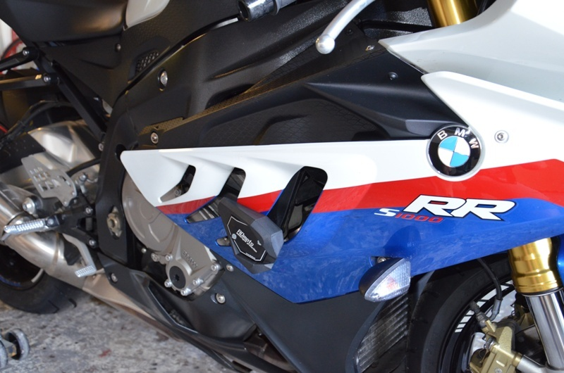
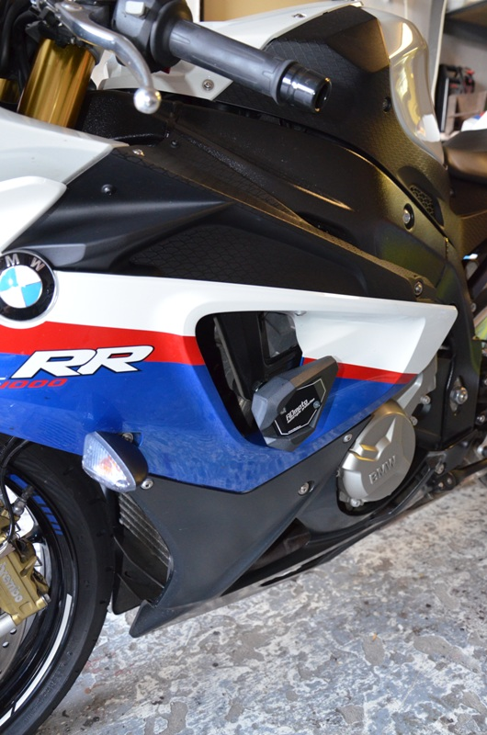
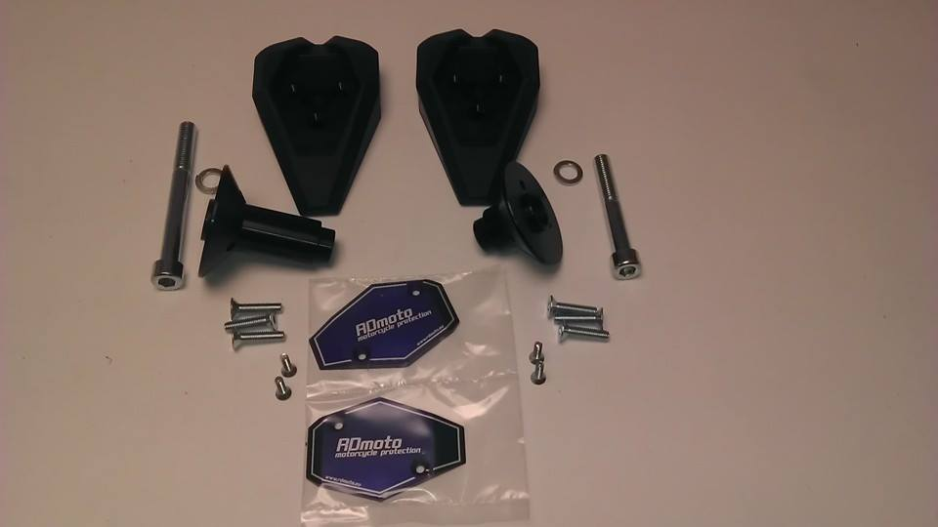
2
5
4
3
3
6
7
1
2
5
4
7
6
1

