B4
BMW S1000RR 2010-

Fitting kit:

ID. | Description | Cat.N | Qt
1 | Steel box M10 | X1 | 2
2 | Bolt M10x80mm | 852 | 2
3 | Dural. cylinder d=10mm | 287 | 2

Instalation to assembly:

- Place steel boxes ID.1 into the protectors.
- Insert bolts and under the protectors place ID.3.
- This kit assembly into the chassi.

Warning – we recommend to use safety glue on threads of all bolts (moderate strong – blue colour).

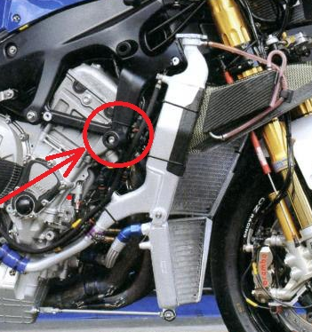
2
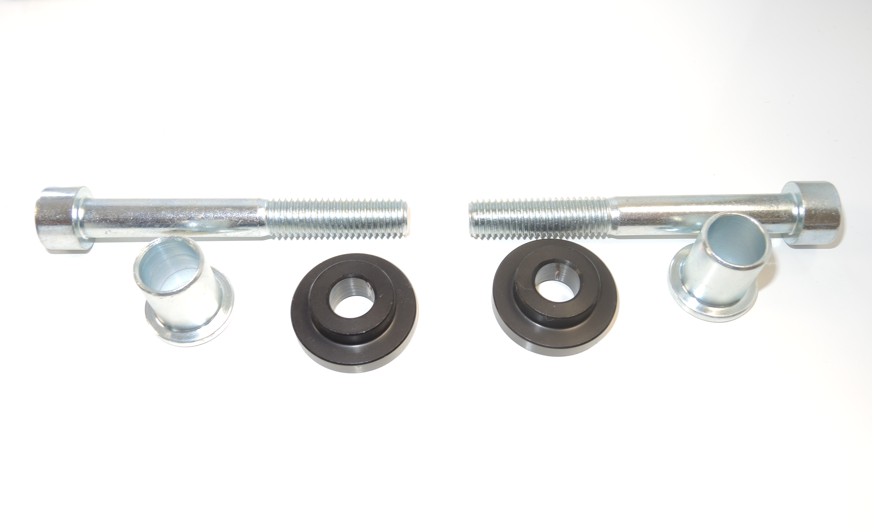
3
1

