B5SD
BMW F800R 2009-
ID | Description | Cat.N | Qt
1 | Slider holder | 537 | 2
2 | Alu. adapter | 11 | 2
3 | Alu. spacer | 452 | 2
4 | Bolt M10x130 | 885 | 2
5 | Bolt M8x25 | 815 | 4
6 | Washer | 800 | 4

1
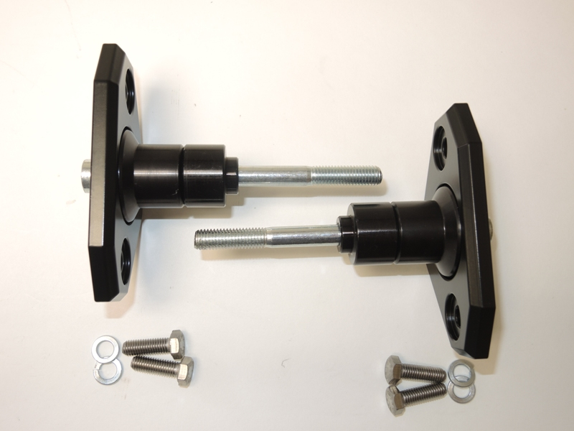
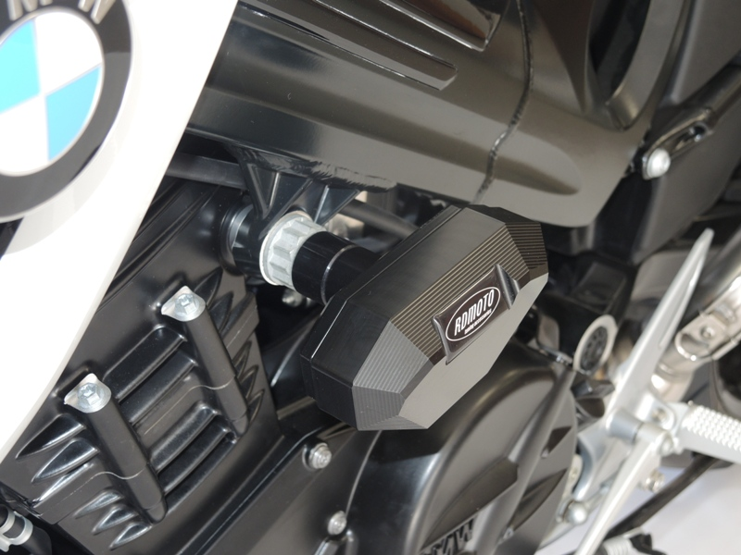
Assembly instruction:
2
3

- Assembly for left and right side is same.
- Dismantle original bolts M10 from chassi.
4
- Put together slider holder includ spacers and bolts ID.4. This kit assembly to the chassi.
- Fix sliders by bolts ID.5 + washers ID.6 from back side the slider holder.

Note: We recommend use glue of all threads during assembly. Medium strong.
5
6

