B5S
BMW F800R 2009-´11

Kit for left side: Kit for right side:
ID. | Description | Cat.N | Qt
1 | Alu. slider adapter | DV-316 | 1
2 | Bolt M6x25 | 877 | 3
3 | Bolt M4x16 | 876 | 2
4 | Bolt M10x90mm | 880 | 1
5 | Washer M10- spring | 801 | 1
ID. | Description | Cat.N | Qt
1 | Alu. slider adapter | DV-316 | 1
2 | Bolt M6x25 | 877 | 3
3 | Bolt M4x16 | 876 | 2
4 | Bolt M10x90mm | 880 | 1
5 | Washer M10- spring | 801 | 1
6 | Alu. spacer d=6mm | 453 | 1

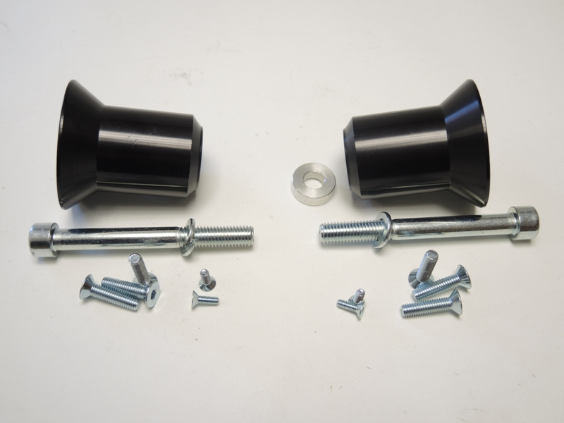

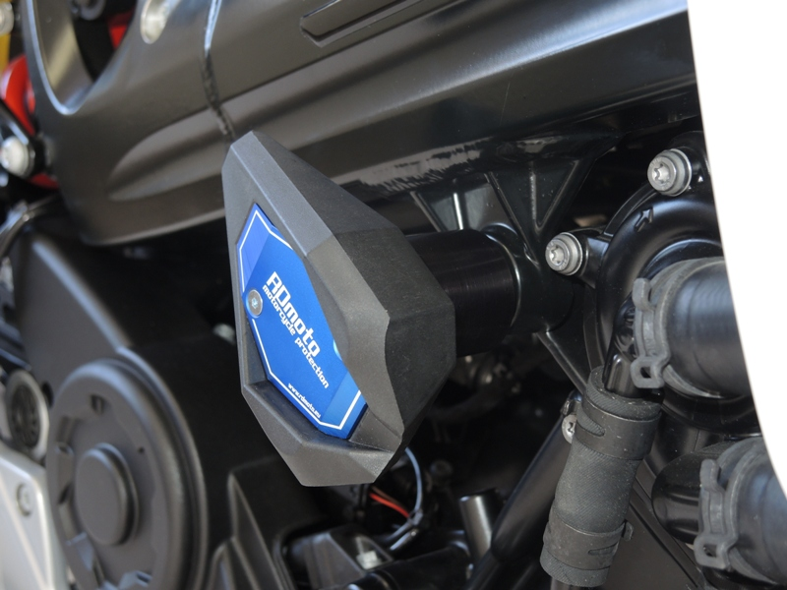
Assembly left side:
- Dismantle original bolt from left side.
- Place washer ID.5 on the bolt ID.4 and insert it into the alu. slider adapter ID.1.
- This kit mount on the chassi.
- Fix slider by bolts ID.2 and place alu. cover. Use bolts ID.3.

Assembly right side:
- Dismantle original bolt from left side.
- Place washer ID.5 on the bolt ID.4 and insert it into the alu. slider adapter ID.1.
- Insert alu. spacer ID.6 into the chassi.
- Alu. slider holder mount on the chassi.
- Fix slider by bolts ID.2 and place alu. cover. Use bolts ID.3.

Note: During assembly use glue of all threads, medium strong.

