B5
BMW F800R 2009-´11

Kit for left side: |  |  |  |  | Kit for right side:
ID | Description | Cat.N | Qt |  | ID | Description | Cat.N | Qt
1 | Steel box M10 | X1 | 1 |  | 1 | Steel box M10 | X1 | 1
2 | Bolt M10x120mm | 881 | 1 |  | 2 | Bolt M10x120mm | 881 | 1
3 | Alu. spacer d=20mm | 2 | 1 |  | 3 | Alu. spacer d=26mm | 452 | 1

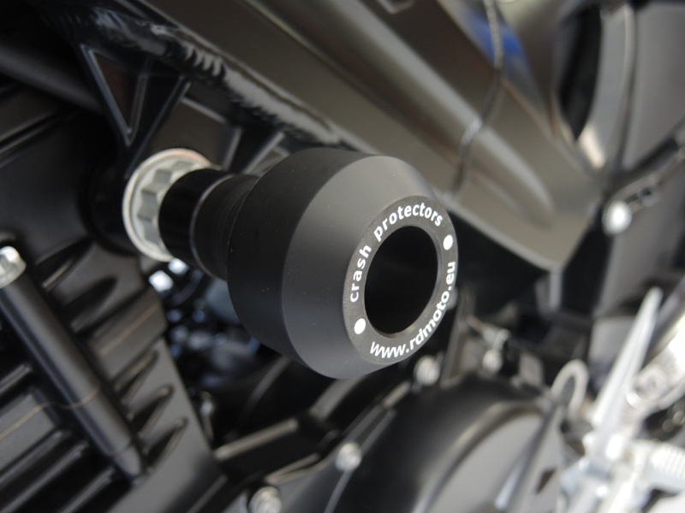
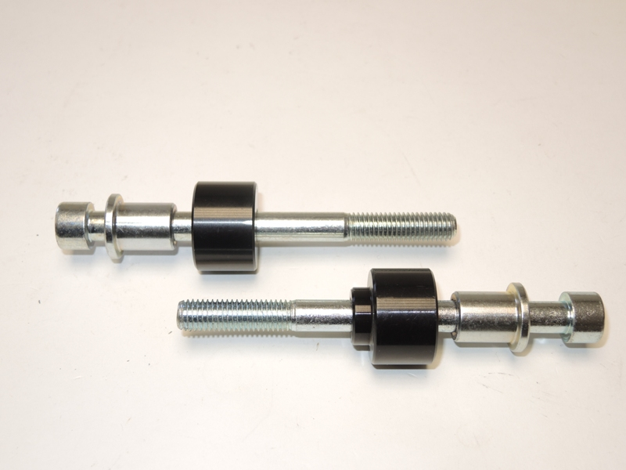

Assembly instruction:

- Dismantle original bolts M10 from chassi.
- Into the protectors insert steel sleeve ID.1. Under the protectors place alu. spacers ID.3. Shorter for left side.
- Tighten it by bolts ID.2.

Note: Use glue of all threads during assembly. Medium strong.

