B6SD
BMW S1000RR HP4

Kit for left side: Kit for right side:

Note | Description | Cat.N | Qty
1 | Steel adapter for SLD | 672 | 1
2 | Duralumin reduction | 1140 | 1
3 | Bolt M10x65 | 943 | 2
4 | Washer M10 | 804 | 2
5 | Al cylinder 6,7mm | 1105 | 2
6 | 3M Tape | - | 1
7 | Bolt M10x60 | 850 | 1
8 | Dural.holder for SLD | 537 | 1
9 | Bolt M8x25 | 815 | 2
10 | Washer M8 | 800 | 2
11 | Washer M10-spring | 801 | 1

Note. | Description | Cat.N | Qty
1 | Steel adapter for SLD | 673 | 1
2 | Duralumin reduction | 1136 | 1
3 | Bolt M10x60 | 973 | 2
4 | Al cylinder 7,2mm | 1107 | 2
6 | 3M Tape | - | 1
7 | Bolt M10x50 | 849 | 1
8 | Dural.holder. for SLD | 537 | 1
9 | Bolt M8x25 | 815 | 2
10 | Washer M8 | 800 | 2
11 | Washer M10-spring | 801 | 1
Mounting left side:
- Dismantle fairing from bike.
- Dismantle original bolts from frame.
- Under the steel adapter (note 1) insert aluminium cylinders (note 5).
- For mounting use bolts M10x65 (note 3) and washers (note 4).
- Put on the bike fairing and after:
- Put on the bolt (note.7) washer M10 (n.11) insert this bolt throught the dural.holder (n.8) and dural.reduction (n.2).
- This set gripp on the steel bracket.
- Use bolts M8 (n.9)and washers M8 (n.10) for mounting slider.

Mounting right side:

- Dismantle fairing from bike.
- Dismantle original bolts from frame.
- Under the steel adapter (note 1) insert aluminium cylinders (note 4).
- Under the steel adapter insert aluminium adapter (note 4) = 7,2mm.
- Use the bolts M10x60mm (note 3).
- Put on the bike fairing and after:
- Put on the bolt (note.7) washer M10 (n.11) insert this bolt throught the dural.holder (n.8) and dural.reduction (n.2).
- This set gripp on the steel bracket.
- Use bolts M8 (n.9) and washers M8 (n.10) for mounting slider.
We recomanded- Used the glue of all threads.
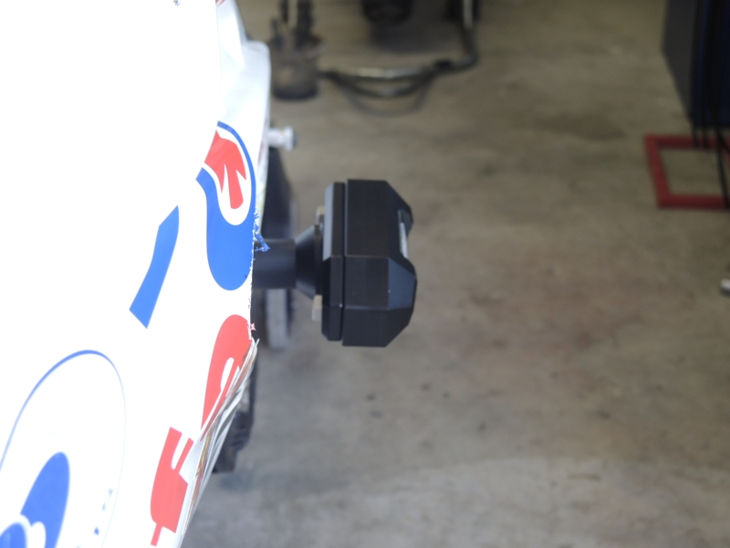
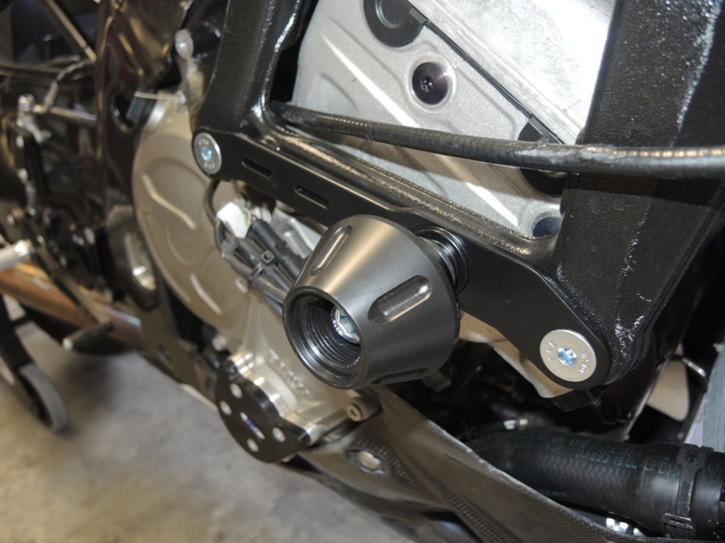
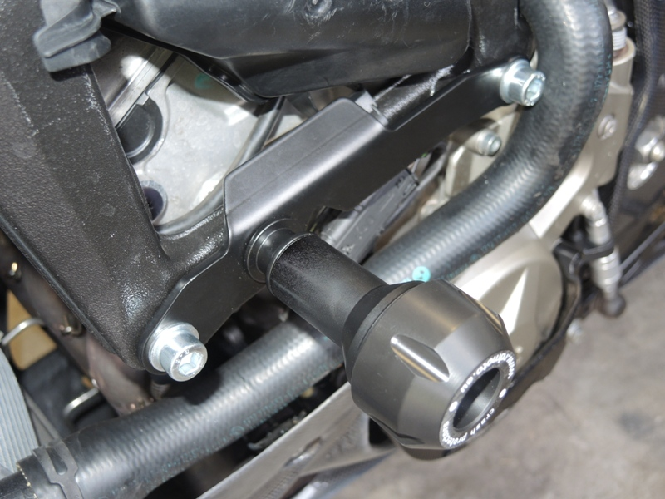
Ilustration photos:

