B7SD
BMW S 1000R 2014-

Fitting kit left side: Fitting kit right side:
ID | Description | Cat.N | pcs
1 | Steel Adapter | 692 | 1
2 | Dural. cylinder d=6,5 | 1105 | 1
3 | Bolt M10x60 | 850 | 1
4 | Washer M10 | 804 | 1
5 | Polyamid cylinder 20mm | X6 | 1
6 | Bolt M8x25 | 831 | 1
7 | Poly.spacer d=6mm | X64 | 1
8 | Bolt M6x16 | 962 | 1
9 | Washer M6 | 947 | 1
10 | Bolt M10x80 | 852 | 1
11 | Dural cylinder – 50mm | 13 | 1
12 | Washer stringed | 801 | 1
13 | 3M Tape | 3M | 2
14 | Washer M8 | 802 | 2
15 | Bolt M8x25 | 815 | 2
16 | Diamond adapter | 537 | 1
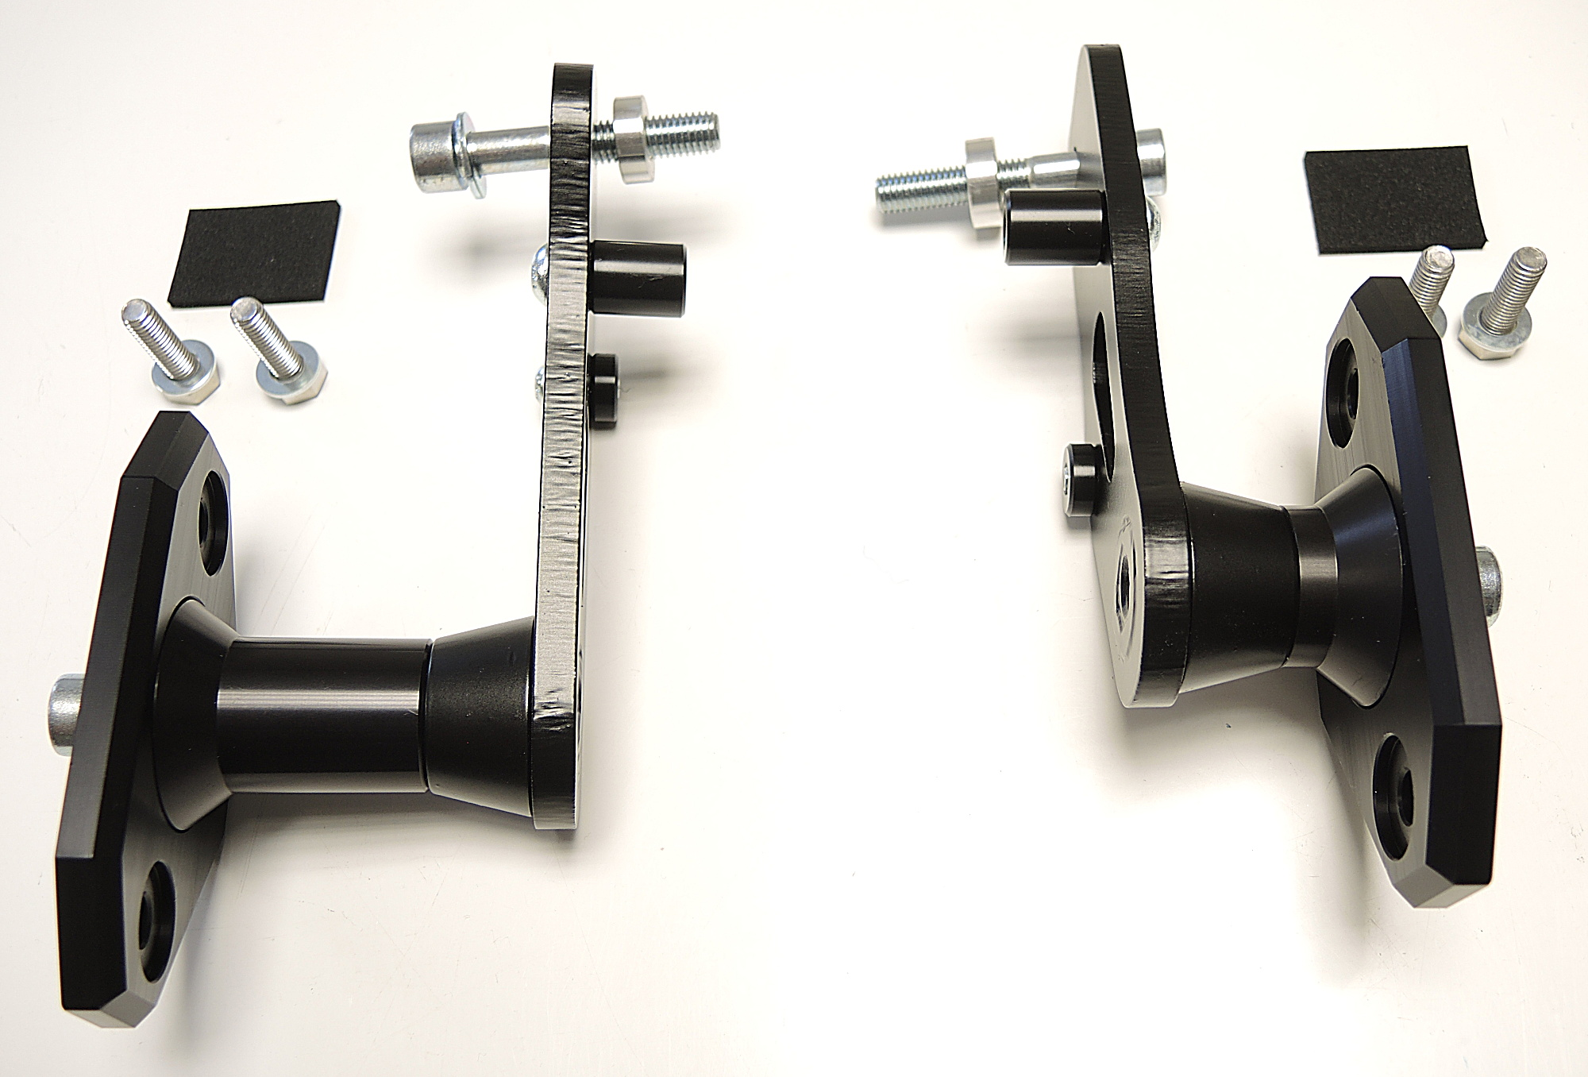
ID | Description | Cat.N | pcs
1 | Steel adapter | 693 | 1
2 | Dural. cylinder d=7 | 1107 | 1
3 | Bolt M10x60 | 850 | 1
4 | Washer M10 | 804 | 1
5 | Polyamid.cylinder 20mm | X6 | 1
6 | Bolt M8x25 | 831 | 1
7 | Poly.spacer d=6mm | X64 | 1
8 | Bolt M6x16 | 962 | 1
9 | Washer M6 | 947 | 1
10 | Bolt M10x55 | 1002 | 1
11 | Dural. cylinder – 20mm | DV10 | 1
12 | Washer stringed | 801 | 1
13 | 3M Tape | 3M | 2
14 | Washer M8 | 802 | 2
15 | Bolt M8x25 | 815 | 2
16 | Diamond adapter | 537 | 1

ID3+4+2
ID3+4+2
ID13
ID13
ID5+6

ID5+6
ID14+15
ID7+8+9
ID1
ID14+15

ID7+8+9
ID16
ID1
ID10+12

ID10+12
12
ID16
ID11

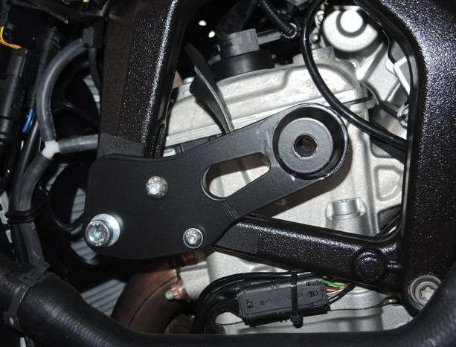
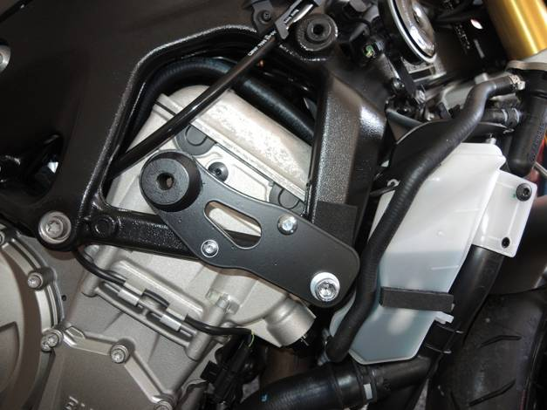
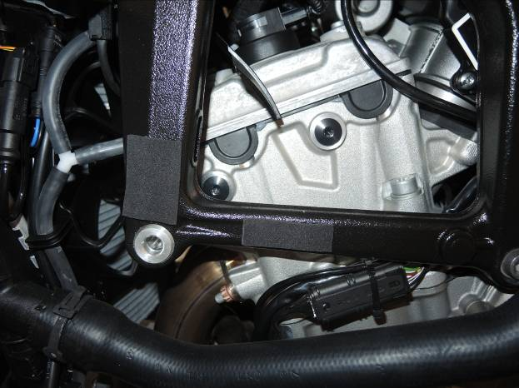
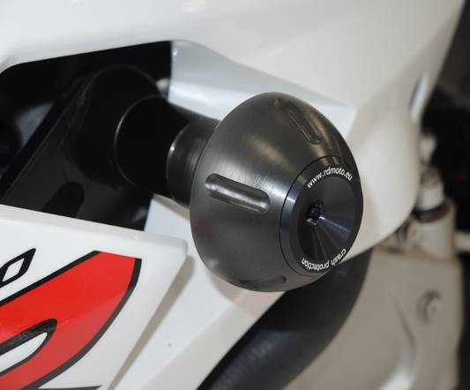

L
R

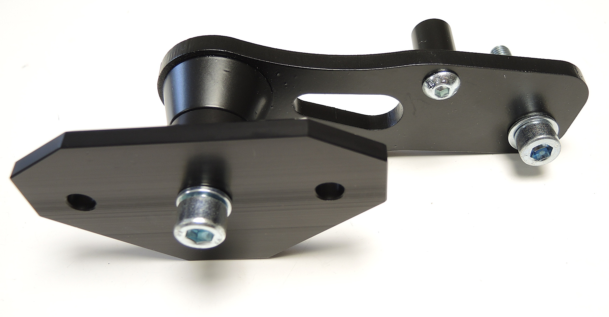
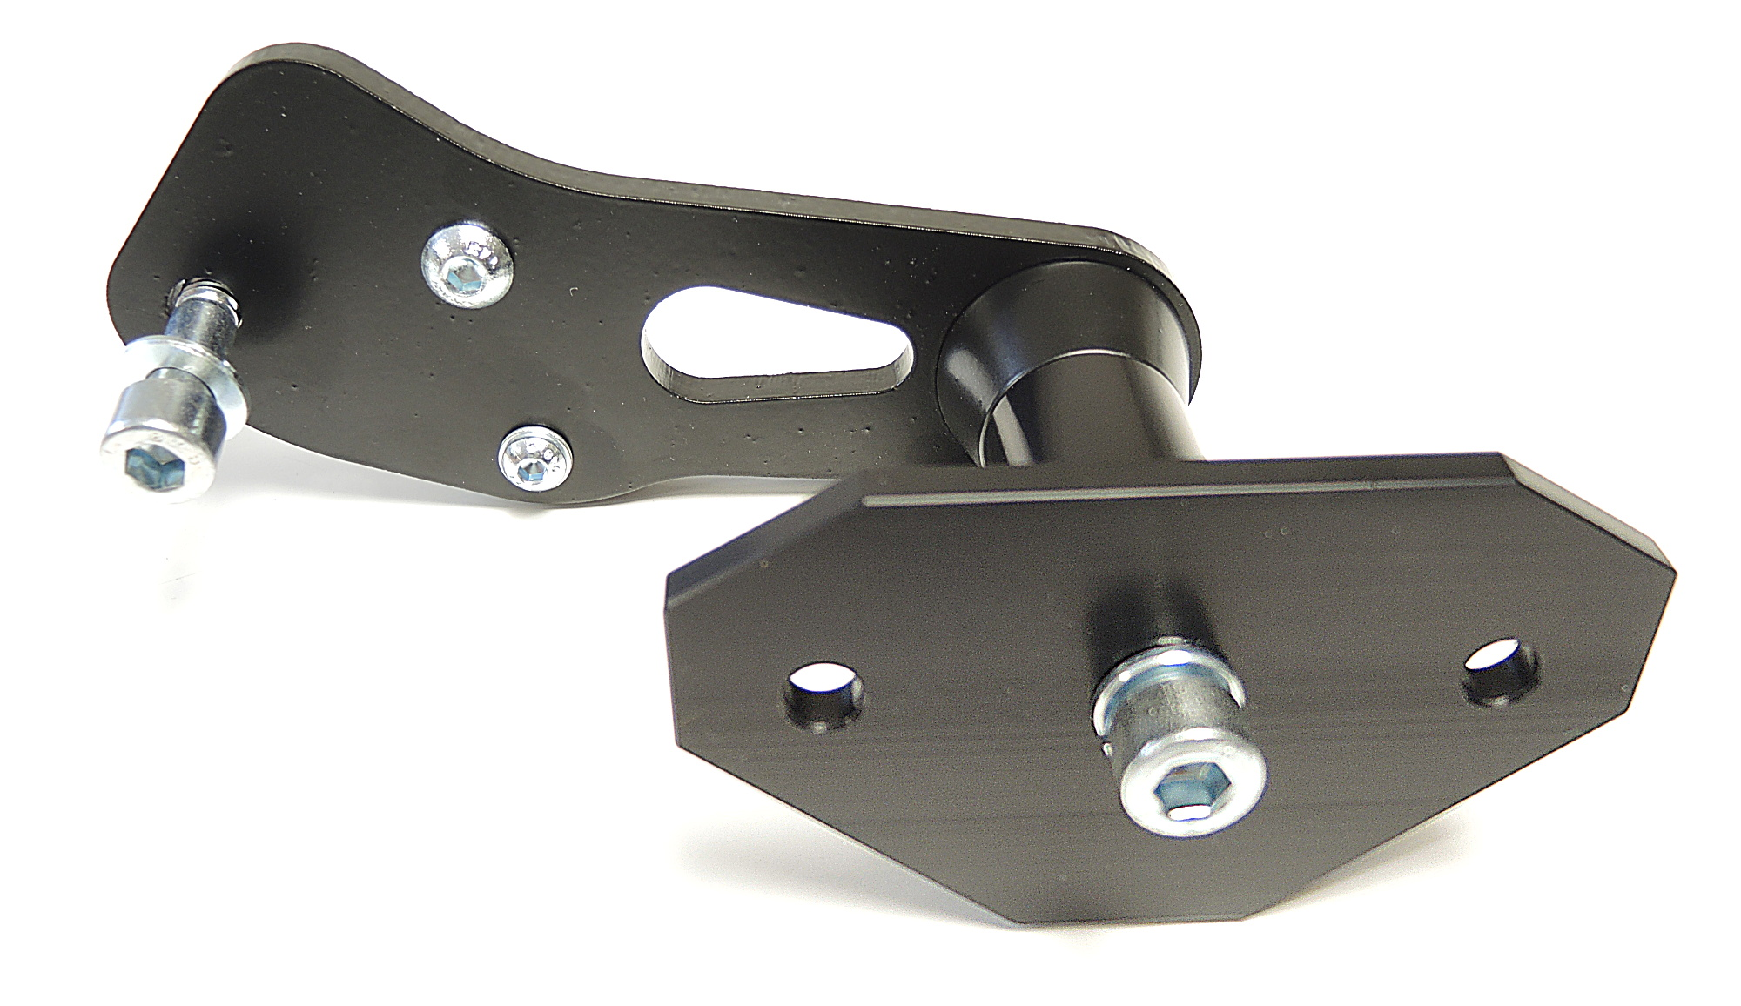
L
R

Instructions:
- We recommend to use the glue on all threads (blue color – medium srong).
- Remove fairing of motorcycle.
- Fit poly cylinder ID7 on the steel adapter ID1 using bolt ID8 and washer ID9.
- Fit poly cylinder ID5 on the back side of steel adapter ID1 using bolt ID6.
- Remove original bolt from frame of motorcycle.
- Stick 3M tape ID13 on the frame.
- Insert dural cylinder ID2* into the frame of motorcycle.
- Fit prepared steel adapter on the frame of motorcycle using bolt ID3 and washer ID4.
- Put fairing back on motorcycle.
- Prepare bolt ID10*.
  - Put washer ID12 on bolt.
  - Put diamond adapter ID16 on bolt.
  - Put dural cylinder ID11* on bolt.
- Now you can mount this kit into steel adapter.
- In the end fit protector using two bolts ID15 and washers ID14.

*(ID2 – longer cylinder is on the right side, ID10 – longer bolt is on the left side, ID11 – longer cylinder is on the left side)

