B7S
BMW S 1000R 2014-

Fitting kit left side: Fitting kit right side:
ID | Description | Cat.N | Qt
1 | Steel Adapter | 692 | 1
2 | Dural. spacer d=6,7 | 1105 | 1
3 | Bolt M10x60 | 850 | 1
4 | Washer M10 | 804 | 1
5 | Polyamid spacer 20mm | X6 | 1
6 | Bolt M8x25 | 831 | 1
7 | Poly.spacer d=6mm | X64 | 1
8 | Bolt M6x16 | 962 | 1
9 | Washer M6 | 947 | 1
10 | 3M Tape | 3M | 2
11 | Dural. adapter for SL01 | DV316 | 1
12 | Dural. spacer d=10 | DV1 | 1
13 | Bolt M10x40 | 854 | 1
14 | Bolt M6x25 | 877 | 3
15 | Bolt M4x16 | 876 | 2
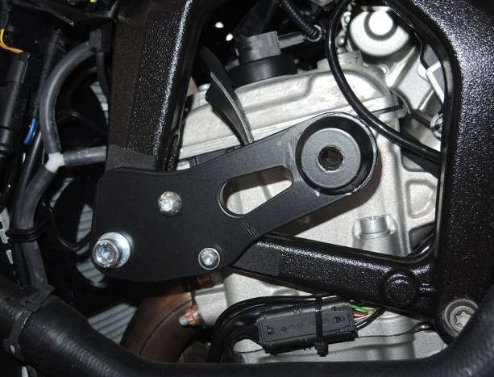
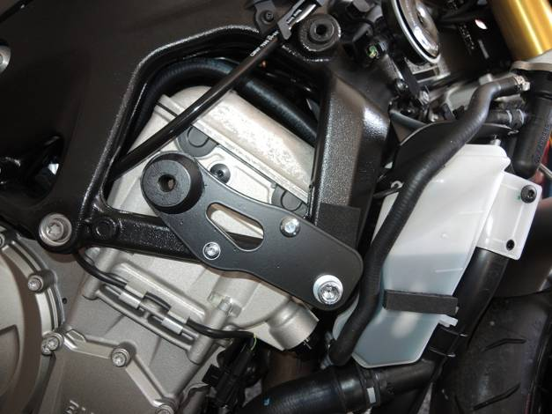
ID | Description | Cat.N | Qt
1 | Steel adapter | 693 | 1
2 | Dural.spacer d=7,2 | 1107 | 1
3 | Bolt M10x60 | 850 | 1
4 | Washer M10 | 804 | 1
5 | Polyamid.spacer 20mm | X6 | 1
6 | Bolt M8x25 | 831 | 1
7 | Poly.spacer d=6mm | X64 | 1
8 | Bolt M6x16 | 962 | 1
9 | Washer M6 | 947 | 1
10 | 3M Tape | 3M | 2
11 | Dural.adapter for SL01 | DV292 | 1
12 | Bolt M10x35 | 847 | 1
13 | Bolt M6x25 | 877 | 3
14 | Bolt M4x16 | 876 | 2
15

7

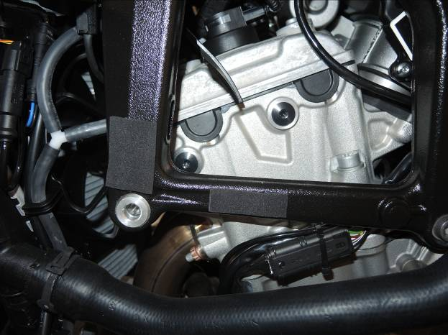

11

10

12
7
1
9,8
3
10
1
11
3
10
11
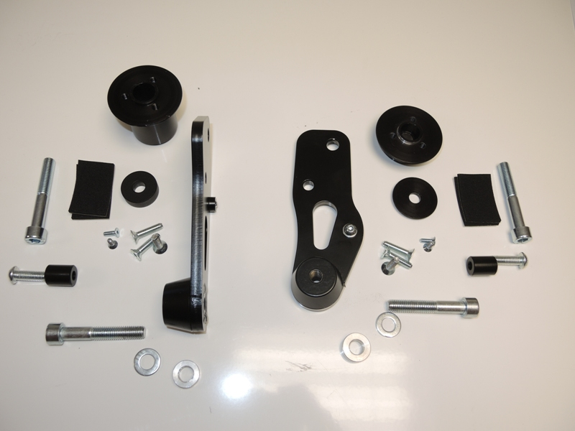
6
4
13
5
2
2
15
14
4
5
6
7
8,9
13,14
12

12
Assembly instruction left side:
- Take left hand side fairing out from bike.
- Do assembly from back side poly spacer ID.7 On the adapter ID.1, use bolt ID.8. Under the bolt place washer ID.9.
- Do assembly from back side poly spacer ID.5 On the adapter ID.1, use bolt ID.6.
- Dismantle original bolt M10 from frame (as show on the picture).
- Stick 3M tape on the frame (as on the picture).
- Insert dural. spacer ID.2 into the frame.
- Place steel adapter ID1 with poly spacers on the bike. Use bolt ID.3 with washer ID.4 to assembly.
- Put fairing back to bike.
- Place bolt ID.13 into the dural. adapter ID.11 and spacer ID.12. This kit gripping on the steel adapter and tighten.
- Place slider and use bolts ID.14. Place cover and use bolts ID.15.

Assembly instruction right side:
- Take left hand side fairing out from bike.
- Do assembly from back side poly spacer ID.7 On the adapter ID.1, use bolt ID.8. Under the bolt place washer ID.9.
- Do assembly from back side poly spacer ID.5 On the adapter ID.1, use bolt ID.6.
- Dismantle original bolt M10 from frame (as show on the picture).
- Stick 3M tape on the frame (as on the picture).
- Insert dural. spacer ID.2 into the frame.
- Place steel adapter ID1 with poly spacers on the bike. Use bolt ID.3 with washer ID.4 to assembly.
- Put fairing back to the bike.
- Place bolt ID.12 into the dural. adapter ID.11. This kit gripping on the steel adapter and tighten.
- Place slider and use bolts ID.13. Place cover and use bolts ID.14.

We recommend to use glue of all threads, medium strong. (Blue colour Loctite 243)

