B7
BMW S 1000R 2014-

Fitting kit left side: Fitting kit right side:
ID | Description | Cat.N | Qt
1 | Steel Adapter | 692 | 1
2 | Dural. spacer d=6,5 | 1105 | 1
3 | Bolt M10x60 | 850 | 1
4 | Washer M10 | 804 | 1
5 | Polyamid spacer 20mm | X6 | 1
6 | Bolt M8x25 | 831 | 1
7 | Poly.spacer d=6mm | X64 | 1
8 | Bolt M6x16 | 962 | 1
9 | Washer M6 | 947 | 1
10 | Steel box | X1 | 1
11 | Bolt M10x70 | 851 | 1
12 | Dural. spacerd=30 | 3 | 1
13 | 3M Tape | 3M | 2
ID | Description | Cat.N | Qt
1 | Steel adapter | 693 | 1
2 | Dural.spacer d=7 | 1107 | 1
3 | Bolt M10x60 | 850 | 1
4 | Washer M10 | 804 | 1
5 | Polyamid.spacer 20mm | X6 | 1
6 | Bolt M8x25 | 831 | 1
7 | Poly.spacer d=6mm | X64 | 1
8 | Bolt M6x16 | 962 | 1
9 | Washer M6 | 947 | 1
10 | Steell box | X1 | 1
11 | Bolt M10x45 | 848 | 1
12 | 3M Tape | 3M | 2

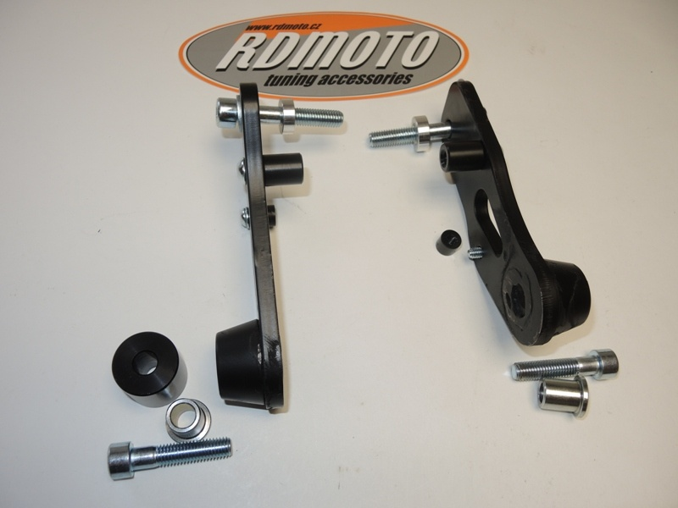
3,4
2
2

6
6
5
5

8, 9
7
7

1

12
1

11

10
10

11

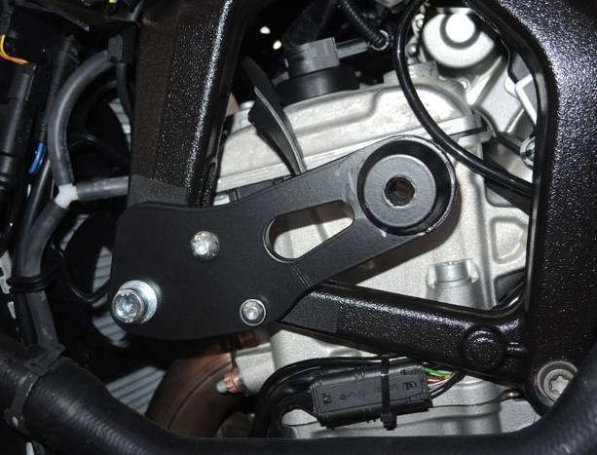
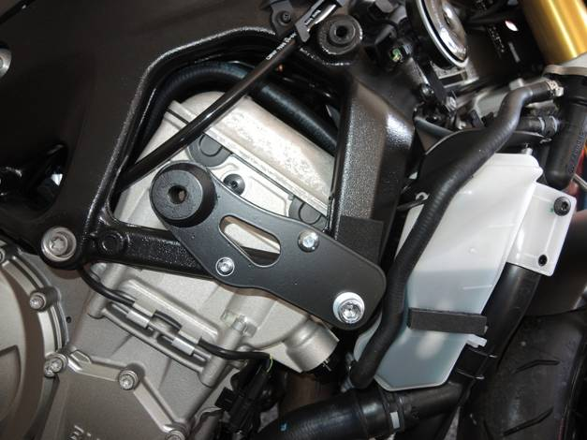
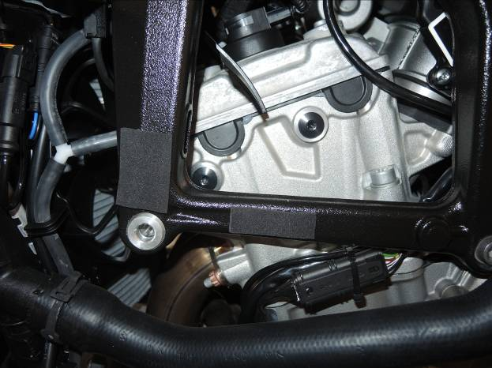
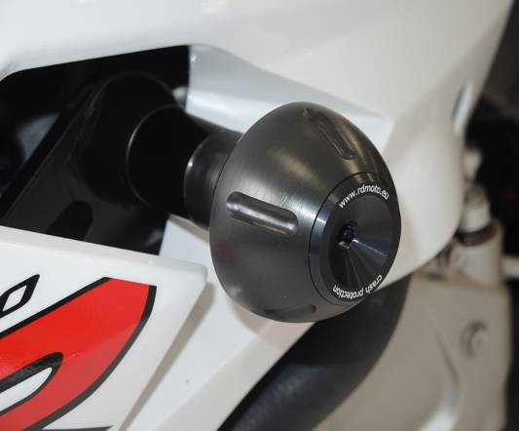
12

Assembly instruction left side:
- Take left hand side fairing out from bike.
- Do assembly from back side poly spacer ID.7 On the adapter ID.1, use bolt ID.8. Under the bolt place washer ID.9.
- Do assembly from back side poly spacer ID.5 On the adapter ID.1, use bolt ID.6.
- Dismantle original bolt M10 from frame (as show on the picture).
- Stick 3M tape on the frame (as on the picture).
- Insert dural. spacer ID.2 into the frame.
- Place steel adapter ID1 with poly spacers on the bike. Use bolt ID.3 with washer ID.4 to assembly.
- Put fairing back to the bike.
- Insert steel box ID.10 into the protector. This kit mounting on the steel adapter by bolt ID.11. Place spacer ID.12 under the protector and tighten it.

Assembly instruction right side:
- Take left hand side fairing out from bike.
- Do assembly from back side poly spacer ID.7 On the adapter ID.1, use bolt ID.8. Under the bolt place washer ID.9.
- Do assembly from back side poly spacer ID.5 On the adapter ID.1, use bolt ID.6.
- Dismantle original bolt M10 from frame (as show on the picture).
- Stick 3M tape on the frame (as on the picture).
- Insert dural. spacer ID.2 into the frame.
- Place steel adapter ID1 with poly spacers on the bike. Use bolt ID.3 with washer ID.4 to assembly.
- Put fairing back to the bike.
- Insert steel box ID.10 into the protector. This kit mounting on the steel adapter by bolt ID.11.

We recommend to use glue of all threads, medium strong. (Blue colour Loctite 243)

