B8S
BMW S 1000XR 2015-

Fitting kit left side: Fitting kit right side:
ID | Description | Cat.N | Qt
1 | Alu. holder for protector | 701 | 1
2 | Alu. spacer d=6,7 | 1105 | 2
3 | Bolt M10x60 rear | 850 | 1
4 | Bolt M10x65 front | 943 | 1
5 | Washer M10 | 804 | 1
6 | 3M tape | 3M | 1
7 | Plastic cover | X4 | 2
8 | Alu. adapter d=70mm | 351 | 1
9 | Bolt M10x45mm | 848 | 1
10 | Bolt M6x25 | 877 | 3
11 | Bolt M4x16 | 876 | 2
ID | Description | Cat.N | Qt
1 | Alu. holder for protector | 700 | 1
2 | Alu. spacer d=7,2mm | 1107 | 1
3 | Bolt M10x65 | 943 | 1
4 | Bolt M8x30 | 942 | 1
5 | Poly.cylinder d=20mm | X6 | 1
6 | 3M tape | 3M | 1
7 | Plastic cover | X4 | 2
8 | Alu. adapter d=45mm | 352 | 1
9 | Bolt M10x35mm | 847 | 1
10 | Bolt M6x25 | 877 | 3
11 | Bolt M4x16 | 876 | 2

4
10
11

7
2
3
5
4
10

6
5
3
11
7
2
1
8
8

1

6
9

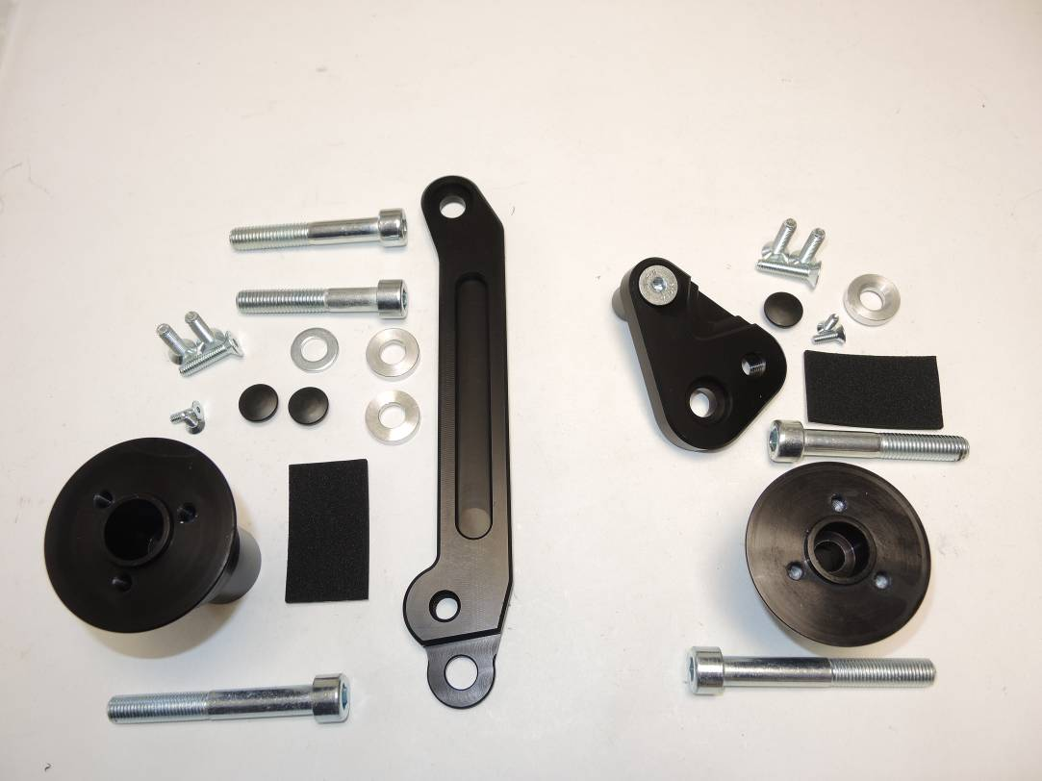

9

12
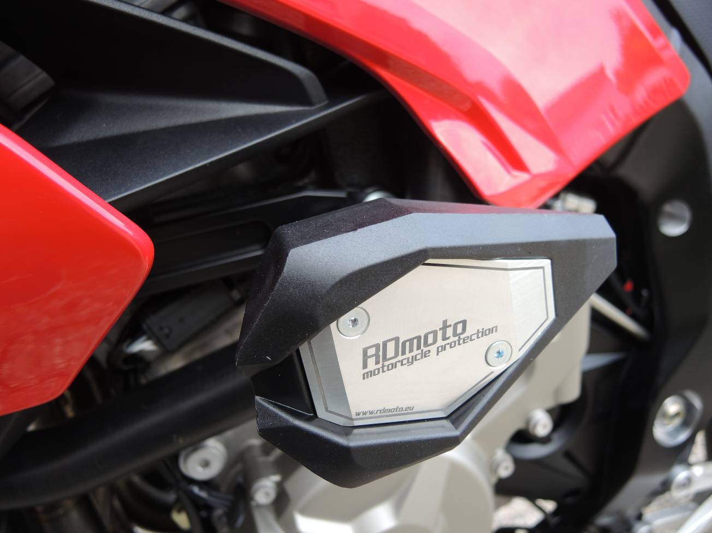
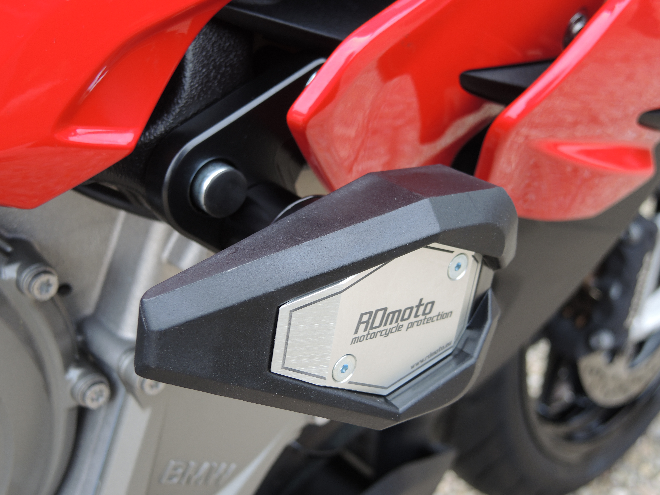

Warning: During assembly use glue of threads. Medium strong.
Assembly instruction:

- Dismantl fairing bolts from the left side. You needen´t fairing put down. Make a space for M10 bolts and dismantle these bolts.
- Place spacers ID.2 into the both holes in the frame. Sticking 3M tape on the frame.
- Alu. holder ID.1 place on the frame and moutning it by bolts ID.3, ID.4 and washer ID.5.
- Bolt ID.3 with washer ID.5 use for rear gripping. For front gripping use use bolt ID.4. Into the bolts place plastic covers ID.7.
- Now put fairing back the bike. Bolt ID.9 is for mounting dural.adapter for SL01 ID.8.
- Place slide rand tighten it by bolts ID.10, inser alu. cover into the slider use bolts ID.11.
- Right side. Dismantle rear bolt M10 from frame. Into the frame place alu.spacer ID.2 Poly. cylinder ID.5 put from back side the dural holder ID.1 and tighten it by bolt ID.4.
- Place 3M tape on the frame. Bolt ID.3 is for assembly dural. holde ID.1 on the frame. Place plastic cover into the bolt.
- Bolt ID.9 is for mounting dural.adapter for SL01 ID.8.
- Place slide rand tighten it by bolts ID.10, inser alu. cover into the slider use bolts ID.11.

