B8
BMW S 1000XR 2015-

Fitting kit left side: Fitting kit right side:
ID | Descrip. | Cat.N | Qt
1 | Dural. adapter | 701 | 1
2 | Dural. spacer d=6,7 | 1105 | 2
3 | Bolt M10x60 rear | 850 | 1
4 | Bolt M10x65 front | 943 | 1
5 | Washer M10 | 804 | 1
6 | 3M Tape | 3M | 1
7 | Plast. cover | X4 | 2
8 | Steel insert | X1 | 1
9 | Dural. spacer d=40mm | DV4 | 1
10 | Bolt M10x75 | 1007 | 1
4
ID | Descrip. | Cat.N | Qt
1 | Dural. adapter | 700 | 1
2 | Dural.spacer d=7,2mm | 1107 | 1
3 | Bolt M10x65 | 943 | 1
4 | Bolt M8x30 | 942 | 1
5 | Poly. cylinder d=20mm | X6 | 1
6 | 3M tape | 3M | 1
7 | Plast. cover | X4 | 2
8 | Steel insert | X1 | 1
9 | Dural.spacer d=20mm | DV2 | 1
10 | Bolt M10x55 | 1002 | 1
4
7
1
5
2
1
2
3
9
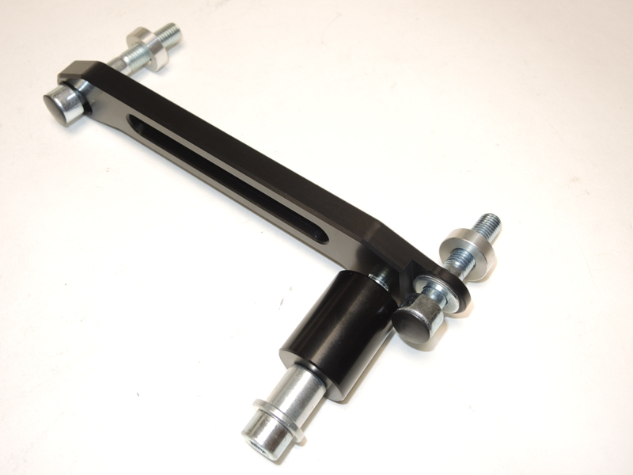
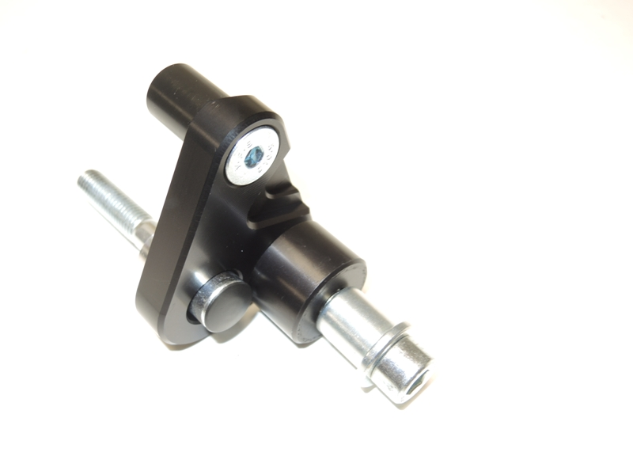
10
8
7
5
9
3
10
2
7
8

During assembly to proceed as the pictures.

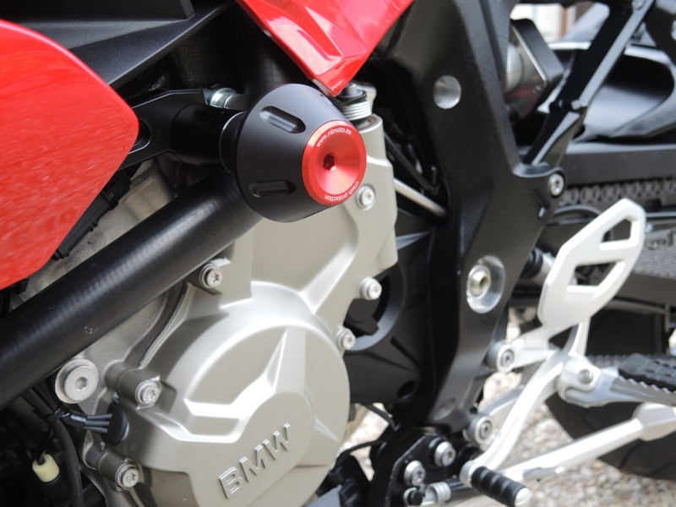

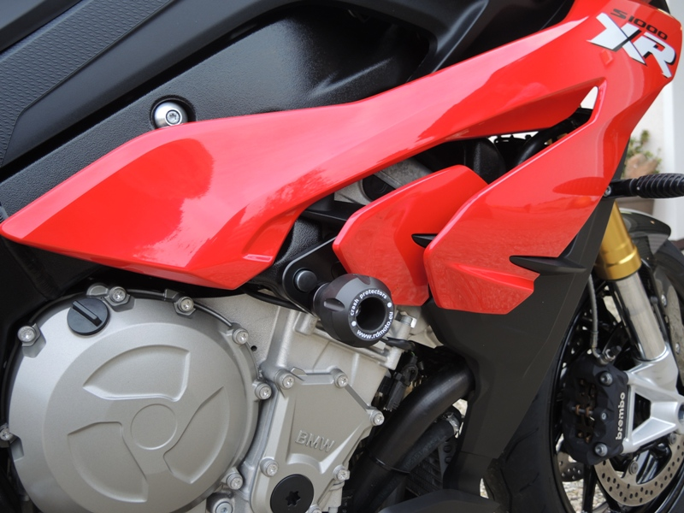

12

Assembly instruction:
1. Remove orig. Screws from the left side of the motorcycle frame. 3M tape stick on the frame.
2. According to the attached photos assemble duralumin adapter ID.1. Place ID.2 spacers into the frame.
3. Tighten the screws M10. Get back fairing on the bike.
4. Insert the steel box ID.8. into the protector. Under the protector Place dural. ID.9 spacer. By bolts ID.10 mounting protector.
5. The right side. Use bolt ID.4 for mounting poly.cylinder ID.5 from the back side. On the frame stick 3M tape and remove orig. M10 screw. Place alu. spacer into the frame. ID.2.
6. Insert the steel box ID.8. into the protector. Under the protector Place dural. ID.9 spacer. By bolts ID.10 mounting protector.

Note: During installation, we recommend using glue on the threads (blue color)

