B9-2SD
BMW F800R 2014-
ID | Description | Cat.No | Pcs
1 | SLD carrier | 537 | 2
2 | Dural. adapter | 11 | 2
3 | Spacer sleeve | 452 | 2
4 | Bolt M10x130 | 885 | 2
5 | Bolt M8x25 | 815 | 4
6 | Washer M8 | 800 | 4

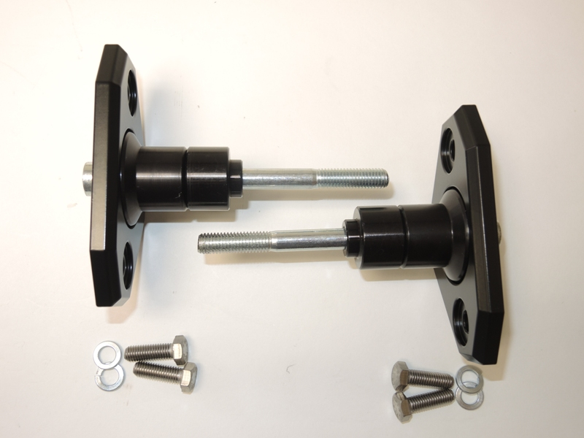
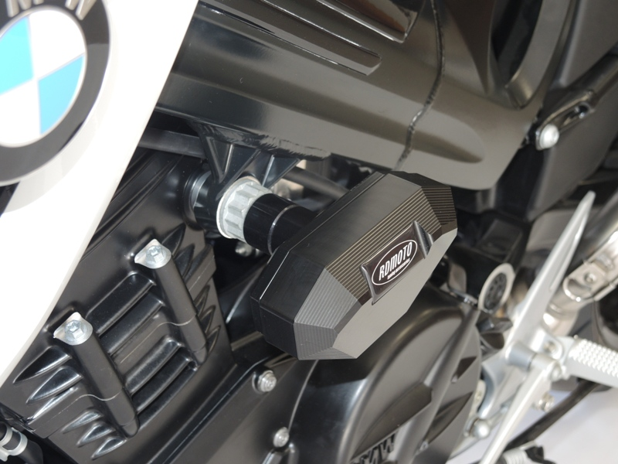
Mounting instructions:

- Mount according to the attached pictures.
3
1
- The procedure for the left and right sides is the same.
- We recomment installing one side first and then installing the other side..
2
- Remove the original bolt M10 from the motorcycle frame.
- Insert the SLD carrier ID.1 on the bolt ID.4.
- Slide the fitted adapter ID.2 under the carrier.
6
4
- Insert the spacer sleeve ID. 3 into the frame.
5
- Mount the protector to the frame.
- Insert the bolts ID.5 including the washers ID.6 from the rear and mount the slider.

Warning: We recommend using medium strength (blue) thread glue during assembly.

