B9-2S
BMW F800R 2014-

Kit for the left side: Kit for the right side:
ID. | Description | Cat.no. | pcs
1 | Adapter moto | DV-316 | 1
2 | Bolt M6x25 | 877 | 3
3 | Bolt M4x16 | 876 | 2
4 | Bolt M10x90mm | 880 | 1
5 | Washer M10- perova | 801 | 1
ID. | Description | Cat.no. | pcs
1 | Adapter moto | DV-316 | 1
2 | Bolt M6x25 | 877 | 3
3 | Bolt M4x16 | 876 | 2
4 | Bolt M10x90mm | 880 | 1
5 | Washer M10 - pérová | 801 | 1
6 | Dural spacer d=6mm | 453 | 1

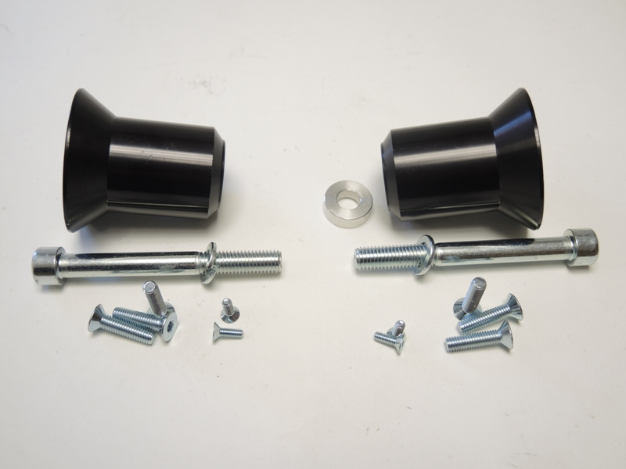

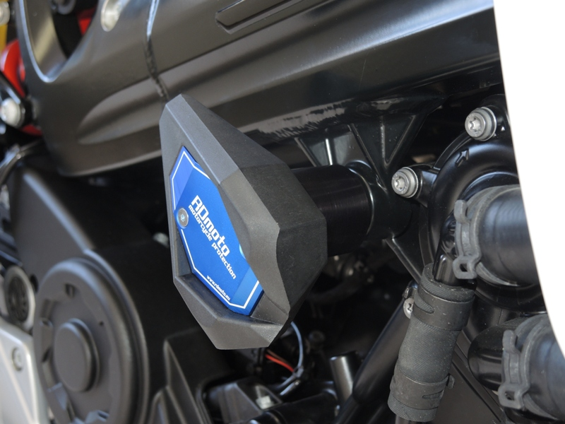
Installation – left side:
- Remove original bolt from the frame of motorcycle.
- Insert bolt+washer (ID4+ID5) into dural adapter (ID1)
- Mount this kit on the frame of motorcycle.
- Fit slider using bolts (ID2). Fit coloured cover on the slider using bolts (ID3)

Installation – right side:
- Remove original bolt from the frame of motorcycle.
- Insert bolt+washer (ID4+ID5) into dural adapter (ID1)
- Insert dural spacer (ID6) into the frame.
- Mount this kit on the frame of motorcycle.
- Fit slider using bolts (ID2). Fit coloured cover on the slider using bolts (ID3)

We recommend to use the glue on all threads (medium strong – blue colour).

