B9-2
BMW F800R 2014-

Kit for the left side |  |  |  |  | Kit for the right side
ID | Description | Cat.no. | pcs |  | ID | Description | Cat.no. | pcs
1 | Steel insert M10 | X1 | 1 |  | 1 | Steel insert M10 | X1 | 1
2 | Screw M10x120mm | 881 | 1 |  | 2 | Screw M10x120mm | 881 | 1
3 | dural. roller - 20mm | 2 | 1 |  | 3 | dural. roller - 26mm | 452 | 1

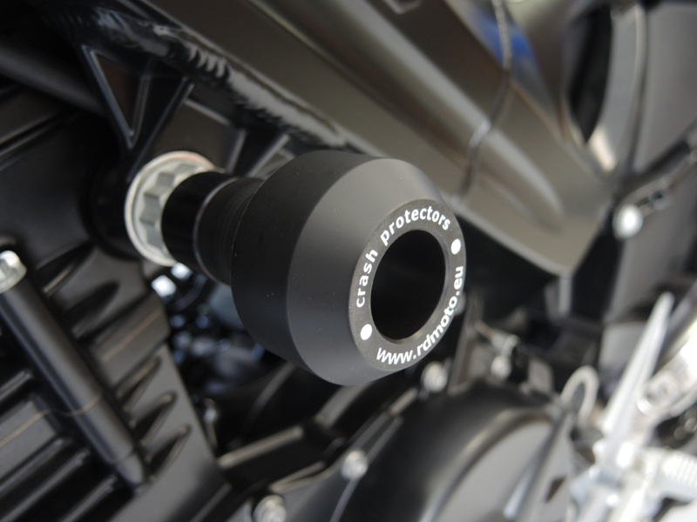
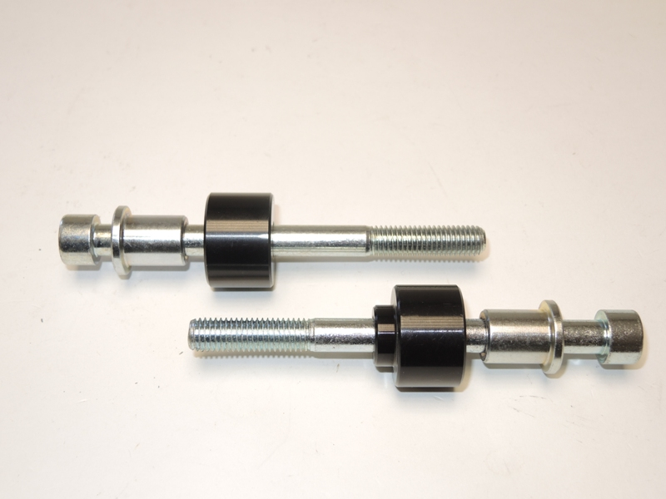

Installation:

- Prepare set same as in the picture above.
- Don’t forget that dural roller (ID3) is a bit longer on the right side (26mm) instead of 20mm on the left.

We recommend to use the glue on all threads (medium strong).

