B9SDM
BMW F800 R 2014-

Mounting Kit – Left Side: Mounting Kit – Right Side:
ID | Description | Cat.No | Pcs
1 | Steel holder | 675 | 1
2 | Dural. sleeve l=29,5mm | 1154 | 1
3 | Dural. sleeve l=6,5mm | 1105 | 1
4 | Bolt M10x110 | 879 | 1
5 | Bolt M10x85 | 981 | 1
6 | Washer M10 | 804 | 2
7 | Plastic cap | X4 | 2
8 | Bolt M10x35 | 847 | 1
9 | Dural. SLDM reduction | 9 | 1
10 | SLDM carrier | 537/B | 1
11 | Bolt M6x20 | 1024 | 2
12 | Washer M6 | 1023 | 2
ID | Description | Cat.No | Pcs
1 | Steel holder | 675 | 1
2 | Dural. sleeve l=41mm | 1153 | 1
3 | Dural. sleeve l=13mm | 1155 | 1
4 | Bolt M10x120 | 881 | 1
5 | Bolt M10x90 | 880 | 1
6 | Washer M10 | 804 | 2
7 | Plastic cap | X4 | 2
8 | Bolt M10x35 | 847 | 1
9 | Dural. SLDM reduction | 9 | 1
10 | SLDM carrier | 537/B | 1
11 | Bolt M6x20 | 1024 | 2
12 | Washer M6 | 1023 | 2
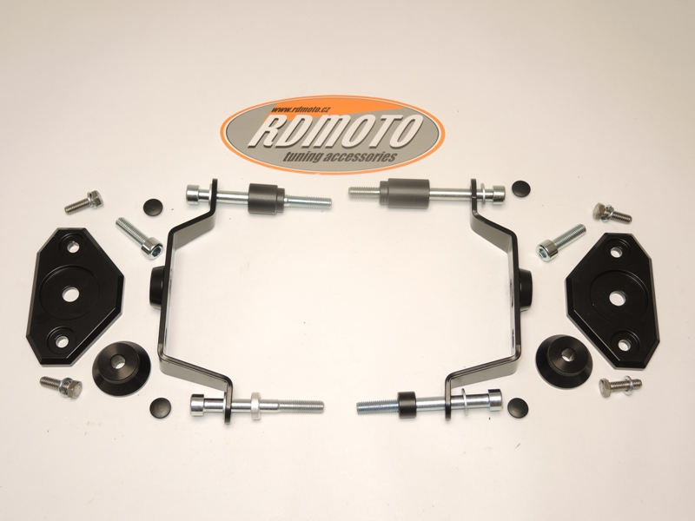

Mounting instructions – Left Side:
- Remove original bolts M10 from the frame.
- Insert the bolts into the steel holder ID.1 for the protector. Place the washers ID.6. under the bolts. Insert the bolt ID.4 into the front part. Use the bolt ID.5 for rear mounting.
- Thread the sleeves on these bolts. Front sleeve ID.2 mounted in the frame. Rear sleeve ID.3.
- Mount this assembly on the motorcycle frame.
- Insert the plastic caps ID.7 into the bolts.
- Thread the slider carrier ID.10 on the bolt ID.8. Insert the fitted dural. reduction ID.9 under the carrier.
- Mount this assembly on the steel holder.
- Mount the slider using bolts ID.11 and washers ID.12.

Mounting instructions – Right Side:
- Remove original bolts M10 from the frame.
- Insert the bolts into the steel holder ID.1 for the protector. Place the washers ID.6. under the bolts. Insert the bolt ID.4 into the front part. Use the bolt ID.5 for rear mounting.
- Thread the sleeves on these bolts. Front sleeve ID.2 mounted in the frame. Rear sleeve ID.3.
- Mount this assembly on the motorcycle frame.
- Insert the plastic caps ID.7 into the bolts.
- Thread the slider carrier ID.10 on the bolt ID.8. Insert the fitted dural. reduction ID.9 under the carrier.
- Mount this assembly on the steel holder.
- Mount the slider using bolts ID.11 and washers ID.12.

Warning: We recommend using medium strength (blue) thread glue during assembly.
