B9S
BMW F800 R 2014-

Kit for the left side: Kit for the right side:
ID | Description | Cat.no. | pcs
1 | Steel adpater | 675 | 1
2 | Dural. spacer d=29,5 | 1154 | 1
3 | Dural. spader d=6mm | 1105 | 1
4 | Bolt M10x110 | 879 | 1
5 | Bolt M10x85 | 981 | 1
6 | Washer M10 | 804 | 2
7 | Plastic cap | X4 | 2
8 | Dural adapter | 292 | 1
9 | Bolt M10x35 | 847 | 1
10 | Bolt M6x25 | 877 | 3
11 | Bolt M4x16 | 876 | 2
12
ID | Description | Cat.no. | pcs
1 | Steel adapter | 675 | 1
2 | Dural. spacer d=41mm | 1153 | 1
3 | Dural. spacer d=13mm | 1155 | 1
4 | Bolt M10x120 | 881 | 1
5 | Bolt M10x90 | 880 | 1
6 | Washer M10 | 804 | 2
7 | Plastic cap | X4 | 2
8 | Dural adapter | 292 | 1
9 | Bolt M10x35 | 847 | 1
10 | Bolt M6x25 | 877 | 3
11 | Bolt M4x16 | 876 | 2
12

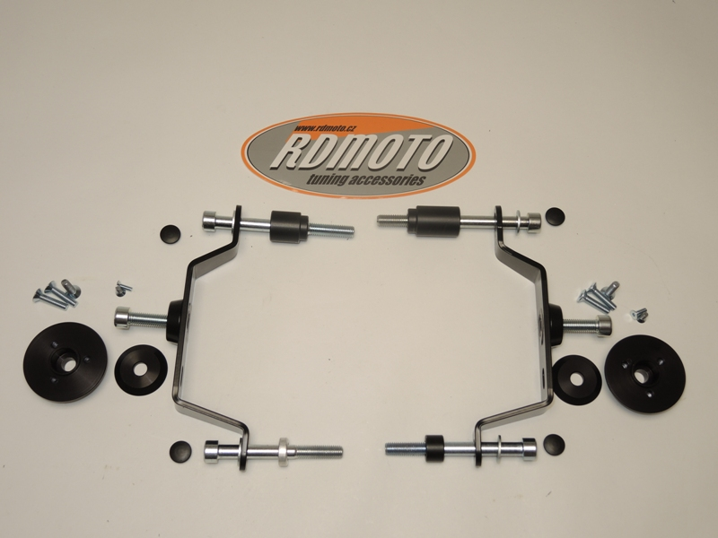

4,6
2
4,6
2
9
10,11
10,11
1

9
8
1

8
3
3

5,6
5,6

Installation(left side):
- Remove original M10 bolt from the frame of motorcycle.
- Insert bolts (ID4 – front, ID5 – rear) with washers into dural adapter (ID1).
- Place spacers (ID2 – front, ID3 – rear) on these bolts.
- Mount this kit on the frame of motorcycle.
- Insert plastic covers into bolts.
- Insert bolt (ID10) with washer (ID8) into dural adapter (ID9). Fit this set on the steel adapter.
- Fit slider on the slider adapter using bolts M6 (ID11).
- Fit coloured cover on the slider using bolts M4 (ID12).

Montáž pravá strana:
- Remove original M10 bolt from the frame of motorcycle.
- Insert bolts (ID4 – front, ID5 – rear) with washers into dural adapter (ID1).
- Place spacers (ID2 – front, ID3 – rear) on these bolts.
- Mount this kit on the frame of motorcycle.
- Insert plastic covers into bolts.
- Insert bolt (ID9) dural adapter (ID8). Fit this set on the steel adapter.
- Fit slider on the slider adapter using bolts M6 (ID10).
- Fit coloured cover on the slider using bolts M4 (ID11).

Note: longer spacers and bolts are on the right side.

We recommend to use the glue on all threads (blue colour – medium strong).
