B9
BMW F800 R 2014-

Fitting kit left side: Fitting kit right side:
ID | Description | Cat.N | Qt
1 | Steel adapter | 675 | 1
2 | Alu.spacer d=29,5 | 1154 | 1
3 | Alu. spacer d=6mm | 1105 | 1
4 | Bolt M10x110 | 879 | 1
5 | Bolt M10x85 | 981 | 1
6 | Washer M10 | 804 | 2
7 | Plastic cap | X4 | 2
8 | Bolt M10x35 | 847 | 1
9 | Steel box | X1 | 1
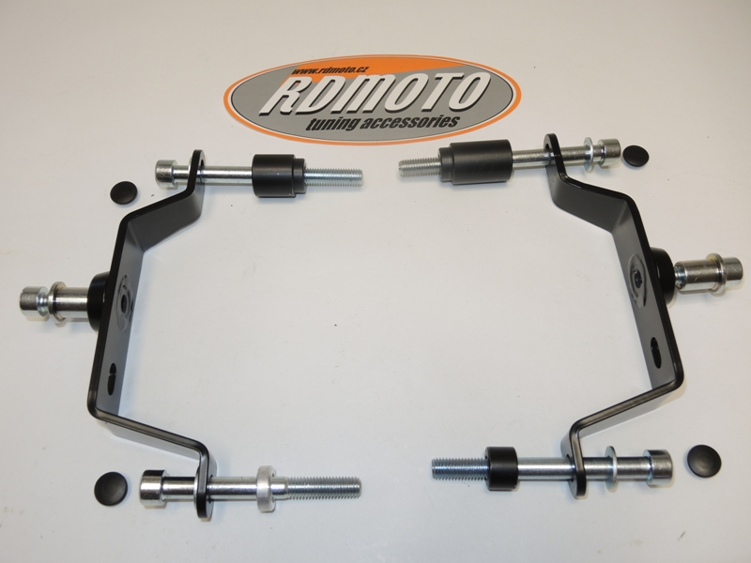
ID | Description | Cat.N | Qt
1 | Steel adapter | 675 | 1
2 | Alu. spacer d=41mm | 1153 | 1
3 | Alu. spacer d=13mm | 1155 | 1
4 | Bolt M10x120 | 881 | 1
5 | Bolt M10x90 | 880 | 1
6 | Washer M10 | 804 | 2
7 | Plastic cap | X4 | 2
8 | Bolt M10x35 | 847 | 1
9 | Steel box | X1 | 1

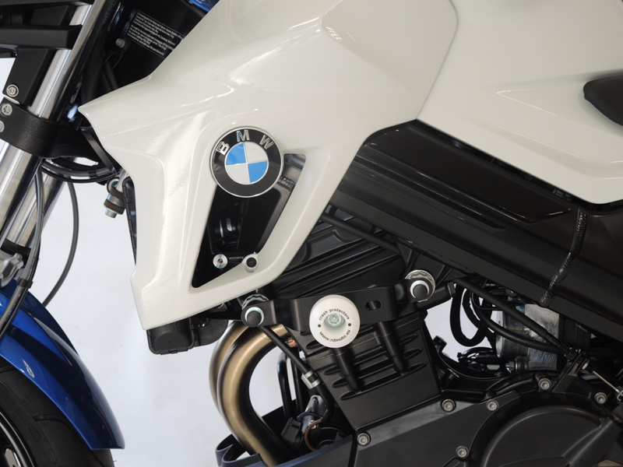
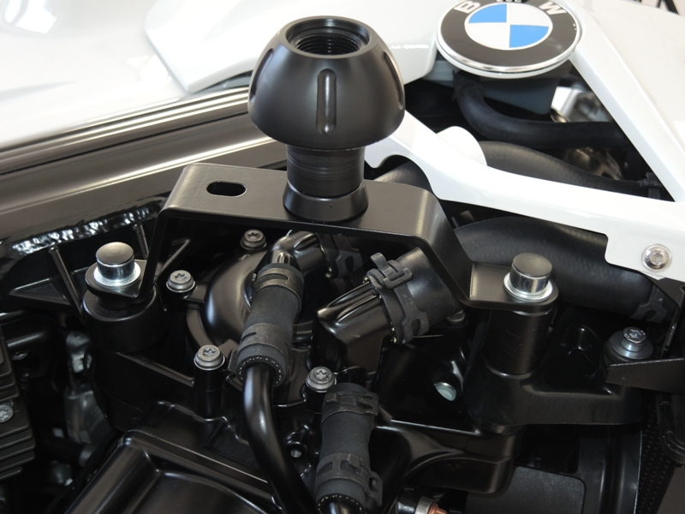

Assembly left side:
- Dismantle original bolts M10 from chassi.
- Insert bolt ID.4 front gripping with washer ID.6 into the steel adapter ID.1. Rear gripping use bolt ID.5 + washer ID6.
- Into the frame place spacers. Front spacer is ID.2 rear is ID.3.
- Tighten bolts M10.
- Place plastic covers into head bolts.
- Into teh crash bobbin insert steel box ID.9 and fix protector by bolt ID.8

Assembly right side:
- Dismantle original bolts M10 from chassi.
- Insert bolt ID.4 front gripping with washer ID.6 into the steel adapter ID.1. Rear gripping use bolt ID.5 + washer ID6.
- Into the frame place spacers. Front spacer is ID.2 rear is ID.3.
- Tighten bolts M10.
- Place plastic covers into head bolts.
- Into teh crash bobbin insert steel box ID.9 and fix protector by bolt ID.8

During assembly use medium strong glue for all treads.

