BN2
Benelli TNT 899 ´09- /1130 ´07-

Kit for left side: |  |  |  |  | Kit for right side:
Note | Description | Cat.no. | Quant. |  |  | Note | Description | Cat. no | Quant.
1 | Steel box M12 | X2 | 1 |  |  | 1 | Steel box M12 | X2 | 1
2 | Bolt M12x135x1,25mm | 991 | 1 |  |  | 2 | Bolt M12x135x1,25mm | 991 | 1
3 | dural. cylinder d=76mm | 497 | 1 |  |  | 3 | dural. cylinder d=72mm | 496 | 1
Mounting kit:

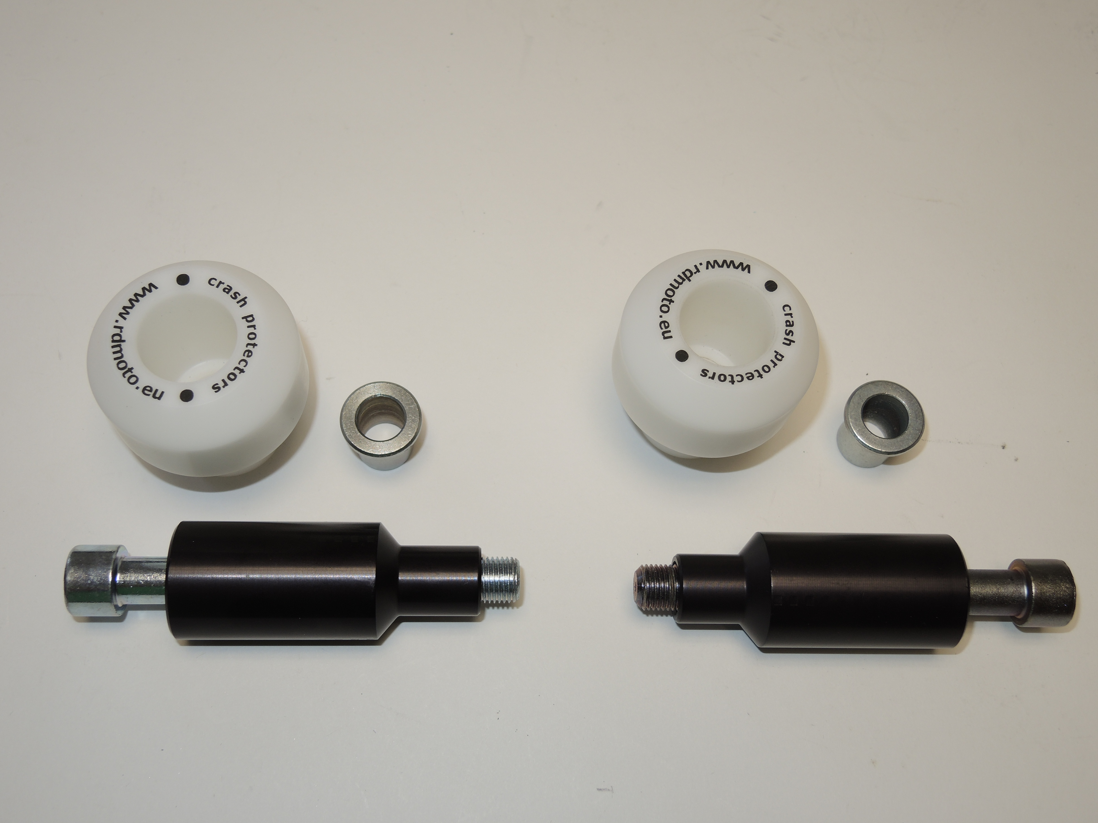

Instruction for left side:

- Take off original bolt from frame.
- Insert to the frame duralumin cylinder (note 3).
- Inside the protector put on steel box (note 1).
- Trough the protectors slide the bolt (note 2) and thighten on the bike.

Warning - the threads of the screws is recommended to use glue (blue color).

Instruction for right side:

- Take off original bolt from frame.
- Insert to the frame duralumin cylinder (note 3).
- Inside the protector put on steel box (note 1).
- Trough the protectors slide the bolt (note 2) and thighten on the bike.

