BN3-2
Benelli BN600R 2013-

Mounting Kit Left Side: Mounting Kit Right Side:
ID | Popis | Kat.č. | Ks
1 | Steel Insert M10 | X1 | 1
2 | Bolt M10x160 (155mm) | 979 | 1
3 | Dural. roller | DV5 | 1
4 | Washer M10 | 804 | 1
5 | Nut M10 | 810 | 1
ID | Popis | Kat.č. | Ks
1 | Steel Insert M10 | X1 | 1
2 | Bolt M10x160 (155mm) | 979 | 1
3 | Dural. roller | DV5 | 1
4 | Washer M10 | 804 | 1
5 | Nut M10 | 810 | 1

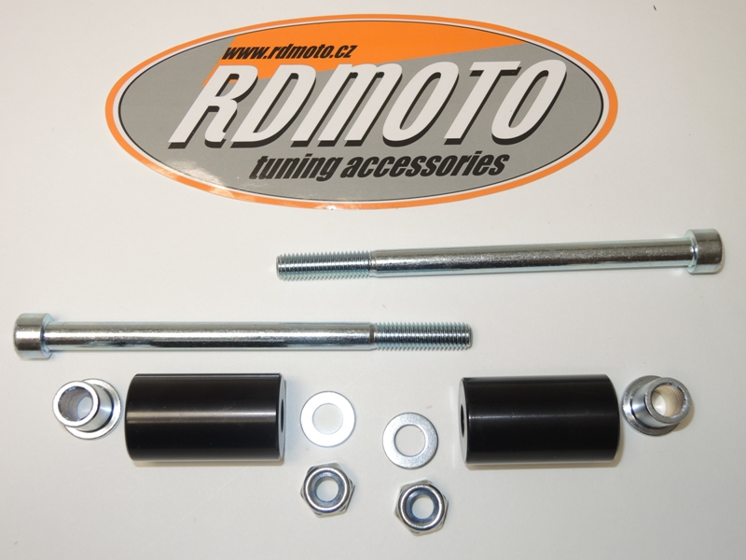

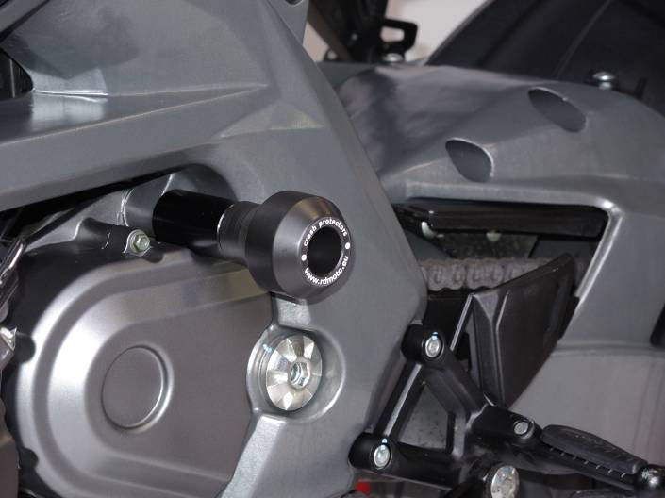
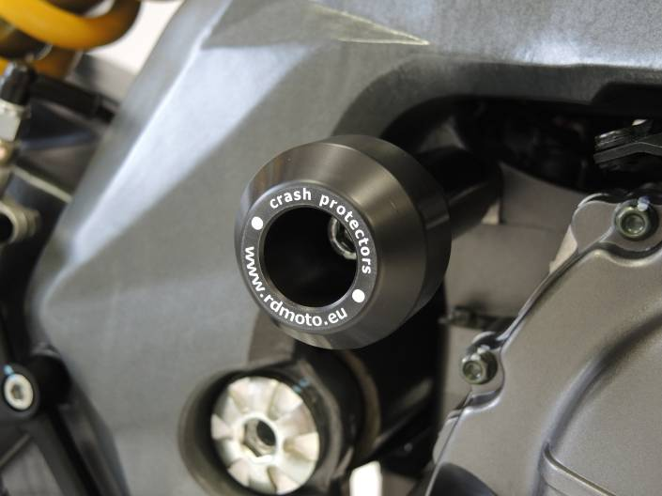

Mounting Instructions Left Side:
- Dismount original M10 bolt from motorcycle frame.
- Equip ID. 2 bolt with ID.1 steel insert.
- Take the equipped bolt and push it into the protector, underneath which you put ID.3 roller.
- Push this assembly through the engine and frame and tighten from back side, using ID.5 nut and ID.4 washer.

Mounting Instructions Right Side:
- Dismount original M10 bolt from motorcycle frame.
- Equip ID. 2 bolt with ID.1 steel insert.
- Take the equipped bolt and push it into the protector, underneath which you put ID.3 roller.
- Push this assembly through the engine and frame and tighten from back side, using ID.5 nut and ID.4 washer.

Note: We recommend using medium strenght thread glue during assembly (blue color).

