BN3SD
Benelli BN600R 2013-

Fitting kit right side: Fitting kit left side:
ID | Description | Cat.N | QTY
1 | Bolt M10x110 | 879 | 1
2 | Washer M10 spring | 801 | 1
3 | Dural. adapter | 149 | 1
4 | Bracket for SLD | 537 | 1
5 | Bolt M8 | 815 | 2
6 | Washer M8 spring | 800 | 2
7 | Dural. cylinder 20mm | DV2 | 1
ID | Description | Cat.N | QTY
1 | Bolt M10x85 | 981 | 1
2 | Washer M10 spring | 801 | 1
3 | Dural. adapter | 149 | 1
4 | Bracket for SLD | 537 | 1
5 | Bolt M8 | 815 | 2
6 | Washer M8 spring | 800 | 2

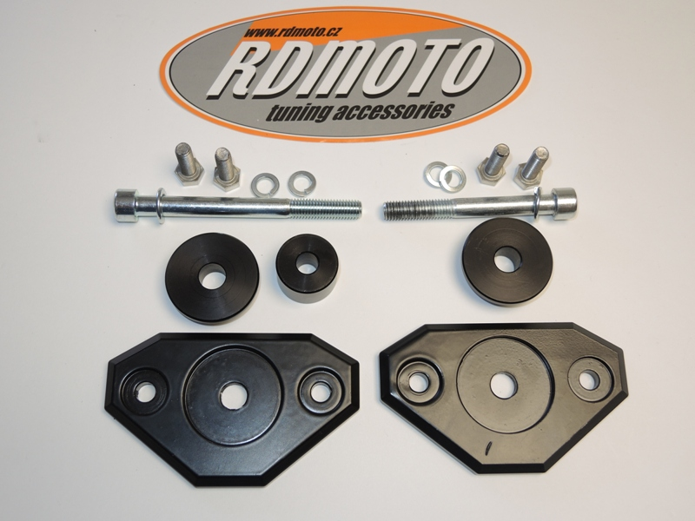

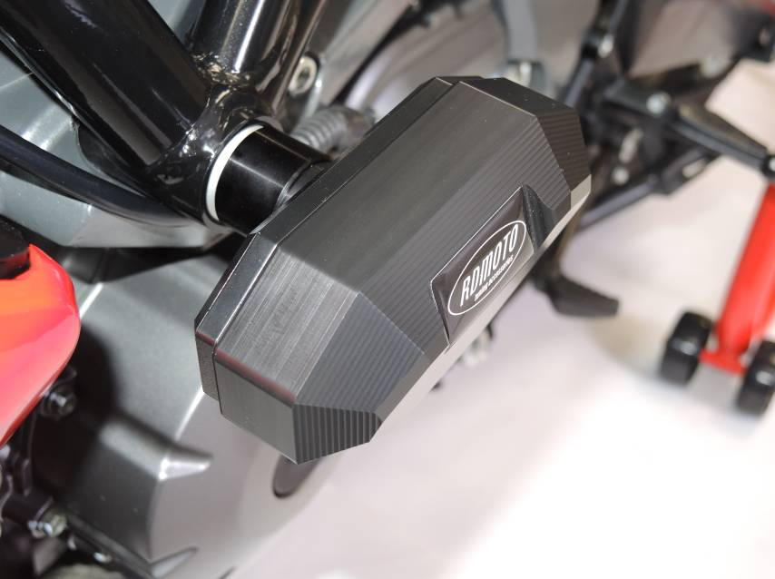
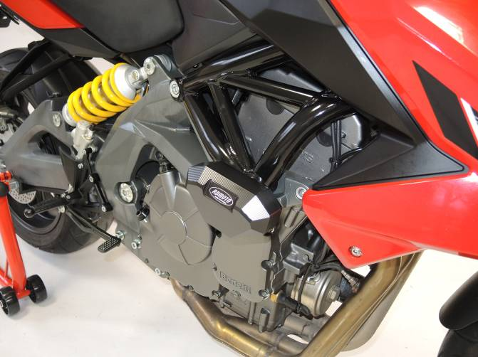

Fitting kit left side:
- Dismantle original bolt from frame.
- Take bolt ID.1. Insert washer ID.2 and bracket ID.4 on the bolt.
- Insert dural. adapter ID.3 and under the adapter put dural.cylinder. ID.7.
- This set, mount into the frame. Original dural. cylinder leave in frame.
- Use bolts ID.5 and washers ID.6 for gripping the slider.

Fitting kit right side:
- Dismantle original bolt from frame.
- Take bolt ID.1. Insert washer ID.2 and bracket ID.4 on the bolt.
- Insert dural. adapter ID.3.
- This set, mount into the frame. Original dural. cylinder leave in frame.
- Use bolts ID.5 and washers ID.6 for gripping the slider.

Warning: Use glue of all threads. Medium strong.

