BN3
Benelli BN600R 2013-

Fitting kit left side: Fitting kit right side:
ID | Description | Cat.No | QTY
1 | Steel box M10 | X1 | 1
2 | Bolt M10x110 | 879 | 1
3 | Dural.cylinder 20mm | DV2 | 1
ID | Description | Cat.N | QTY
1 | Steel box M10 | X1 | 1
2 | Bolt M10x85 | 981 | 1

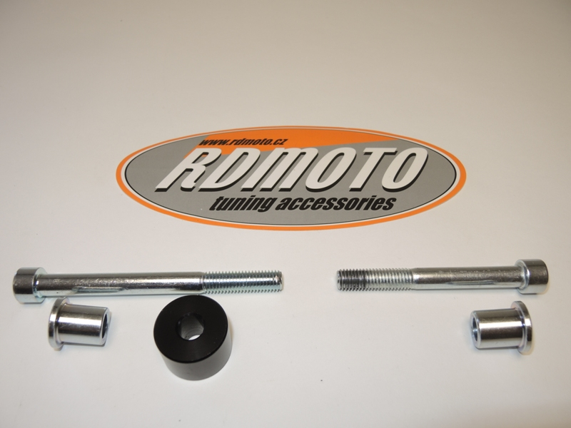

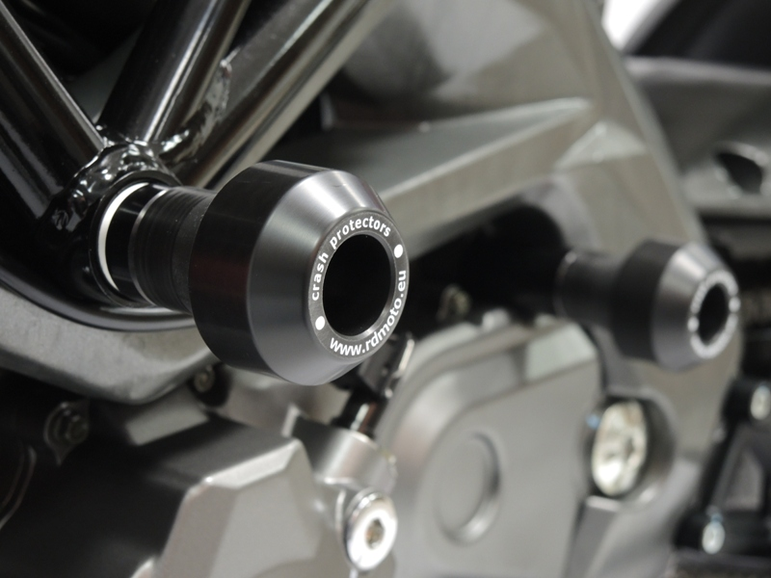

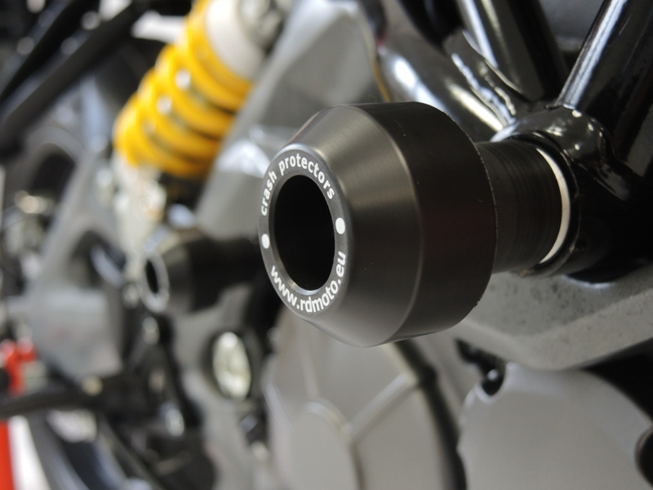

Instruction to assembly:
- Take out original bolt M10, from frame.
- Orig. dural cylinder leave in frame.
- Take bolt ID.2, and put on it steel box. ID.1.
- Into the protector insert bolt with steel box, under the protector insert dural. cylinder ID.3.
- This set fitting on frame.

Instruction to right side:
- Take out original bolt M10, from frame.
- Orig. dural cylinder leave in frame.
- Take bolt ID.2, and put on it steel box. ID.1.
- Into the protector insert bolt with steel box.
- This set fitting on frame.

Warning: We recommend use the glue of all threads. Medium strong.

