BN4S
Benelli BN251 2015-

Assembly ki left side: Assembly kit right side:
ID | Popis | Kat.č. | Ks
1 | Bolt M10x75 | 1007 | 1
2 | Dural. SL adapter | 313 | 1
4 | Bolt M6x25 | 877 | 3
5 | Bolt M4x16 | 876 | 2
6 | Dural.roller d=25,5mm | 1227 | 1
ID | Popis | Kat.č. | Ks
1 | Bolt M10x75 | 1007 | 1
2 | Dural. SL adapter | 313 | 1
4 | Bolt M6x25 | 877 | 3
5 | Bolt M4x16 | 876 | 2
6 | Dural.roller d=25,5mm | 1227 | 1

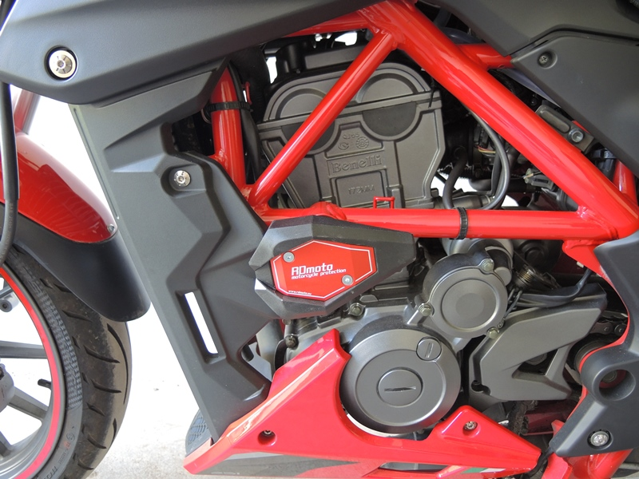
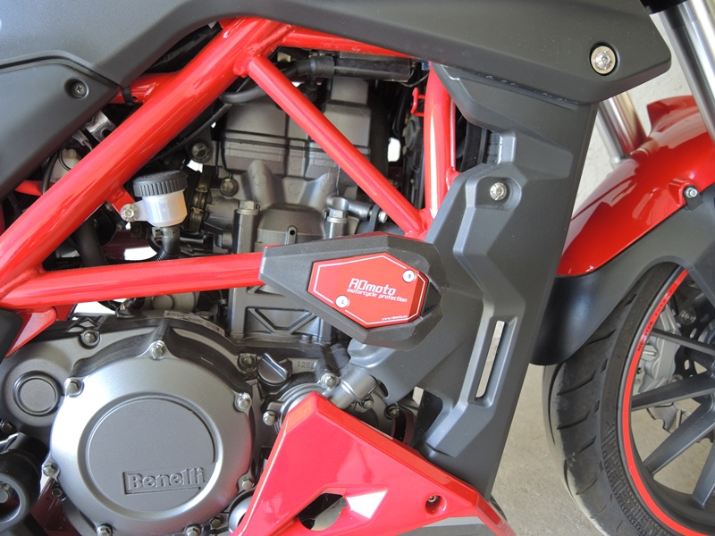

Mount the left side:
- Remove the original M10 bolt from the motorcycle frame.
- On screw ID.1, thread duralumin. SL adapter ID.2 and Dural. roller ID.6.
- Mount this assembly into the frame of the motorcycle
- Using screws ID.4 assemble slider.
- Insert the cap into the slider and tighten it with ID.5 screws.

Mount the Right side:
Installing the right side is the same as the left assembly

Note: When mounting, we recommend using a thread glue (blue).

