BN4
Benelli BN251_2015-

LEFT SIDE KIT |  |  |  |  | RIGHT SIDE KIT
ID | Description | Cat.No. | Pcs |  |  | ID | Description | Cat.No. | Pcs
1 | Steel insert M10 | X1 | 1 |  |  | 1 | Steel insert M10 | X1 | 1
2 | Bolt M10x90 | 880 | 1 |  |  | 2 | Bolt M10x90 | 880 | 1
3 | Dura. Cylinder 25,5mm | 1227 | 1 |  |  | 3 | Dura. Cylinder 25,5mm | 1227 | 1

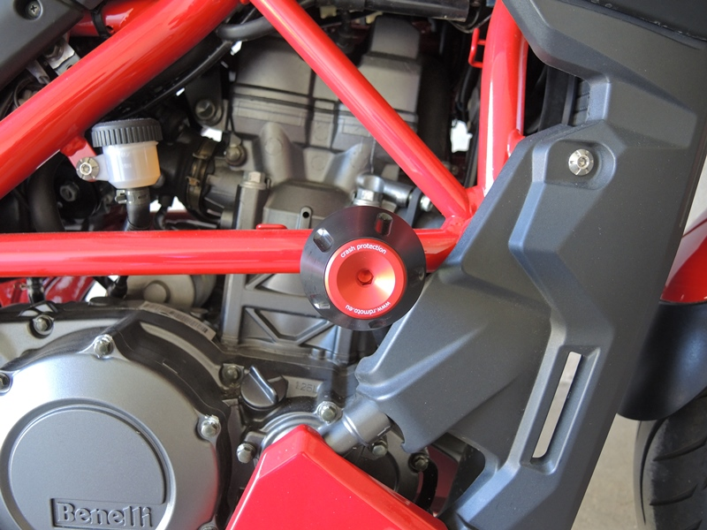

INSTRUCTIONS

- Unbolt original bolt from the frame of motorcycle.
- Insert dural cylinder ID3 into the frame.
- Insert steel insert ID1 and bolt ID2 into the protector.
- Mount this kit into the frame of motorcycle.

We recommend to use safety glue on all threads.

