BN5SD
Benelli BN302 ´15-

Left side kit: |  |  |  |  | Right side kit:
ID. | Description | Cat.no. | Pcs |  |  | ID. | Description | Cat.no. | Pcs
1 | Dural. cylinder into the frame | 1182 | 1 |  |  | 1 | Dural. cylinder into the frame | 1182 | 1
2 | Dural. cylinder for slider | DV9 | 1 |  |  | 2 | Dural. cylinder for slider | DV9 | 1
3 | Bolt M10x85 | 981 | 1 |  |  | 3 | Bolt M10x85 | 981 | 1
4 | SLD adapter | 537 | 1 |  |  | 4 | SLD adapter | 537 | 1
5 | Bolt M8x25 | 815 | 2 |  |  | 5 | Bolt M8x25 | 815 | 2
6 | Washer M8 | 802 | 2 |  |  | 6 | Washer M8 | 802 | 2

Mounting kit:

- Remove original bolt from the frame.
- Insert dural cylinder ID1 into the frame.
- Prepare bolt M10 and put dural cylinder for slider ID2 and SLD adapter ID4 on it.
- Mont this kit into the frame of motorcycle.
- Fit slider using two bolts ID5 and washers ID6.

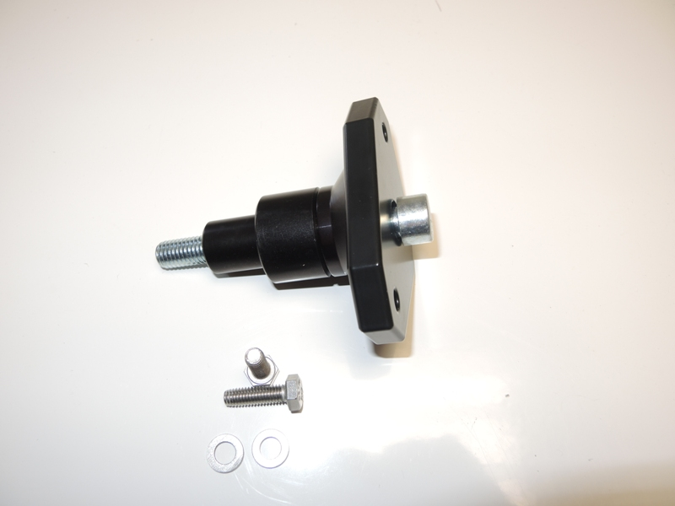
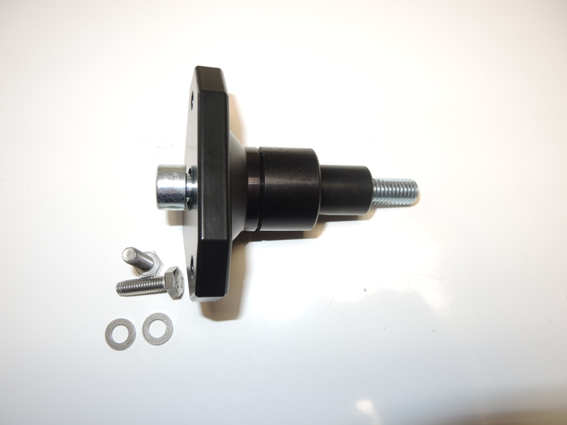
1
2
3
4
5
3
1
2
6
6
5
4
Během montáže doporučujeme použít lepidlo na závity (středně silné).

