BN5S
Benelli BN 302
Kit for the left side: |  |  |  |  | Kit for the right side:
ID | Popis | Kat.číslo | Počet |  |  | ID | Popis | Kat.číslo | Počet
1 | Adapter for slider | DV-317 | 1 |  |  | 1 | Adapter for slider | DV-317 | 1
2 | Bolt M6x25 | 877 | 3 |  |  | 2 | Bolt M6x25 | 877 | 3
3 | Bolt M4x16 | 876 | 2 |  |  | 3 | Bolt M4x16 | 876 | 2
4 | Bolt M10x80mm | 852 | 1 |  |  | 4 | Bolt M10x80mm | 852 | 1
5 | Moto adapter | 1182 | 1 |  |  | 5 | Moto adapter | 1182 | 1
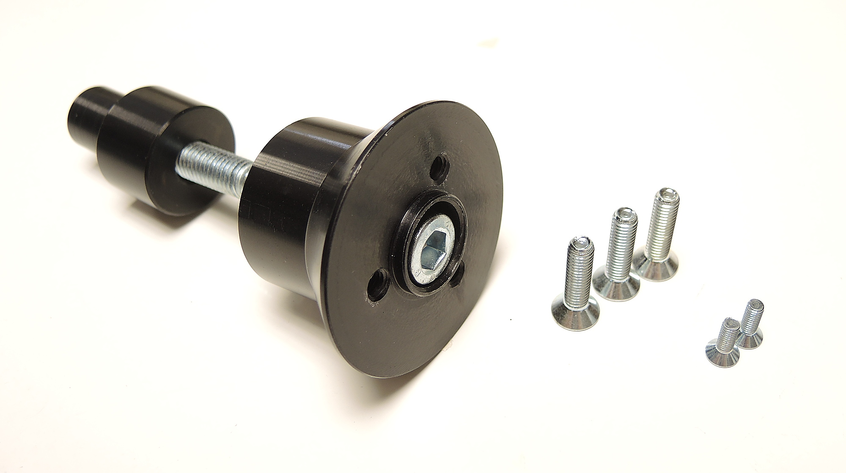

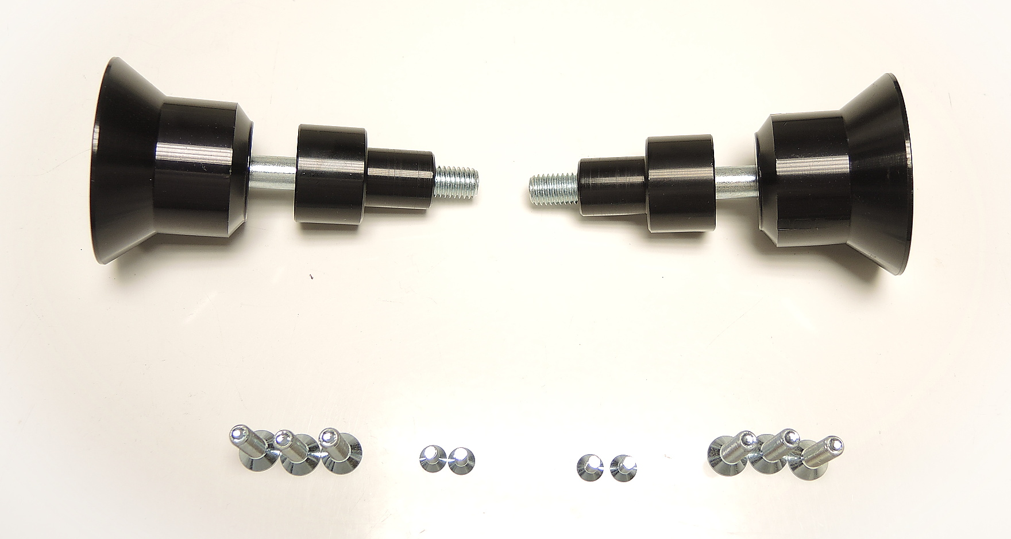
ID1
ID5
direction

ID4

ID2
ID3

Instructions (identical for both sides):

- Remove original bolts from motorcycle according to the picture below.
- Prepare kit for fitting slider.
  - Insert bolt M10 (ID4) into adapter for slider (ID1).
  - Put moto adapter (ID5) on the end of bolt M10 (ID4).
  - Mount this kit on the motorcycle
- Now mount slider on the slider adapter using three M6 bolts (ID2).
- In the end mout coloured cover on the slider using two bolts M4 (ID3).

We recommend to use the glue on all threads (medium strong – blue colour).

