BN5
Benelli BN302 ´15-

Kit for the left side |  |  |  |  | Kit for the right side
ID. | Description | Cat.N | Qt. |  |  | ID. | Description | Cat.N | Qt.
1 | Alu. spacer | 1182 | 1 |  |  | 1 | Alu. spacer | 1182 | 1
2 | Steel box | X1 | 1 |  |  | 2 | Steel box | X1 | 1
3 | Bolt M10x90 | 880 | 1 |  |  | 3 | Bolt M10x90 | 880 | 1

Installation:

- Installation of the left and right protector make in gripping about the attached photo above.
- Place the steel box ID.2 into the protectors.
- Place alu. spacers into the frame.
- Mount crash protectors by bolts ID.3.
- We recommend to done first side and after do assembly second side.

Warning – we recommend to use safety glue on threads of all bolts (moderate strong – blue colour).

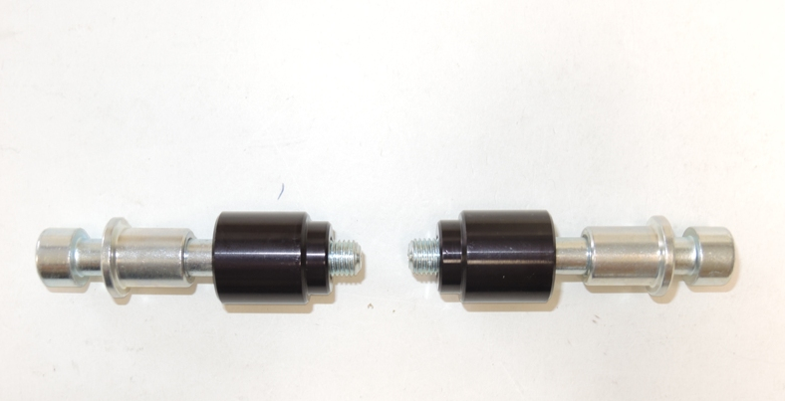

1
2
3
1
2
3

